Unit 3 Lesson 13: More Story Problems with Teen Numbers

WU Number Talk: Add Ones (Warm up)

Student Task Statement
Find the value of each expression mentally.
- $3+4$
- $4+3$
- $10+3$
- $14+3$

1 Sitting or Standing

Student Task Statement
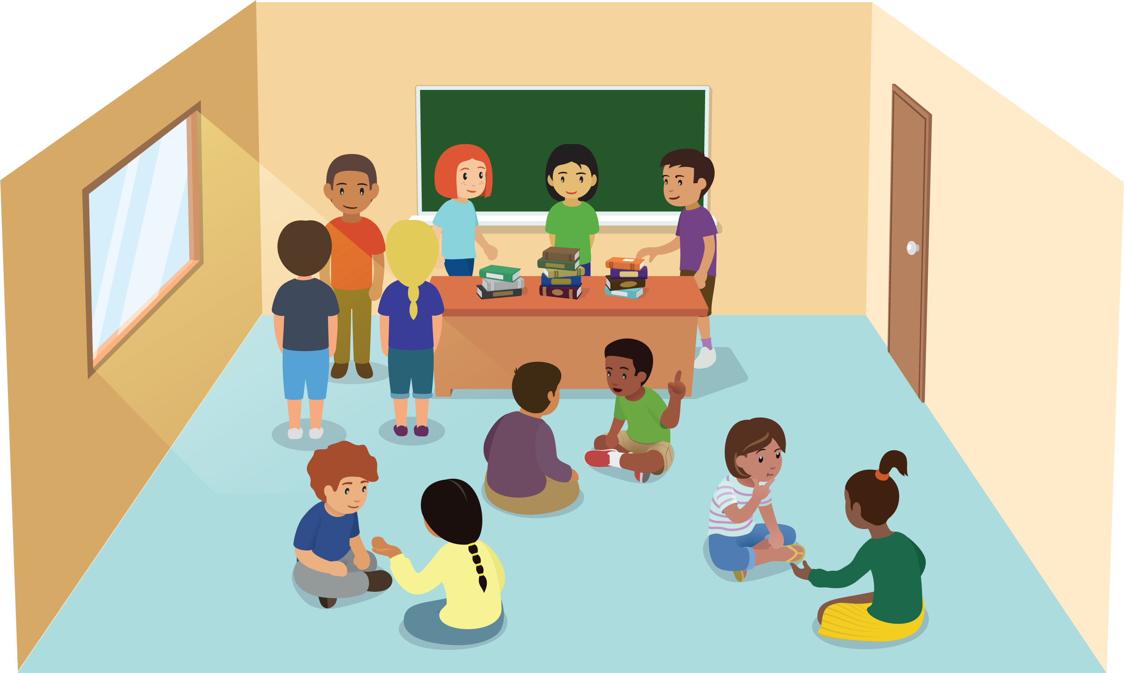
- There are students standing in the classroom.
Some of the students sit down on the rug.
There are still some students standing.
- There are 15 students standing in the classroom.
Some of the students sit down on the rug.
There are still 5 students standing.
How many students sat down on the rug?
Show your thinking using drawings, numbers, or words.
- Equation: ________________________________

2 Solve Story Problems and Compare Methods

Student Task Statement
- There are 17 students in the classroom.
4 students go home.
How many students are still in the classroom?
Show your thinking using drawings, numbers, or words.
- Equation: _____________________________
- There are 17 students in the classroom.
Some students go home.
Then there are 4 students in the classroom.
How many students went home?
Show your thinking using drawings, numbers, or words.
- Equation: _____________________________

3 Centers: Choice Time

Student Task Statement
Choose a center.
Shake and Spill
Compare
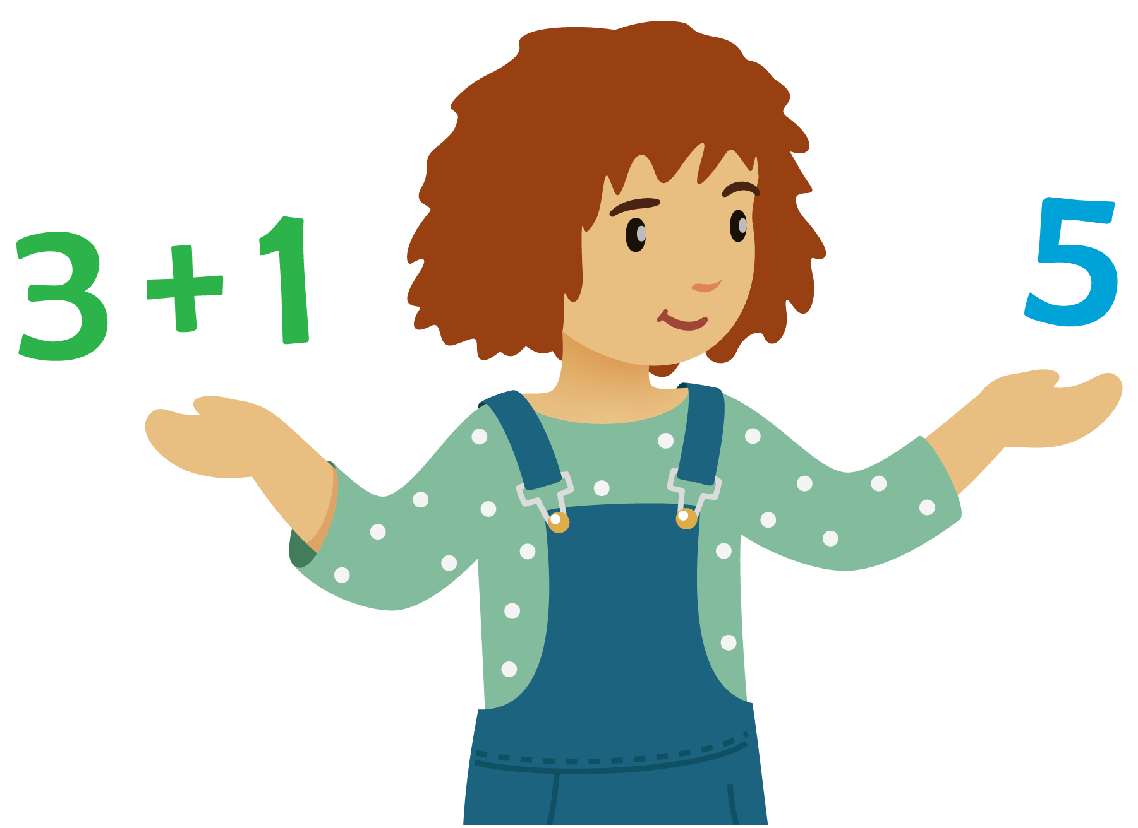
Number Puzzles
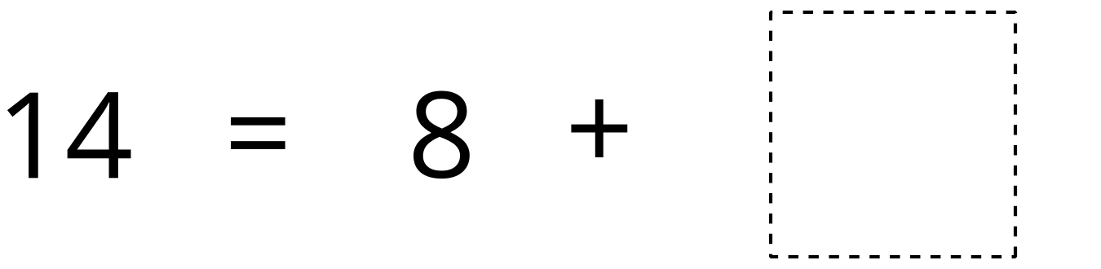
© CC BY 2021 Illustrative Mathematics®

