Unit 2 Lesson 2: Find the Unknown Addend

WU Choral Count: Count Back by 10 (Warm up)

Student Task Statement

1 How Did You Find It?

Student Task Statement
- 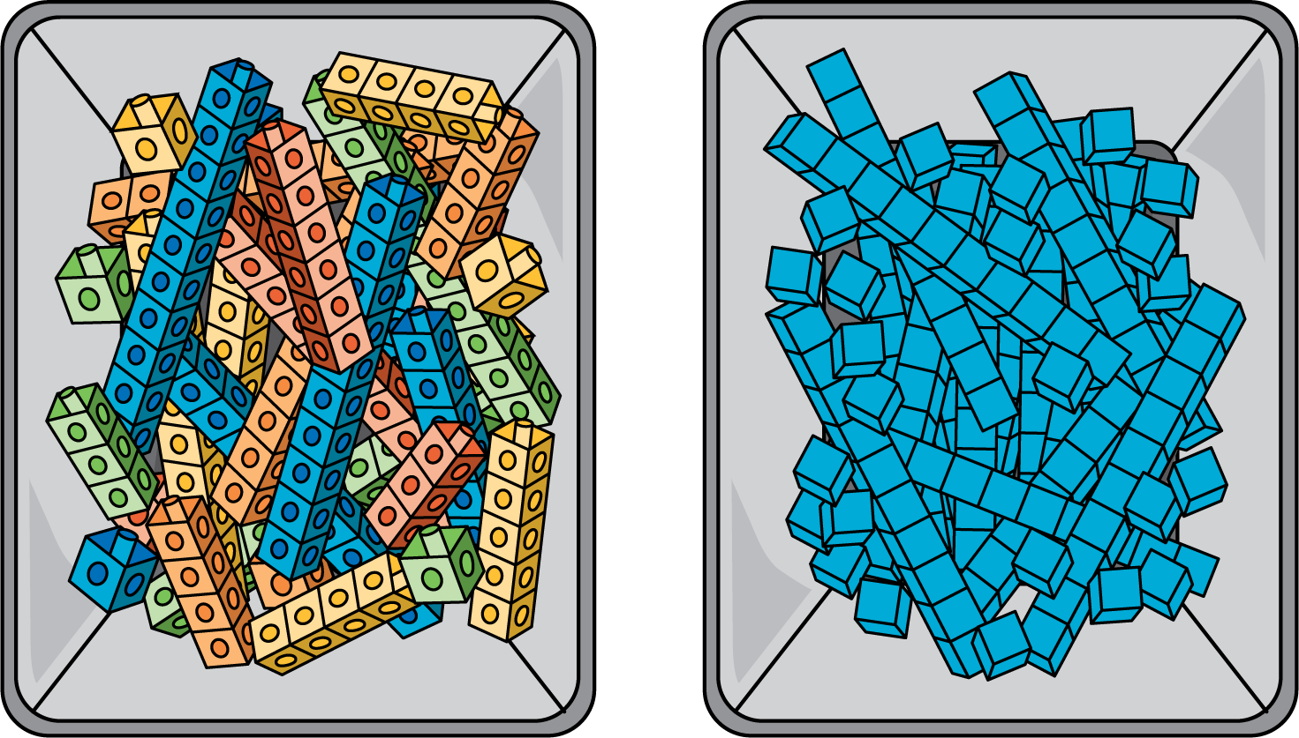
- What is the same and what is different between these tools?
- Find the number that makes the equation true. Show your thinking using the cubes, blocks, or drawings.
- 41+ _=84

2 You Go This Way, I’ll Go That Way

Student Task Statement
Han and Mai use blocks to find the number that makes the equation true.
17+ _=48
- Han starts by using blocks to show 17. Show how he could find the number that makes the equation true.
- Mai starts by using blocks to show 48. Show how she could find the number that makes the equation true.
- Try this one on your own. Choose who will start with 21 and who will start with 96.
- 21+ _=96
- Show your partner how you found the number that makes the equation true.
© CC BY 2021 Illustrative Mathematics®

