Unit 5 Lesson 5: One- and Two-step Comparison Problems

WU Which One Doesn’t Belong: Something's Missing (Warm up)

Student Task Statement
Which one doesn’t belong?

- 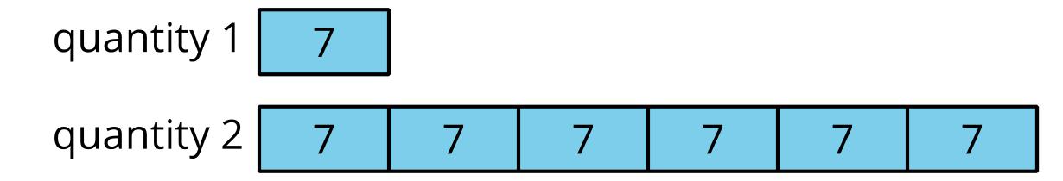

- $6×7=42$

- 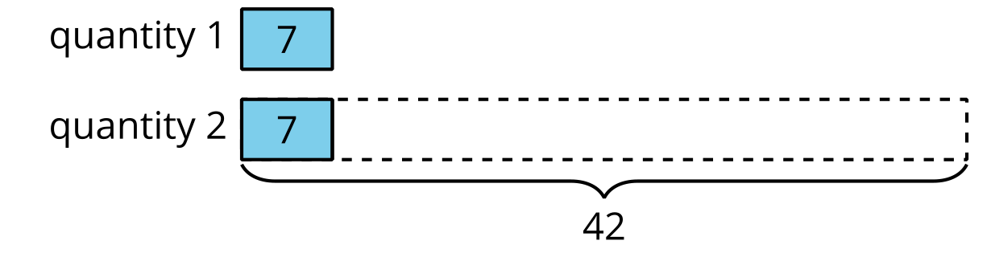

- 42 is 6 times as many as _____.

1 The Book Fair

Student Task Statement
For this year’s book fair, a school ordered 16 science books and 6 times as many picture books.
Last year, the school ordered 4 times as many picture books and 4 times as many science books than they did this year.
- How many picture books were ordered this year?
- How many picture books were ordered last year?
- How many more science experiment books were ordered last year than this year?

2 More Book Fair Purchases

Student Task Statement
- At the book fair, they collected $13 Tuesday morning and 8 times as much as that in the afternoon. How much money did they collect at the book fair on Tuesday?
- On Thursday, Mai purchased a biography for $16 and a comic book for $3. That day, the book fair's amount of total sales was 9 times as much money as Mai spent.
- What was the amount of total sales for the book fair on Thursday?
© CC BY 2021 Illustrative Mathematics®

