Lesson 4: Dive Back Into Division
- Let’s estimate and divide.

Warm-up: Notice and Wonder: Blank Spaces
What do you notice? What do you wonder?
$\underset{_}{}÷\underset{_}{}=136$

4.1: Reasonable Estimates
- Circle the most reasonable estimate. Show your reasoning.
  - $364÷13$
  - 20
  - 30
  - 40
  - $540÷12$
  - 40
  - 50
  - 60
  - $1,​008÷14$
  - 70
  - 80
  - 90
- Find the value of each quotient.
- a.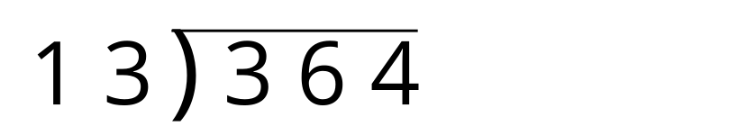
- b.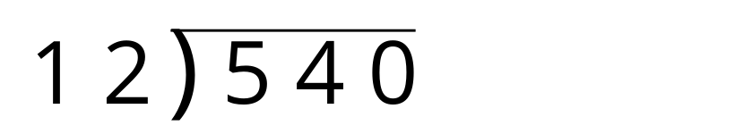
- c.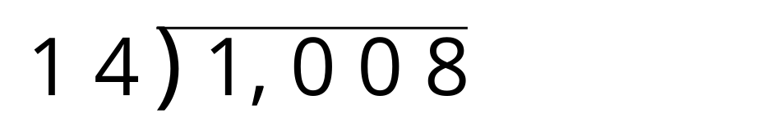

4.2: Missing Dividends and Divisors
- Write different numbers in the blanks that make the equations true.
- $\underset{_}{}÷\underset{_}{}=700$
- $\underset{_}{}÷\underset{_}{}=78$
- $\underset{_}{}÷\underset{_}{}=700$
- $\underset{_}{}÷\underset{_}{}=78$
- $\underset{_}{}÷\underset{_}{}=700$
- $\underset{_}{}÷\underset{_}{}=78$
- $\underset{_}{}÷\underset{_}{}=700$
- $\underset{_}{}÷\underset{_}{}=78$
- $\underset{_}{}÷\underset{_}{}=700$
- $\underset{_}{}÷\underset{_}{}=78$
- What strategy did you use to choose numbers to write in the blanks?
© CC BY 2021 Illustrative Mathematics®

