Lesson 8: Multiplication Fluency
- Let’s practice multiplication.

Warm-up: Number Talk: The Distributive Property
Find the value of each expression mentally.
- $6×15$
- $6×17$
- $6×2\frac{1}{3}$
- $6×2\frac{2}{3}$

8.1: Fluency Practice Choice Time
Choose a game.
- Greatest Product
- Number Puzzles: Multiplication and Division

8.2: Targeted Products
- Using the digits 3, 5, 6, 8, and 9 make a product whose value is close to 50,000.
- 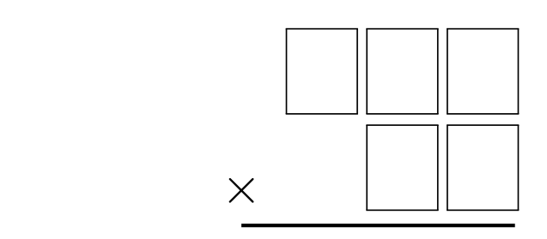
- Using the digits 3, 5, 6, 8, and 9 make a product whose value is close to 20,000.
© CC BY 2021 Illustrative Mathematics®

