Lesson 15: Create Line Plots
- Let’s represent data in line plots.

Warm-up: Number Talk: Subtraction within 50
Find the value of each expression mentally.
- $47−20$
- $47−24$
- $36−10$
- $36−15$

15.1: Measure and Plot Pencil Lengths
- Measure the pencils in centimeters. Work with a partner and check each other’s measurements. Record each measurement in the table.
- pencil length (cm)
- Create a line plot to represent the lengths of all the pencils in your group.

15.2: Plot Pencil Lengths
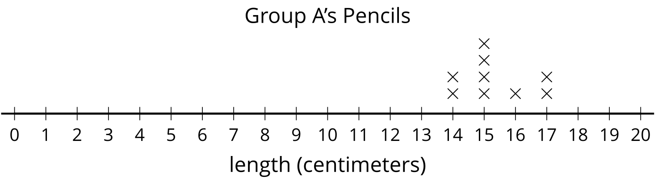
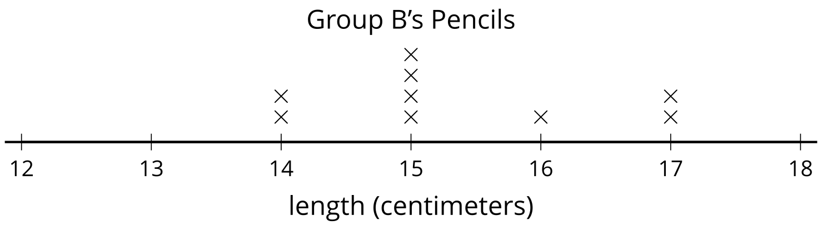
Use this data to create a line plot.
Group C | pencil length (centimeters)
Andre | 12
Clare | 10
Diego | 10
Elena | 10
Han | 13
Jada | 12
Kiran | 14
Noah | 16
Priya | 14
Tyler | 13
© CC BY 2021 Illustrative Mathematics®

