Unit 3 Lesson 14: Center Day 2

WU True or False: Expressions on Both Sides (Warm up)

Student Task Statement
Decide whether each statement is true or false.
Be prepared to explain your reasoning.
- $3+2=3+2$
- $5+1=5+2$
- $4+6=3+7$

1 Introduce Number Puzzles, Within 20

Student Task Statement

2 Centers: Choice Time

Student Task Statement
Choose a center.
Number Puzzles
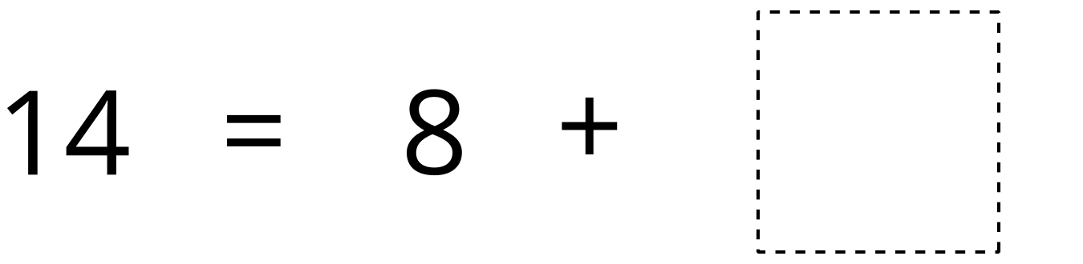
Shake and Spill
Compare
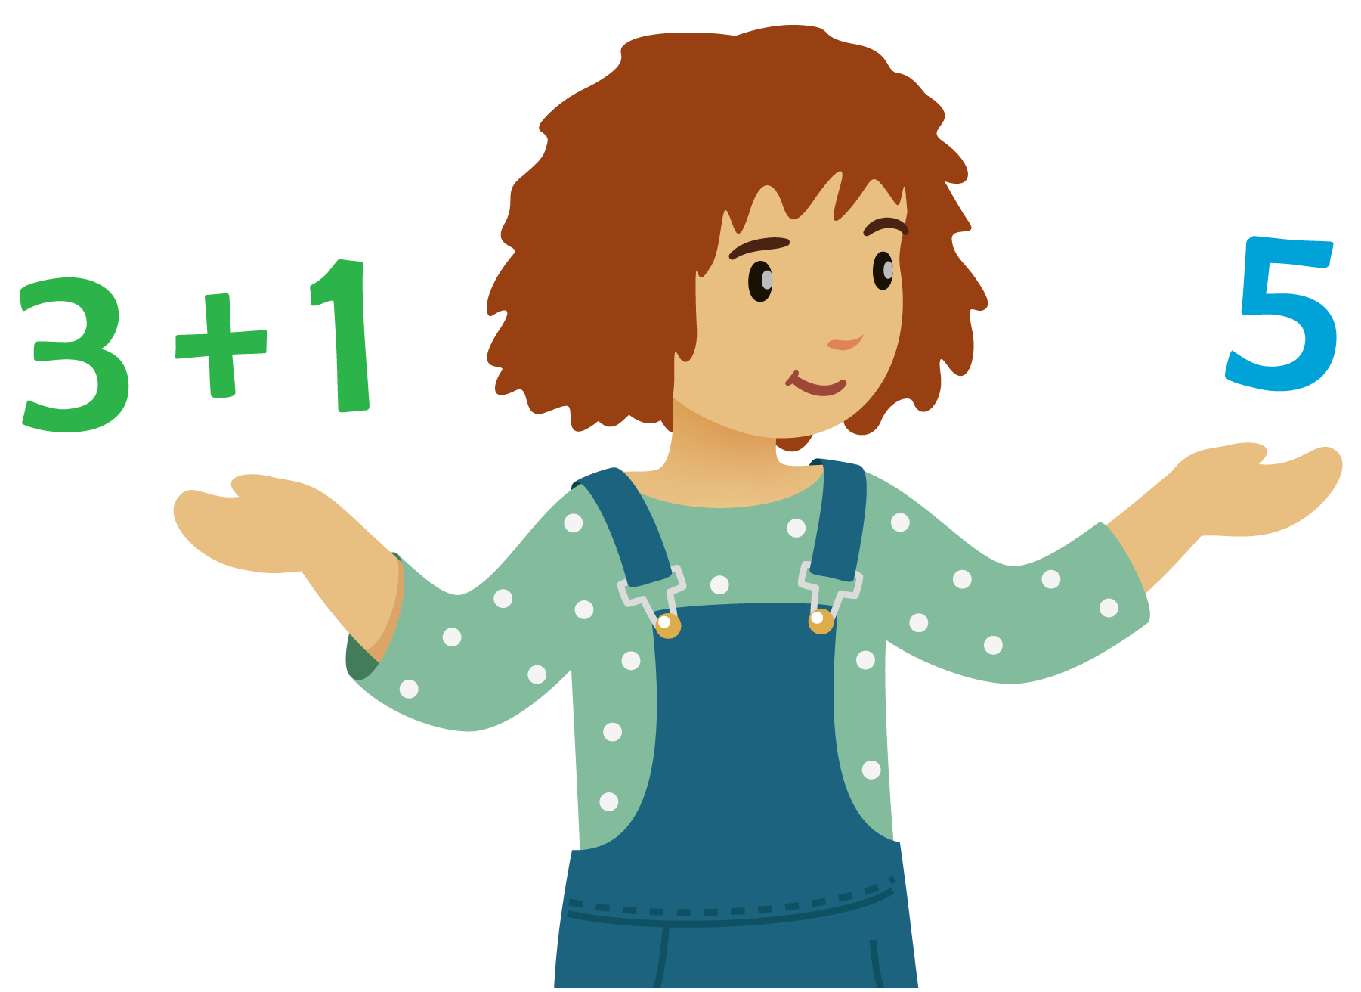
© CC BY 2021 Illustrative Mathematics®

