Lesson 16: Tenths and Hundredths, Together
- Let’s add some tenths and hundredths.

Warm-up: Notice and Wonder: Shaded Rectangles and Squares
Each large square represents 1.
What do you notice? What do you wonder?
A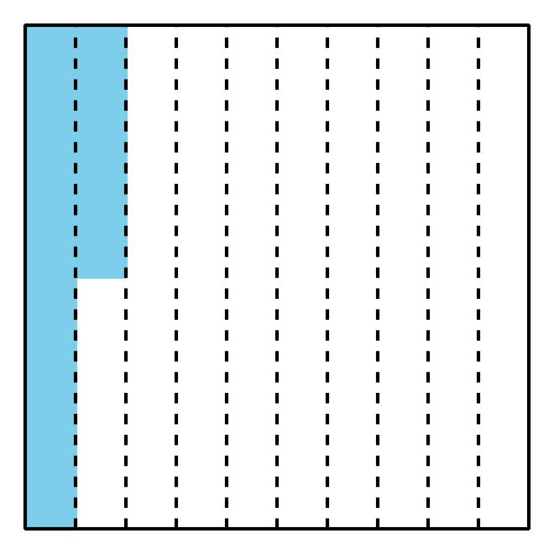
B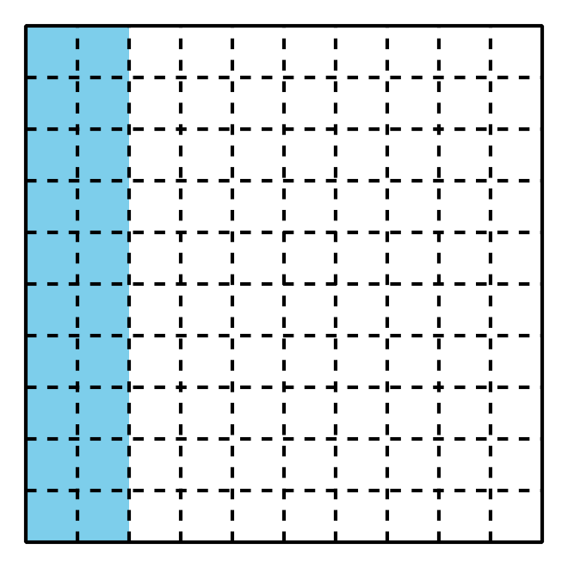

16.1: Tenths and Hundredths
- Complete the table with equivalent fractions in tenths or hundredths. In the last row, write a new pair of equivalent fractions.
 | - tenths | - hundredths
- a. | - $\frac{1}{10}$
- b. | - $\frac{4}{10}$
- c. | - $\frac{6}{10}$
- d. |  | - $\frac{50}{100}$
- e. |  | - $\frac{90}{100}$
- f. | - $\frac{12}{10}$
- g. |  | - $\frac{200}{100}$
- h. | - $2\frac{3}{10}$
- i. |  | - $\frac{125}{100}$
- j. | - \0\0
- Name some fractions that are:
  - between $\frac{50}{100}$ and $\frac{60}{100}$
  - between $\frac{3}{10}$ and $\frac{4}{10}$
- Be prepared to explain your reasoning.

16.2: Walk, Stop, and Sip
Noah walks $\frac{2}{10}$ kilometer (km), stops for a drink of water, walks $\frac{5}{100}$ kilometer, and stops for another sip.
- Which number line diagram represents the distance Noah has walked? Explain how you know.
- 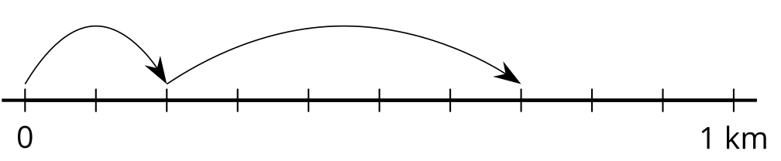
- The diagram that you didn’t choose represents Jada’s walk. Write an equation to represent:
  - the total distance Jada has walked
  - the total distance Noah has walked
- Find the value of each of the following sums. Show your reasoning. Use number lines if you find them helpful.
  - $\frac{5}{10}+\frac{1}{10}$
  - $\frac{50}{100}+\frac{10}{100}$
  - $\frac{5}{10}+\frac{30}{100}$
  - $\frac{15}{100}+\frac{4}{10}$
© CC BY 2021 Illustrative Mathematics®

