Unit 5 Lesson 6: Ten Times as Many

WU Choral Count: 12, 15 and 24 (Warm up)

Student Task Statement

1 Ten Times as Many

Student Task Statement
Here is a diagram that represents two quantities, A and B.
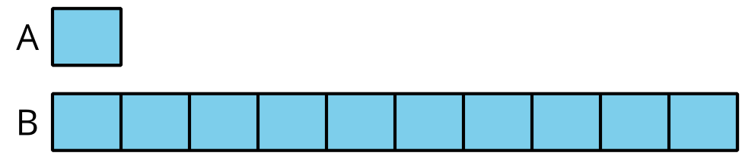
- What are some possible values of A and B?
- Select the equations that could be represented by the diagram.
  - $15×10=150$
  - $16×100=1,​600$
  - $30÷3=10$
  - $5,​000÷5=1,​000$
  - $80×10=800$
  - $12,​000÷10=1,​200$
- For the equations that can't be represented by the diagram:
  - Explain why the diagram does not represent these equations.
  - How would you change the equations so the diagram could represent them?
  - Compare your equations with your partner’s. Make at least two observations about the equations you and your partner wrote.

2 What Remains the Same?

Student Task Statement
- Use the diagram to complete the table.
- value of A | - value of B
- 14 | - 0000000000
- 0000000000 | - 1,000
- 160
 | - 850
- 1,000
 | - 2,070
 | - 3,900
- Select some values from your table to explain or show:
  - How you found the value of B when the value of A is known.
  - How you found the value of A when the value of B is known.

Images for Activity Synthesis
© CC BY 2021 Illustrative Mathematics®

