Unit 5 Lesson 9: Using the Partial Quotients Method

1 Using Base-Ten Diagrams to Calculate Quotients (Warm up)

Student Task Statement
Elena used base-ten diagrams to find $372÷3$. She started by representing 372.
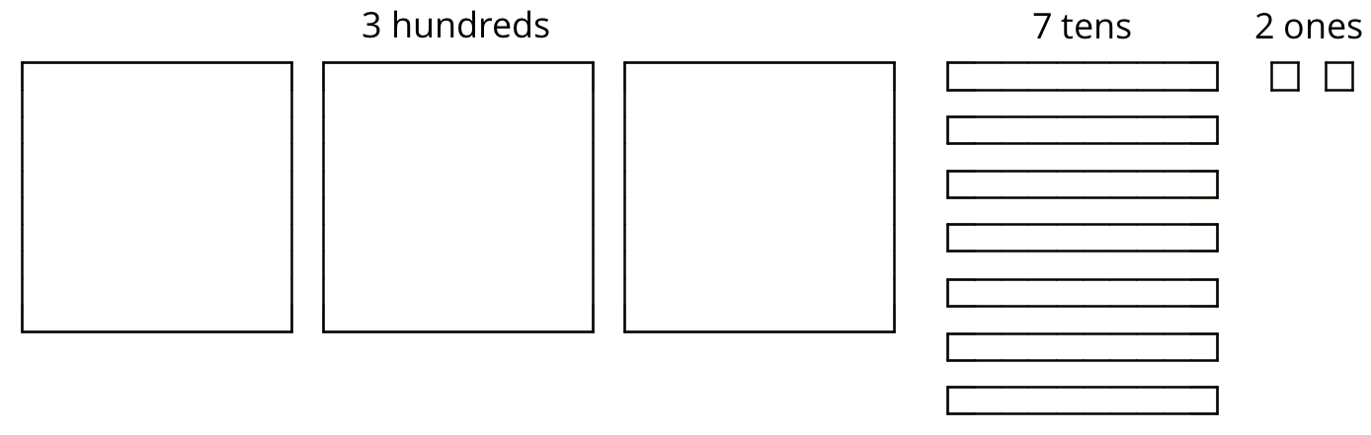
She made 3 groups, each with 1 hundred. Then, she put the tens and ones in each of the 3 groups. Here is her diagram for $372÷3$.
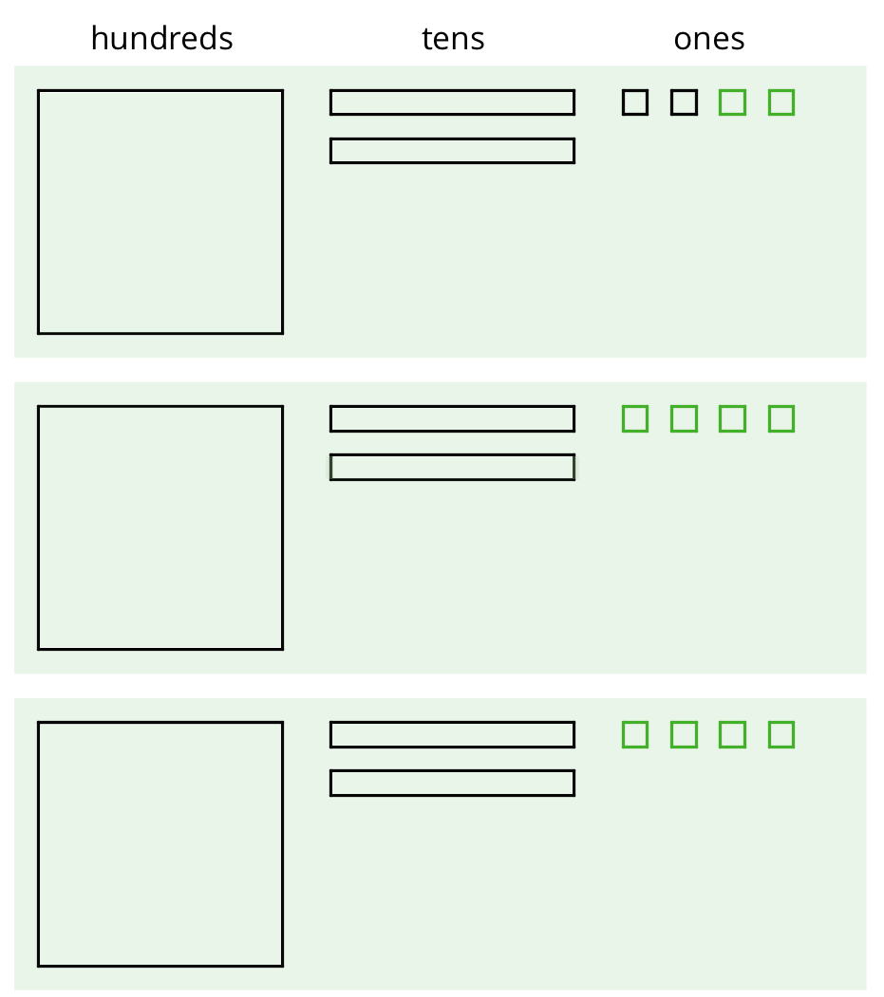
Discuss with a partner:
- Elena’s diagram for 372 has 7 tens. The one for $372÷3$ has only 6 tens. Why?
- Where did the extra ones (small squares) come from?

2 Using the Partial Quotients Method to Calculate Quotients

Images for Launch
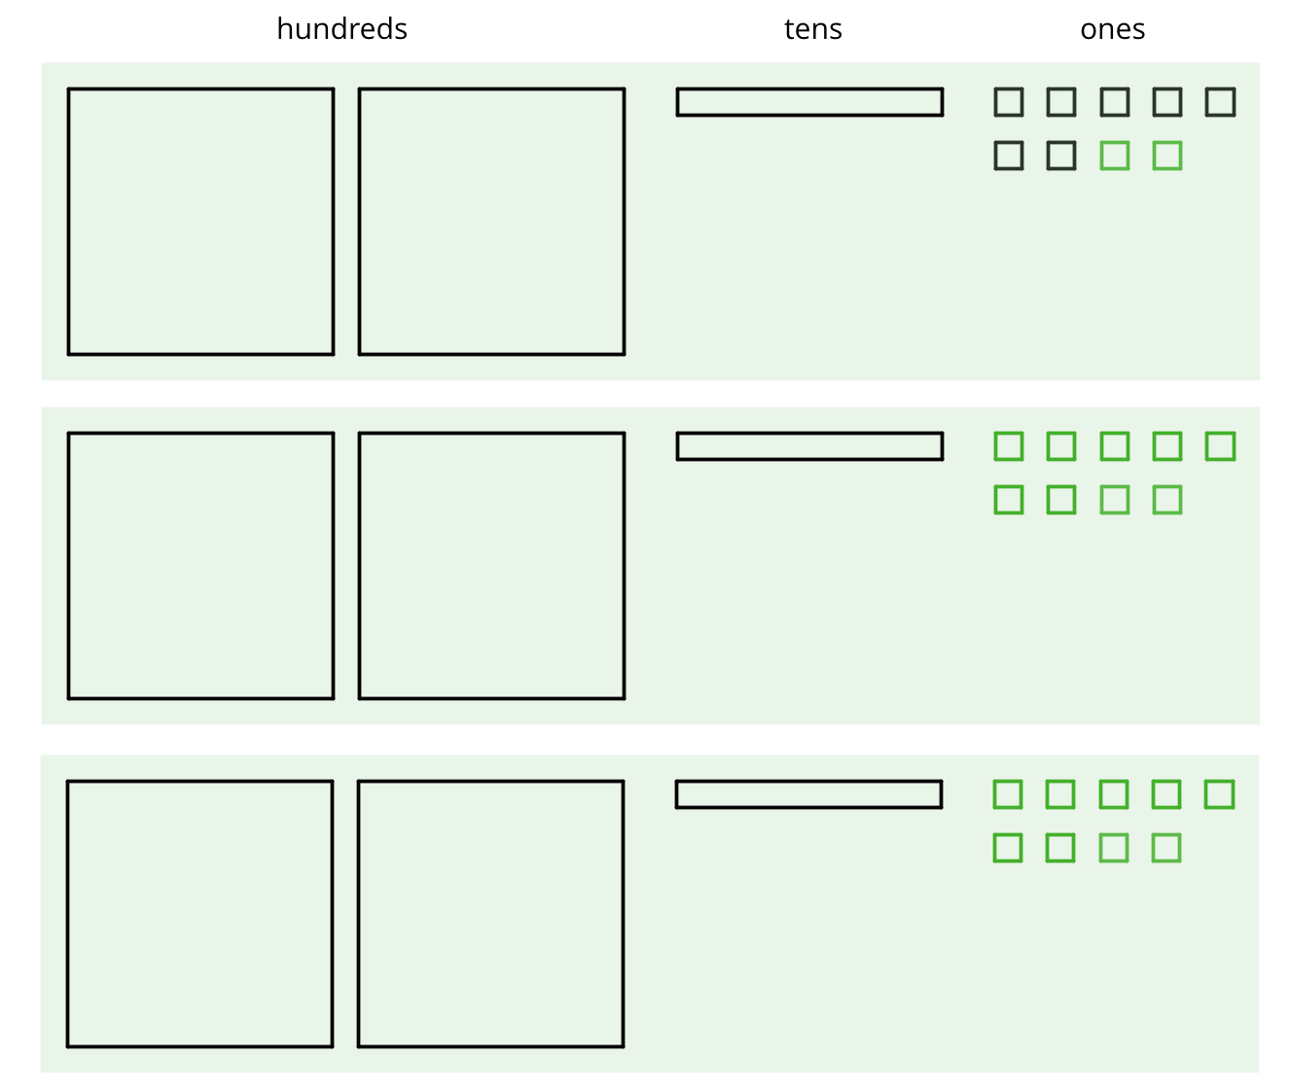

Student Task Statement
- Andre calculated $657÷3$ using a method that was different from Elena’s.
- 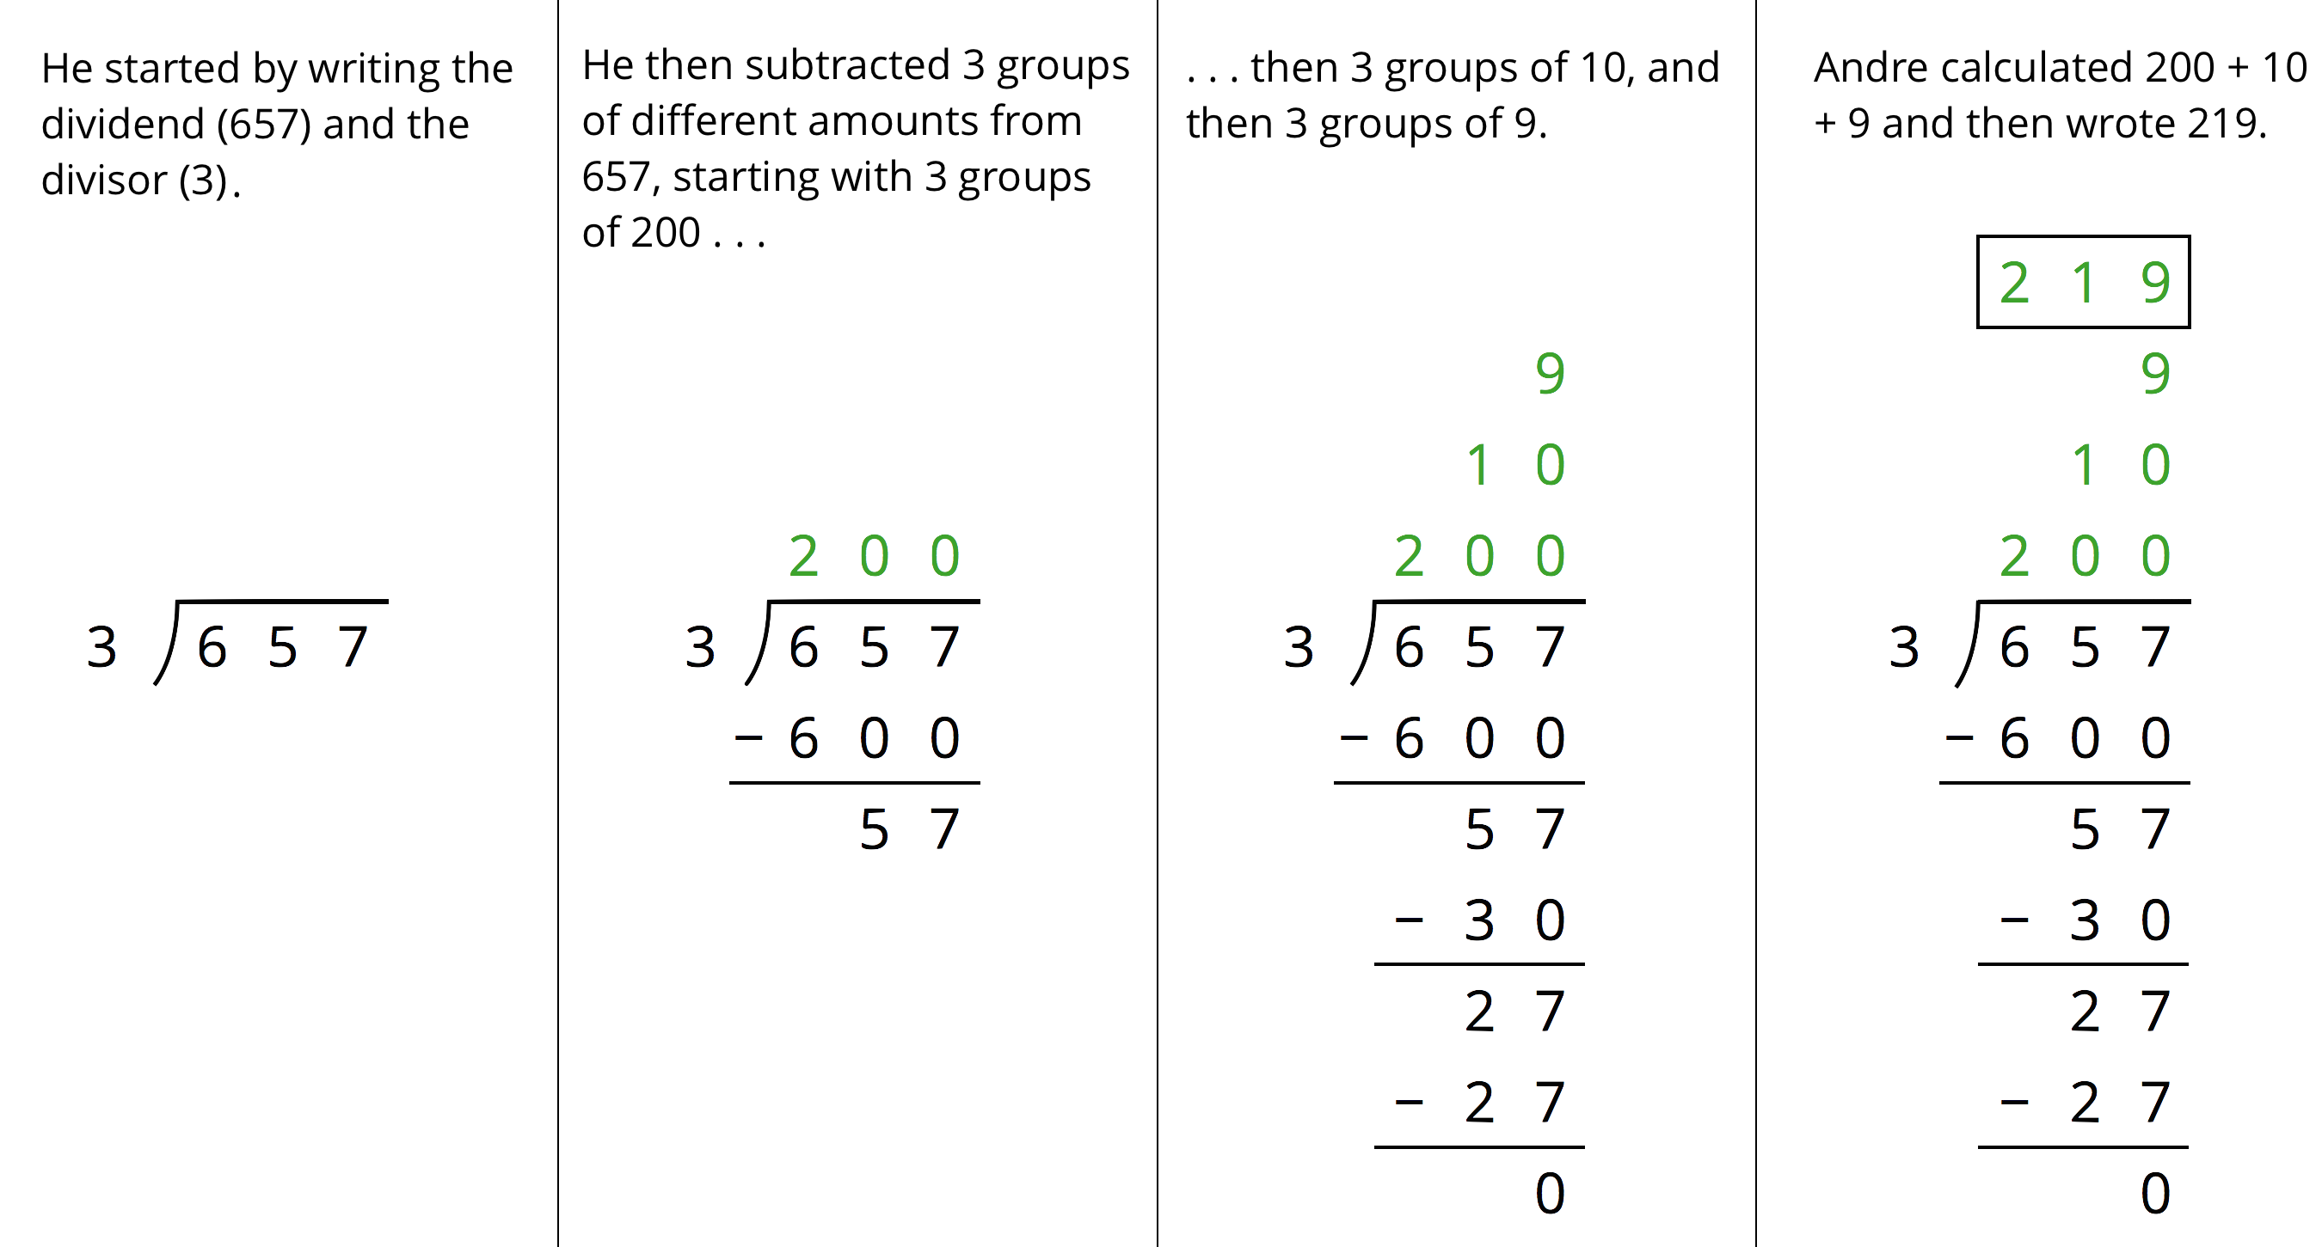
  - Andre subtracted 600 from 657. What does the 600 represent?
  - Andre wrote 10 above the 200, and then subtracted 30 from 57. How is the 30 related to the 10?
  - What do the numbers 200, 10, and 9 represent?
  - What is the meaning of the 0 at the bottom of Andre’s work?
- How might Andre calculate $896÷4$? Explain or show your reasoning.

3 What’s the Quotient?

Student Task Statement
- Find the quotient of $1,​332÷9$ using one of the methods you have seen so far. Show your reasoning.
- Find each quotient and show your reasoning. Use the partial quotients method at least once.
  - $1,​115÷5$
  - $665÷7$
  - $432÷16$
© CC BY Open Up Resources. Adaptations CC BY IM.

