## Unit 2 Lesson 13: Two Graphs for Each Relationship

### 1 True or False: Fractions and Decimals (Warm up)

#### Student Task Statement

Decide whether each equation is true or false. Be prepared to explain your reasoning.

### 2 Tables, Graphs, and Equations

#### Student Task Statement

Your teacher will assign you *one* of these three points:

, , .

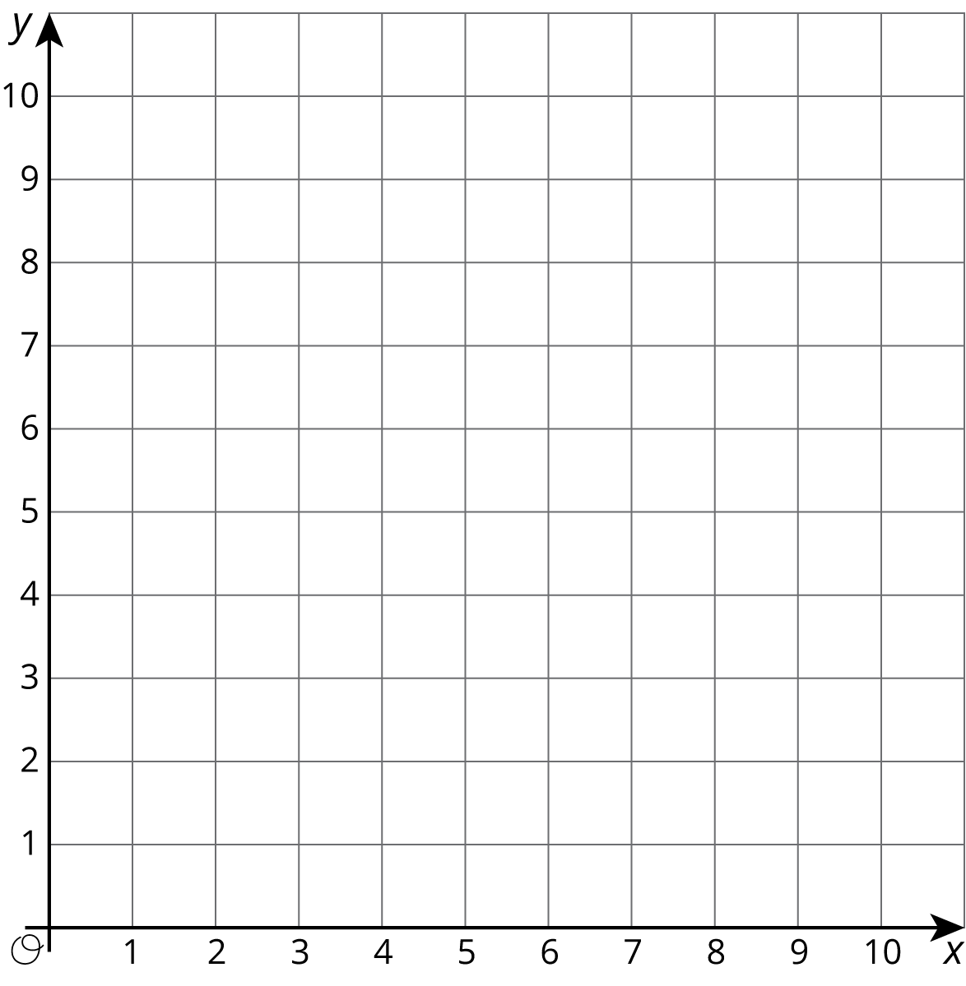

|  |  |  |
| --- | --- | --- |
|  |  |  |
| 0 |  | NA |
| 1 |  |  |
| 2 |  |  |
| 3 |  |  |
| 4 |  |  |
| 5 |  |  |
| 6 |  |  |
| 7 |  |  |
| 8 |  |  |
| 9 |  |  |
| 10 |  |  |

1. On the graph, plot and label *only* your assigned point.
2. Use a ruler to line up your point with the origin, . Draw a line that starts at the origin, goes through your point, and continues to the edge of the graph.
3. Complete the table with the coordinates of points on your graph. Use a fraction to represent any value that is not a whole number.
4. Write an equation that represents the relationship between and defined by your point.
5. Compare your graph and table with the rest of your group. What is the same and what is different about:
   1. your tables?
   2. your equations?
   3. your graphs?
6. What is the -coordinate of your graph when the -coordinate is 1? Plot and label this point on your graph. Where do you see this value in the table? Where do you see this value in your equation?
7. Describe any connections you see between the table, characteristics of the graph, and the equation.

### 3 Hot Dog Eating Contest

#### Student Task Statement

Andre and Jada were in a hot dog eating contest. Andre ate 10 hot dogs in 3 minutes. Jada ate 12 hot dogs in 5 minutes.

Here are two different graphs that both represent this situation.

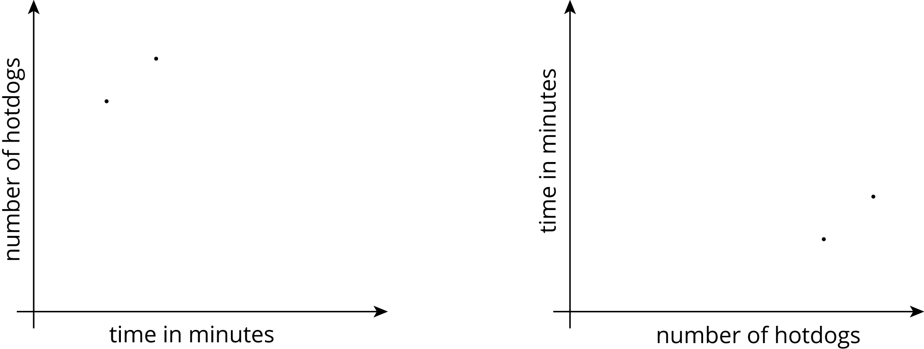

1. On the first graph, which point shows Andre’s consumption and which shows Jada’s consumption? Label them.
2. Draw two lines: one through the origin and Andre’s point, and one through the origin and Jada’s point.
3. Write an equation for each line. Use to represent time in minutes and to represent number of hot dogs.
   1. Andre:
   2. Jada:
4. For each equation, what does the constant of proportionality tell you?
5. Repeat the previous steps for the second graph.
   1. Andre:
   2. Jada:



© CC BY Open Up Resources. Adaptations CC BY IM.