Lesson 9: Drawing Triangles (Part 1)

9.1: Which One Doesn’t Belong: Triangles
Which one doesn’t belong?
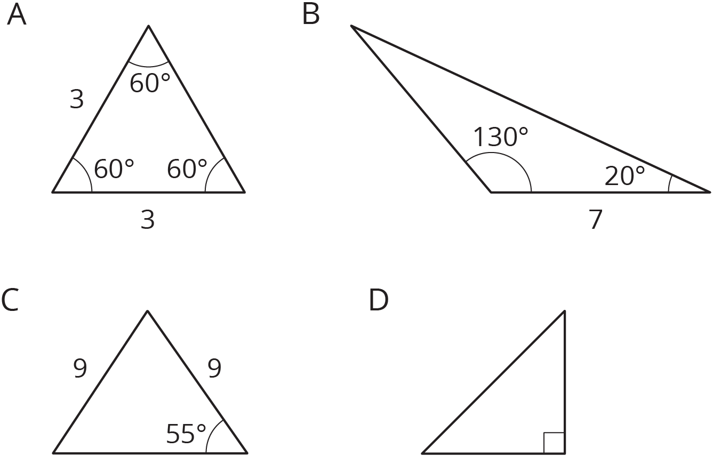

9.2: Does Your Triangle Match Theirs?
Three students have each drawn a triangle. For each description:
- Draw a triangle with the given measurements.
- Measure and label the other side lengths and angle measures in your triangle.
- Decide whether the triangle you drew must be an identical copy of the triangle that the student drew. Explain your reasoning.
- Jada’s triangle has one angle measuring ${75}^{∘}$.
- Andre’s triangle has one angle measuring ${75}^{∘}$ and one angle measuring ${45}^{∘}$.
- Lin’s triangle has one angle measuring ${75}^{∘}$, one angle measuring ${45}^{∘}$, and one side measuring 5 cm.

9.3: How Many Can You Draw?
- Draw as many different triangles as you can with each of these sets of measurements:
  - Two angles measure ${60}^{∘}$, and one side measures 4 cm.
  - Two angles measure ${90}^{∘}$, and one side measures 4 cm.
  - One angle measures ${60}^{∘}$, one angle measures ${90}^{∘}$, and one side measures 4 cm.
- Which of these sets of measurements determine one unique triangle? Explain or show your reasoning.

Are you ready for more?
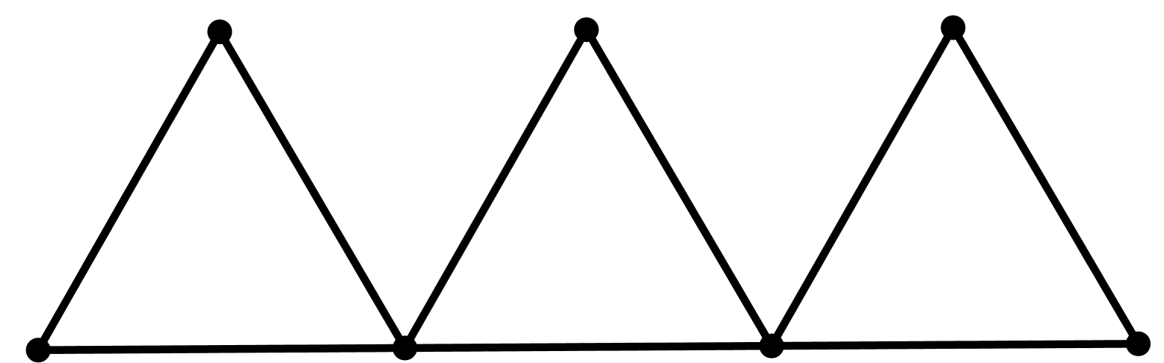
In the diagram, 9 toothpicks are used to make three equilateral triangles. Figure out a way to move only 3 of the toothpicks so that the diagram has exactly 5 equilateral triangles.

Lesson 9 Summary
Sometimes, we are given two different angle measures and a side length, and it is impossible to draw a triangle. For example, there is no triangle with side length 2 and angle measures ${120}^{∘}$ and ${100}^{∘}$:
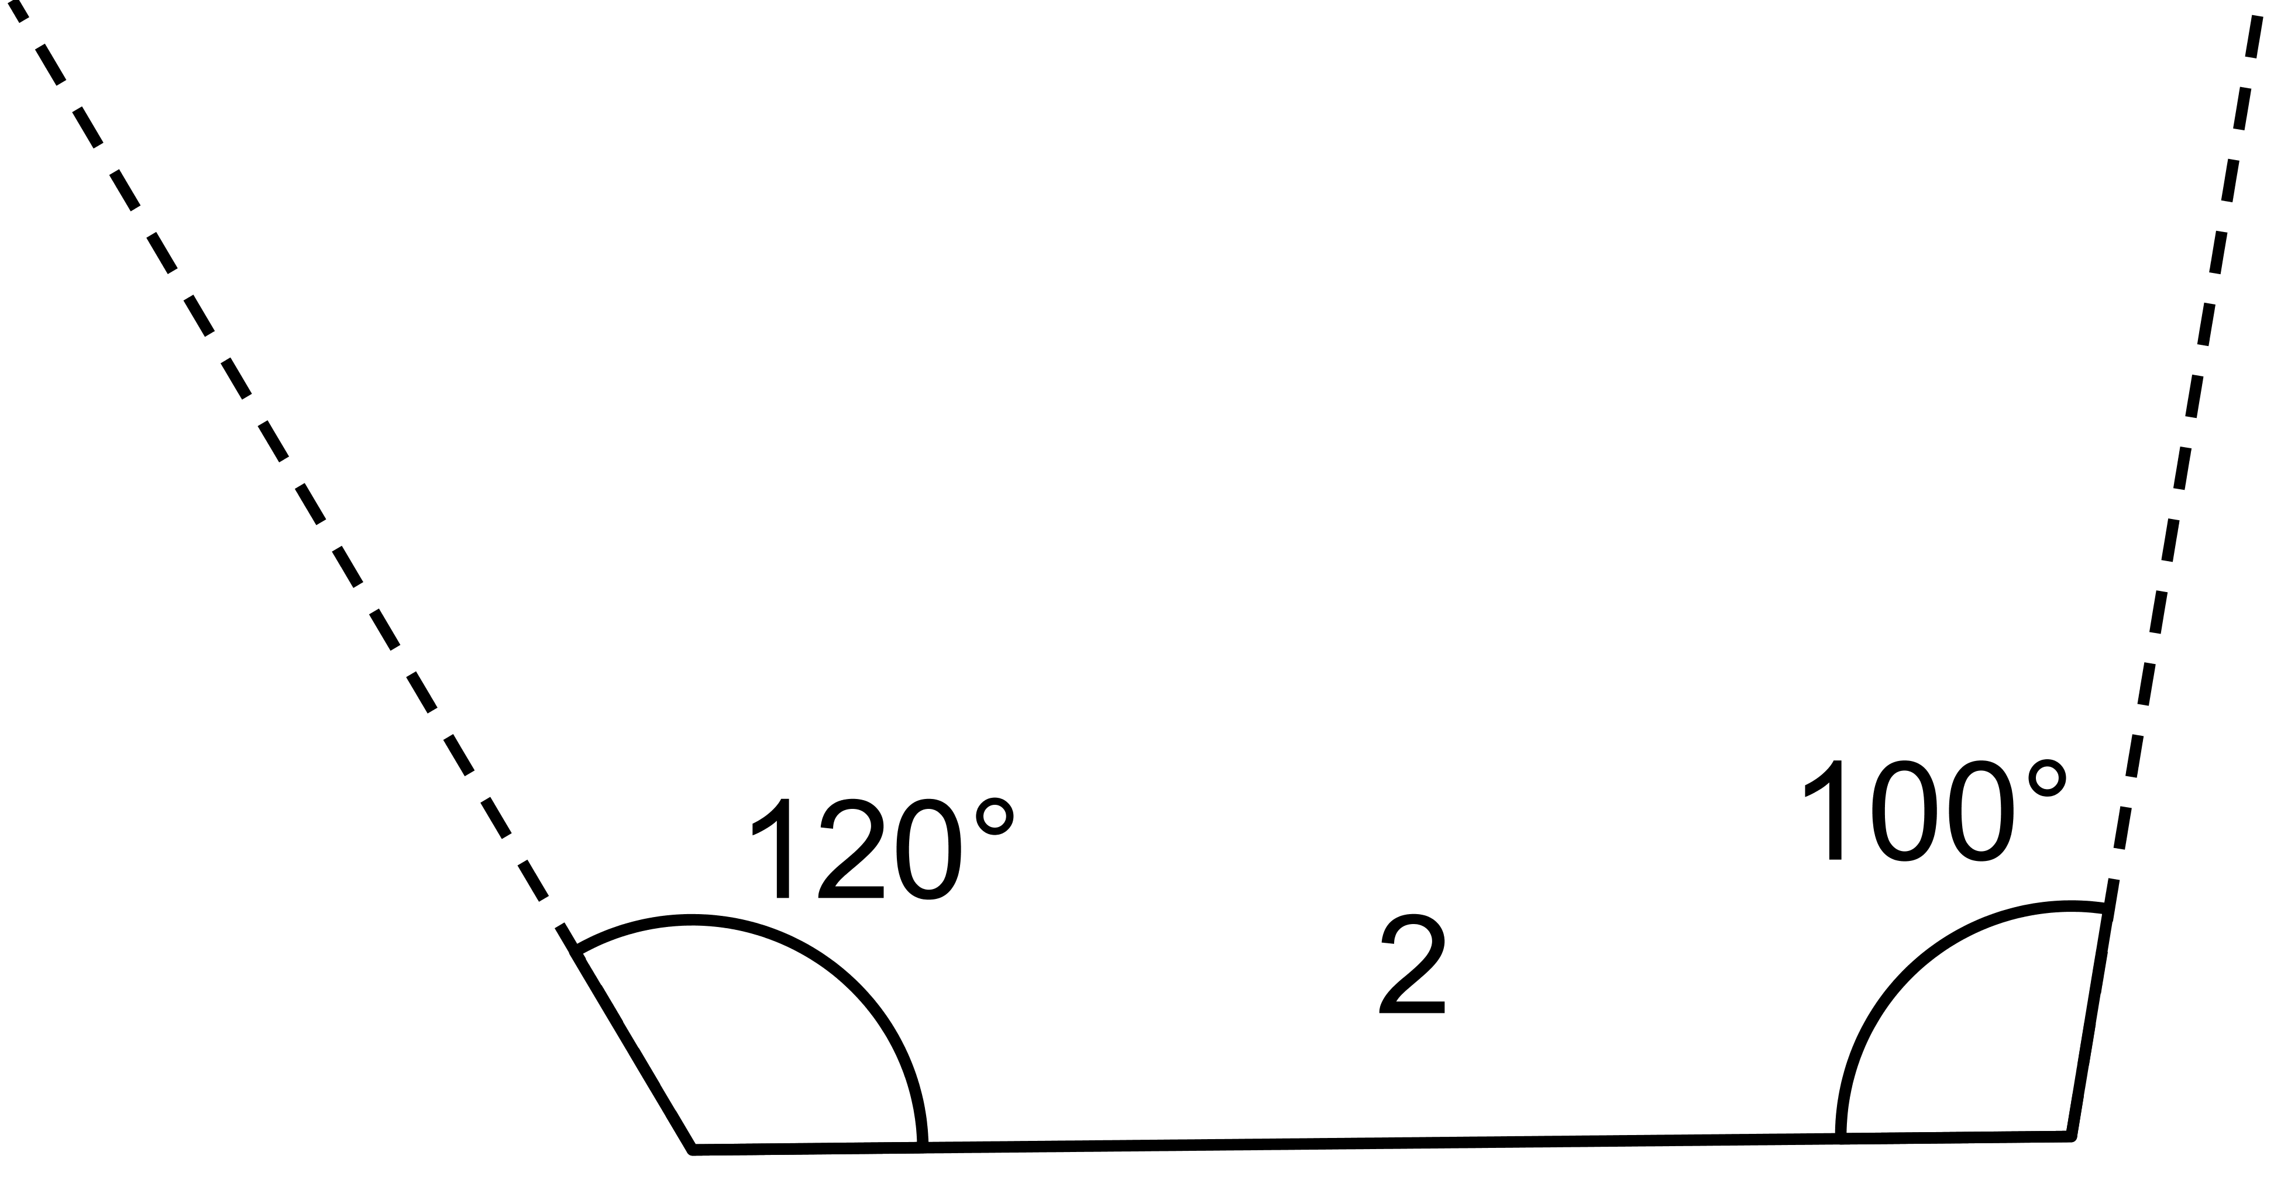
Sometimes, we are given two different angle measures and a side length between them, and we can draw a unique triangle. For example, if we draw a triangle with a side length of 4 between angles ${90}^{∘}$ and ${60}^{∘}$, there is only one way they can meet up and complete to a triangle:
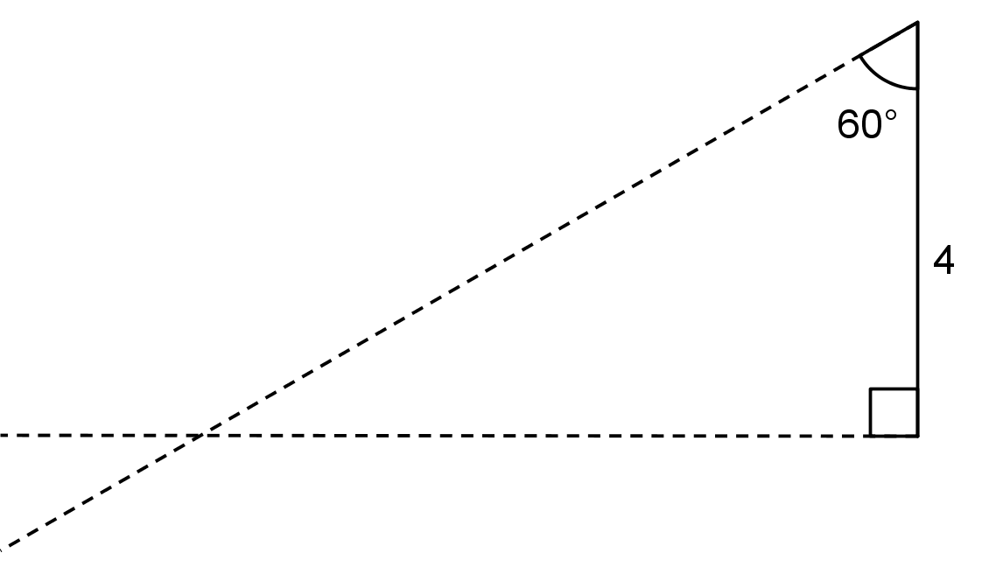
Any triangle drawn with these three conditions will be identical to the one above, with the same side lengths and same angle measures.
© CC BY Open Up Resources. Adaptations CC BY IM.

