Unit 5 Lesson 3: Snap the Cubes

WU Notice and Wonder: Connecting Cube Towers (Warm up)

Student Task Statement
What do you notice?
What do you wonder?
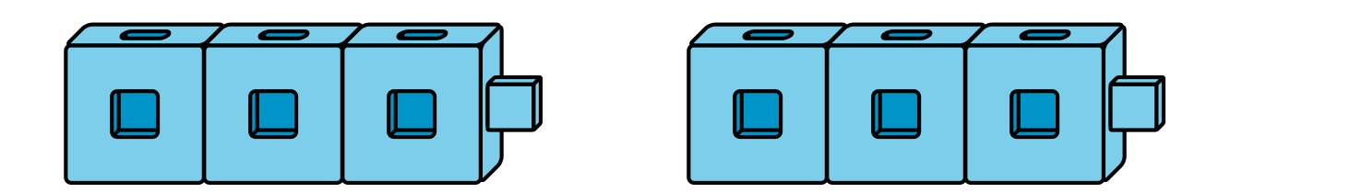
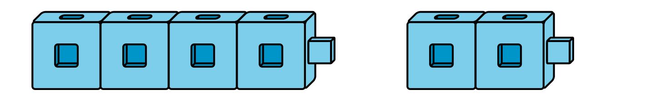
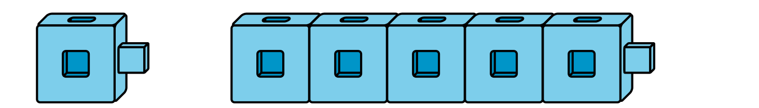

1 Introduce What’s Behind My Back, Show 2 Parts

Student Task Statement
8 cubes
expression: _________________________
expression: _________________________
expression: _________________________
expression: _________________________
8 cubes
expression: _________________________
expression: _________________________
expression: _________________________
expression: _________________________
expression: _________________________

2 More Than One Way

Student Task Statement
4
9
6

7
5
8

3 Centers: Choice Time

Student Task Statement
Choose a center.
What's Behind My Back?
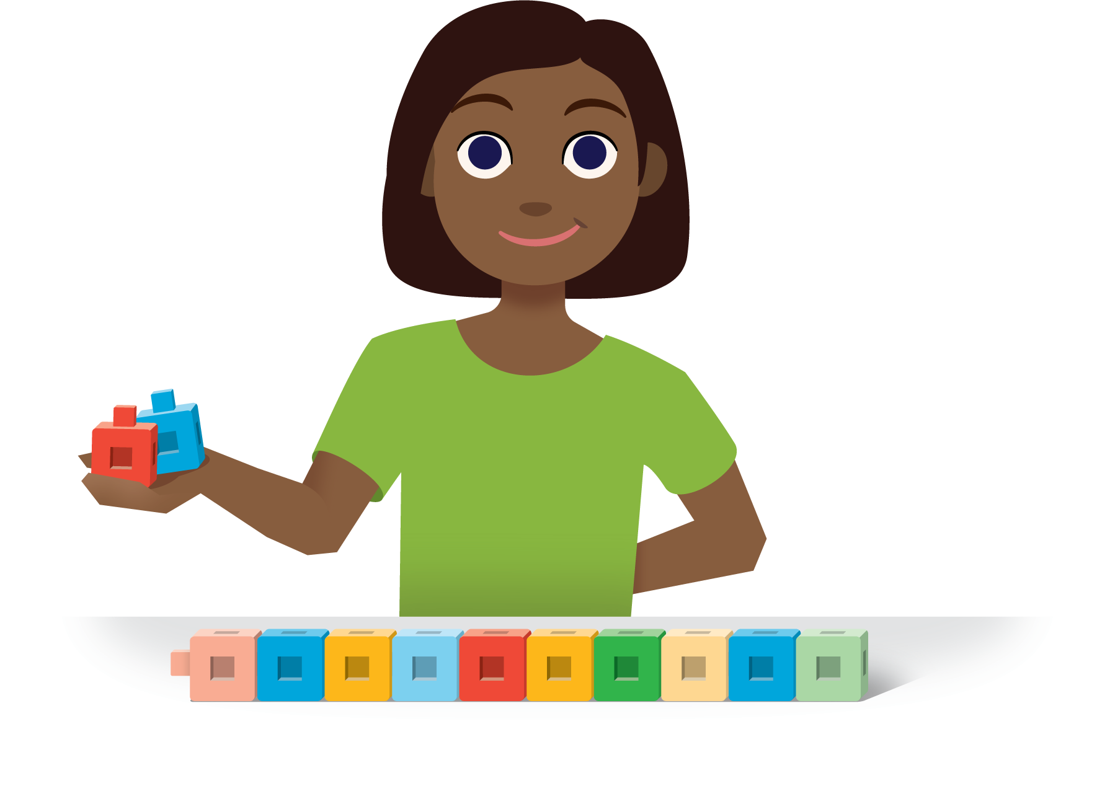
Check it Off
Bingo
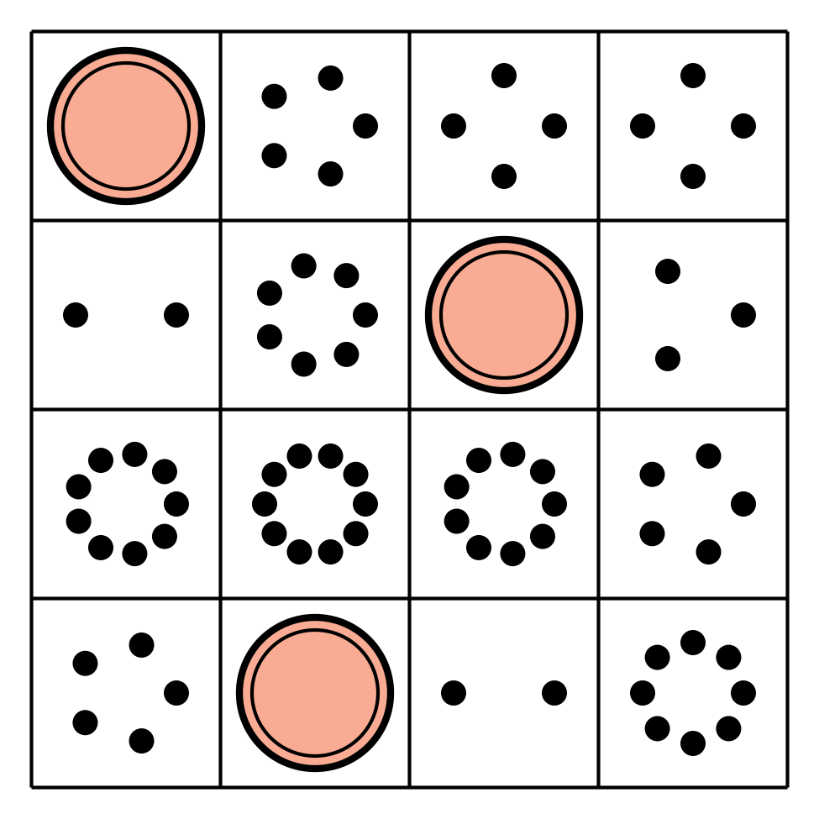
Find the Value of
Expressions
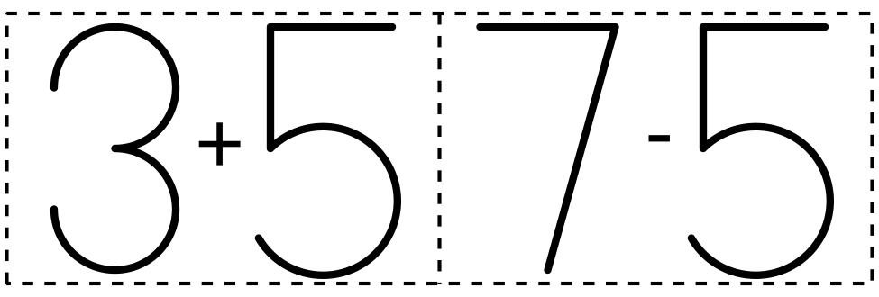
Shake and Spill
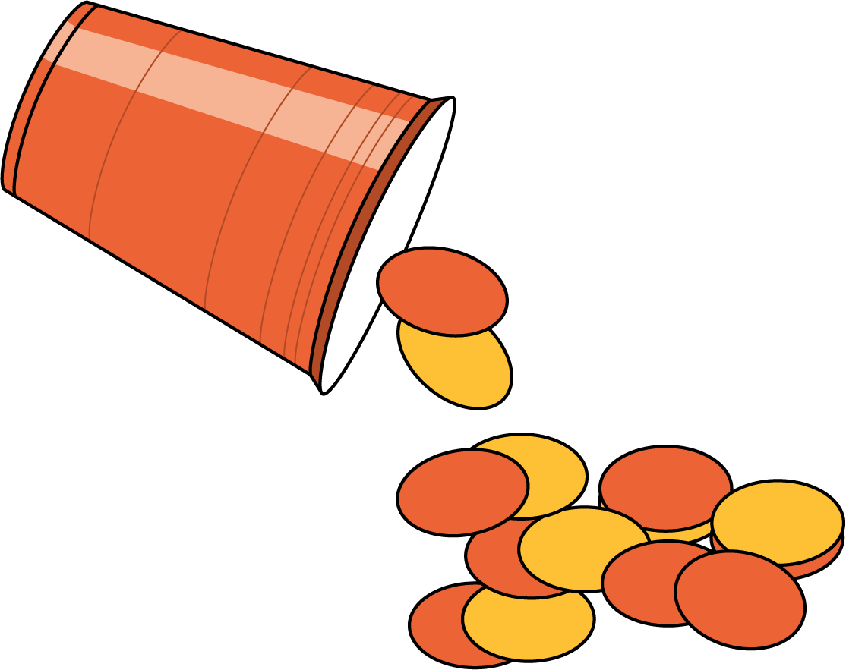

Images for Activity Synthesis
© CC BY 2021 Illustrative Mathematics®

