Unit 7 Lesson 8: Compare Weight

WU Notice and Wonder: Seesaw (Warm up)

Student Task Statement
What do you notice?
What do you wonder?
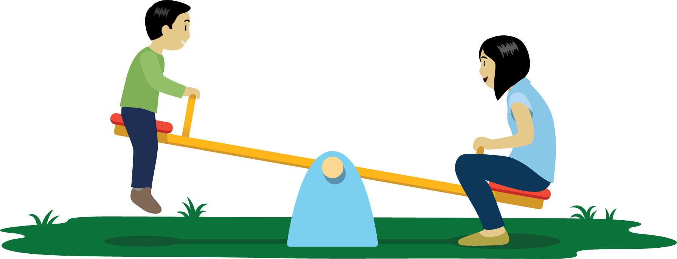

1 Compare Weights of Boxes and Bags

Student Task Statement

2 Compare Weights

Student Task Statement
Choose 2 objects.
Figure out which object is heavier and which is lighter.
Draw a picture of each object.
Circle the object that is heavier.
____________________
____________________
____________________
____________________
____________________
____________________
____________________
____________________

3 Centers: Choice Time

Student Task Statement
Choose a center.
Counting Collections
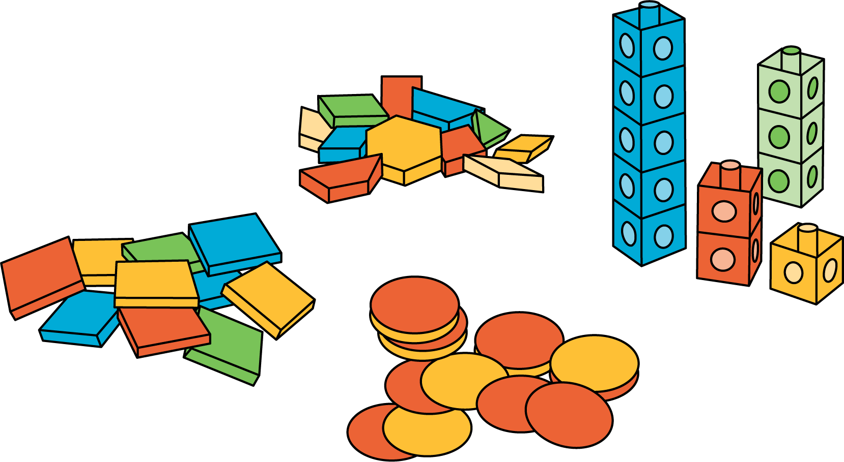
Match Mine
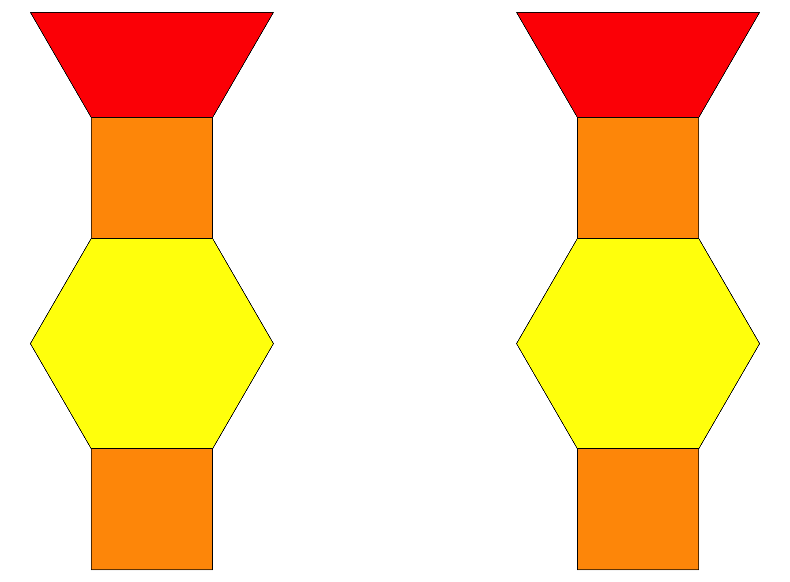
Shake and Spill
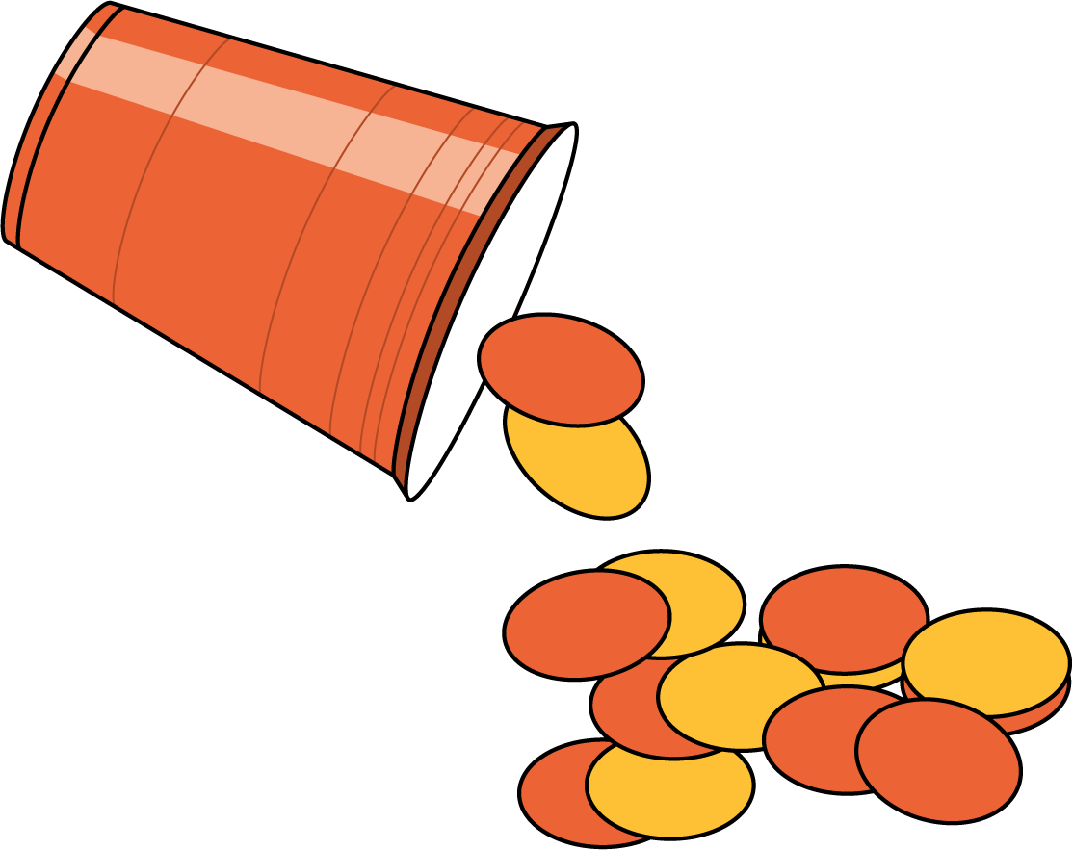
© CC BY 2021 Illustrative Mathematics®

