Lesson 3: Lots of Rectangles
- Let’s express the areas of some rectangles.

3.1: Math Talk: Many Ways to Area
A rectangle is partitioned into smaller rectangles. Explain why each of these expressions represents the area of the entire rectangle.
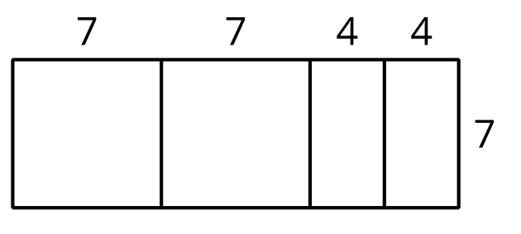
$7\left(7+7+4+4\right)$
$7\left(2⋅7+2⋅4\right)$
$7^{2}+7^{2}+4⋅7+4⋅7$
$2\left(7^{2}\right)+2\left(4⋅7\right)$

3.2: Representing Areas
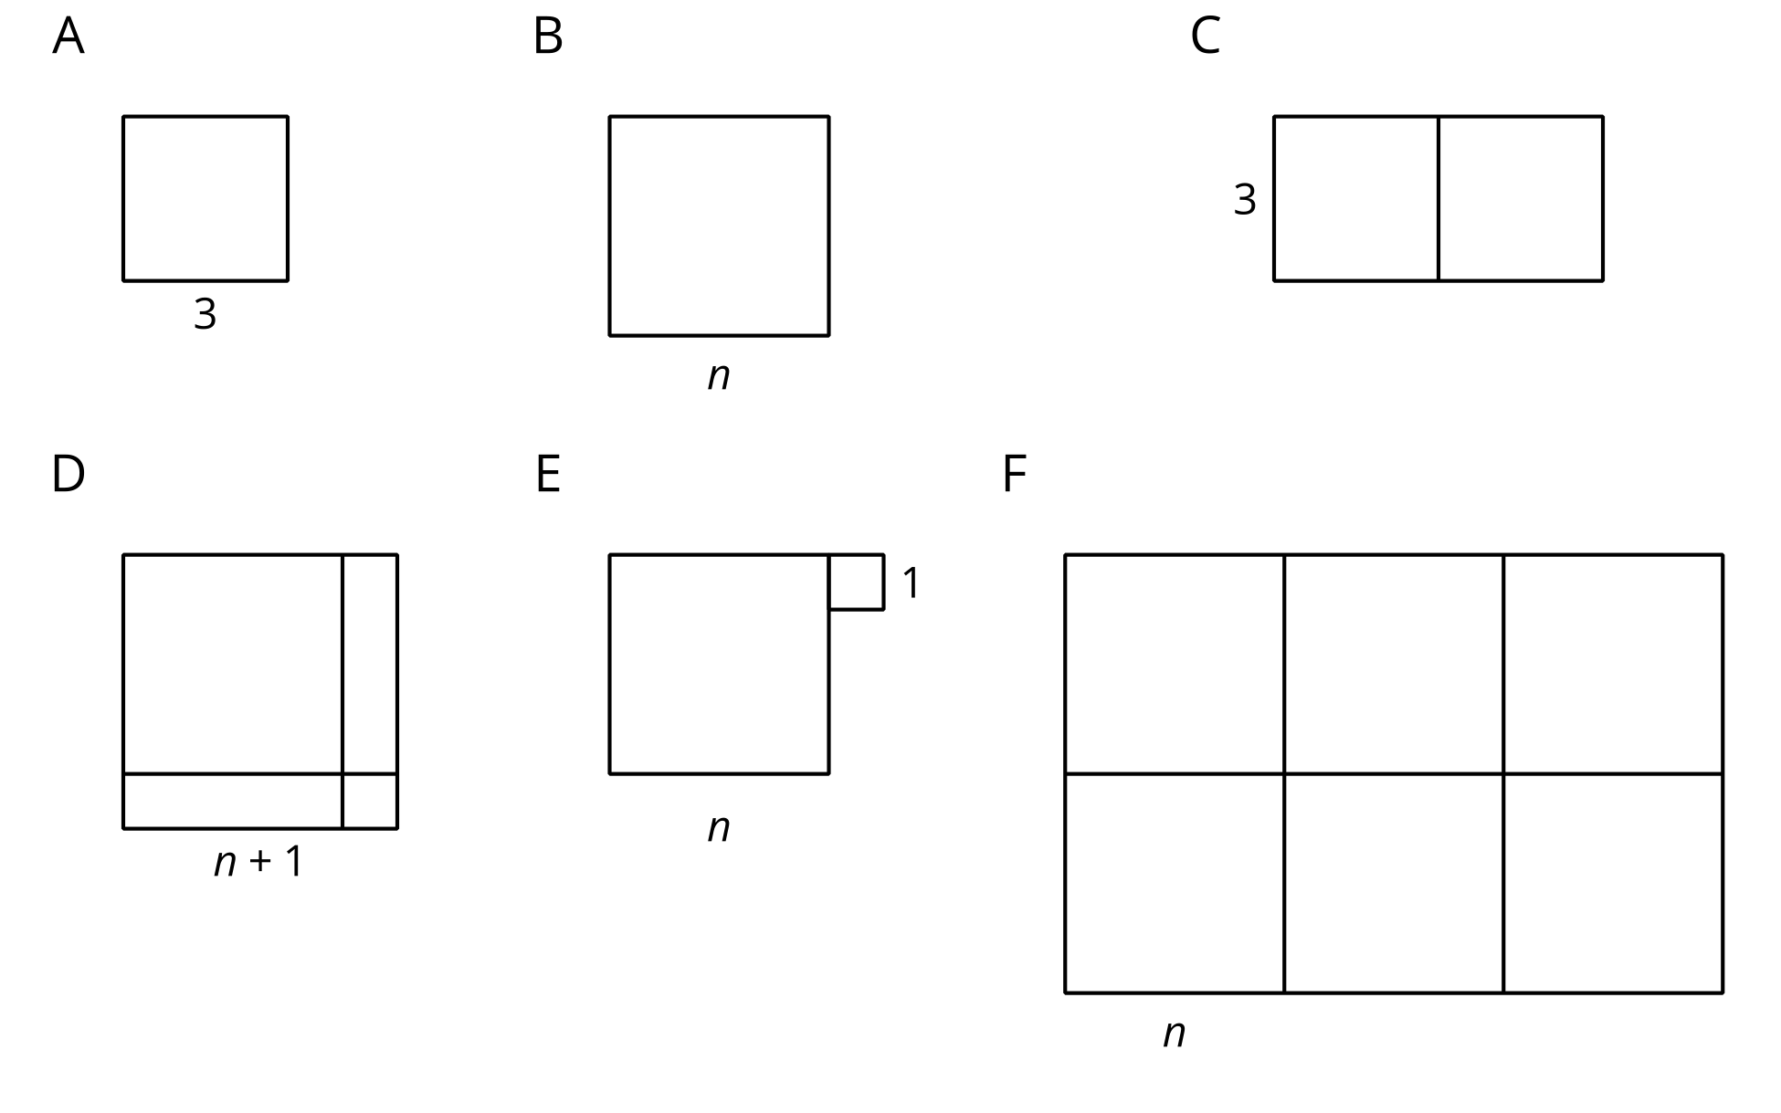
Match each figure with one or more expressions for its area. Every shape that looks like a square is a square.
- $2⋅3^{2}$
- $6n^{2}$
- $n^{2}+1^{2}$
- $3^{2}$
- $\left(n+1\right)\left(n+1\right)$
- $\left(2n\right)\left(3n\right)$
- ${\left(n+1\right)}^{2}$
- $3\left(3+3\right)$
- $n^{2}$
- $\left(n+n\right)\left(n+n+n\right)$
- $3^{2}+3^{2}$

3.3: Areas of Rectangles
Complete the table with the length, width, and area of each rectangle.
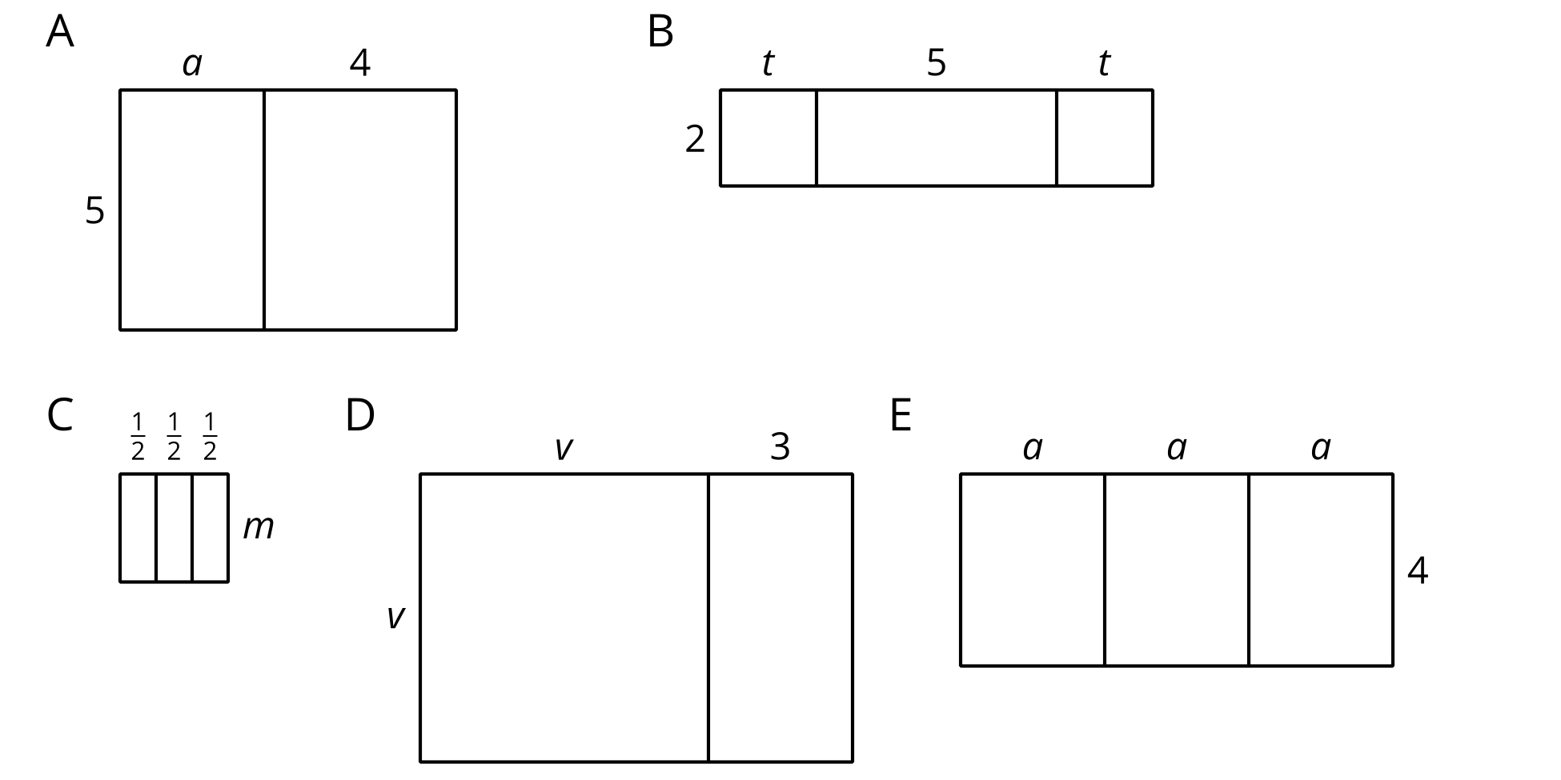
rectangle | length (units) | width (units) | area (square units)
A | $a+4$
B |  | 2
C
D
E
© CC BY 2019 by Illustrative Mathematics®

