Lesson 3: Snap the Cubes
- Let’s find different ways to break apart numbers.

Warm-up: Notice and Wonder: Connecting Cube Towers
What do you notice?
What do you wonder?

3.1: Introduce What’s Behind My Back, Show 2 Parts
8 cubes
expression: _________________________
expression: _________________________
expression: _________________________
expression: _________________________
8 cubes
expression: _________________________
expression: _________________________
expression: _________________________
expression: _________________________
expression: _________________________

3.2: More Than One Way
4
9
6
7
5
8

3.3: Centers: Choice Time
Choose a center.
What's Behind My Back?
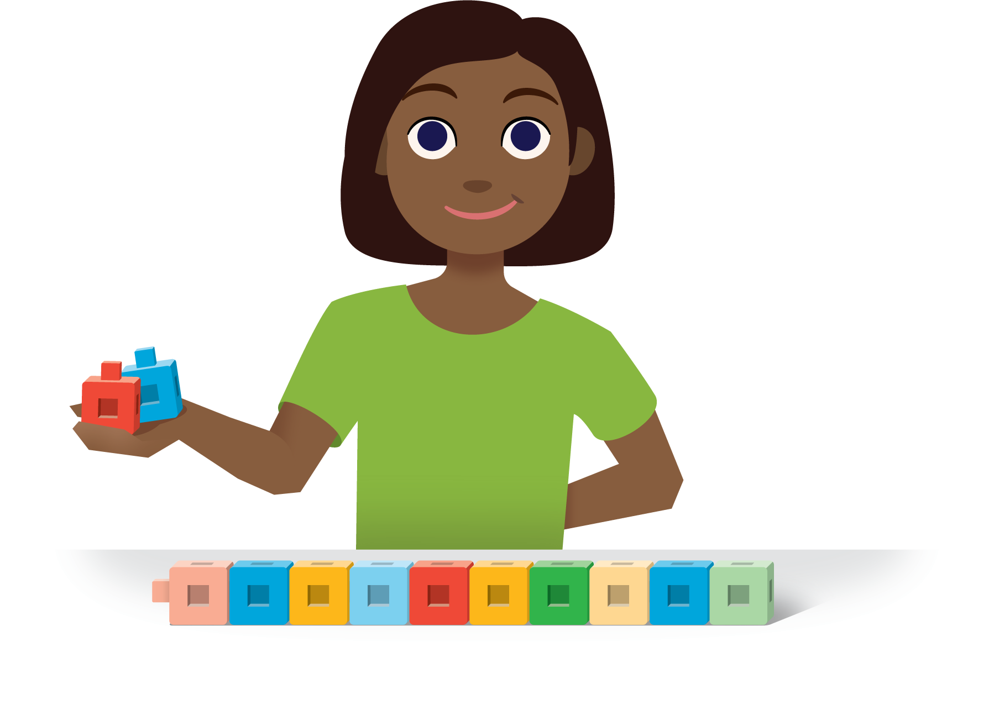
Check it Off
Bingo
Find the Value of
Expressions
Shake and Spill

Section Summary
Section Summary
In this section, we used objects to make and break apart numbers in different ways.
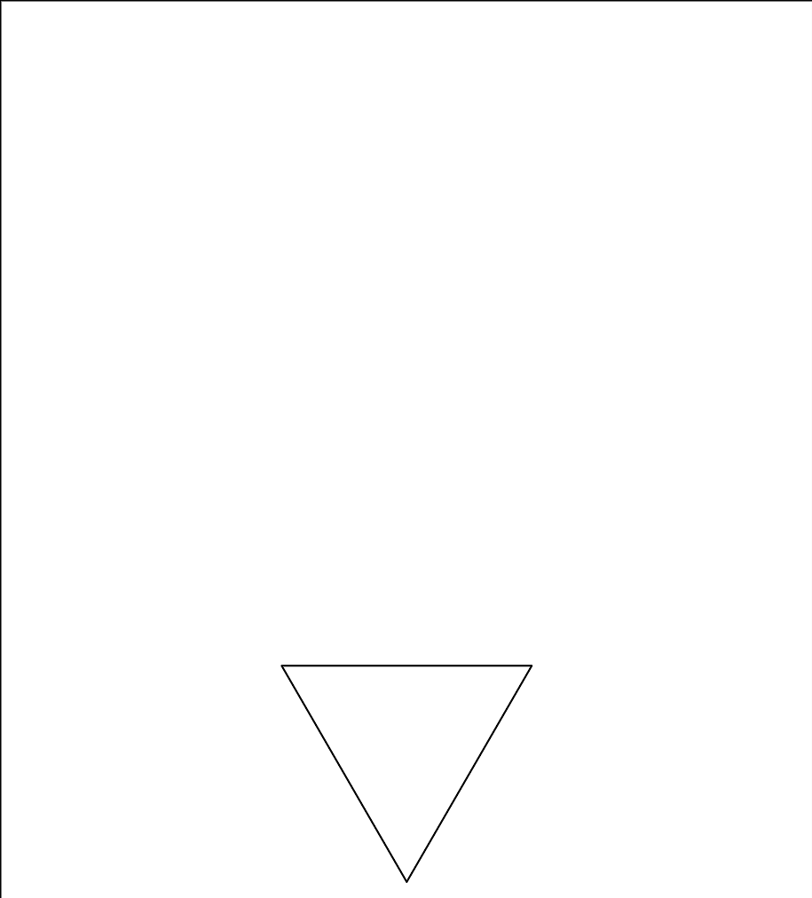
There are 8 pattern blocks.
There are 2 red trapezoids and 6 green triangles.
There are 8 pattern blocks.
There are 3 green triangles and 5 red trapezoids.
We wrote expressions to show different ways to make and break apart numbers.
There are 6 connecting cubes.
6 is $4+2$.
There are 6 connecting cubes.
6 is $1+5$.
© CC BY 2021 Illustrative Mathematics®

