Lesson 2: Writing Equations to Model Relationships (Part 1)
- Let's look at how equations can help us describe relationships and constraints.

2.1: Math Talk: Percent of 200
Evaluate mentally.
25% of 200
12% of 200
8% of 200
$p$% of 200

2.2: A Platonic Relationship
These three figures are called Platonic solids.

Tetrahedron
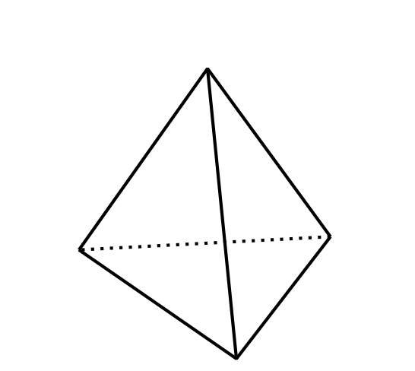

Cube
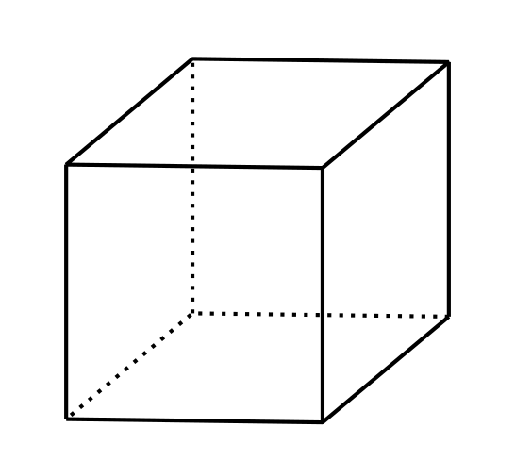

Dodecahedron
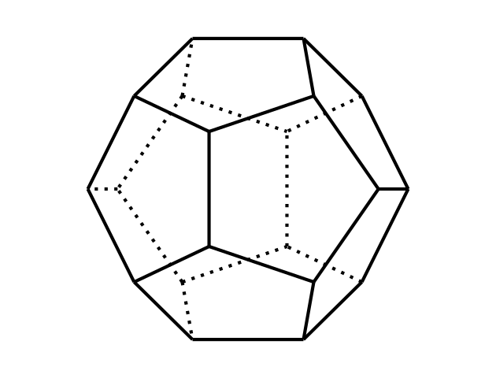
The table shows the number of vertices, edges, and faces for the tetrahedron and dodecahedron.
 | faces | vertices | edges
tetrahedron | 4 | 4 | 6
cube
dodecahedron | 12 | 20 | 30
- Complete the missing values for the cube. Then, make at least two observations about the number of faces, edges, and vertices in a Platonic solid.
- There are some interesting relationships between the number of faces ($F$), edges ($E$), and vertices ($V$) in all Platonic solids. For example, the number of edges is always greater than the number of faces, or $E>F$. Another example: The number of edges is always less than the sum of the number of faces and the number of vertices, or $E<F+V$.
- There is a relationship that can be expressed with an equation. Can you find it? If so, write an equation to represent it.

Are you ready for more?
There are two more Platonic solids: an octahedron which has 8 faces that are all triangles and an icosahedron which has 20 faces that are all triangles.
- How many edges would each of these solids have? (Keep in mind that each edge is used in two faces.)
- Use your discoveries from the activity to determine how many vertices each of these solids would have.
- For all 5 Platonic solids, determine how many faces meet at each vertex.

2.3: Blueberries and Earnings
- Write an equation to represent each situation.
  - Blueberries are $4.99 a pound. Diego buys $b$ pounds of blueberries and pays $14.95.
  - Blueberries are $4.99 a pound. Jada buys $p$ pounds of blueberries and pays $c$ dollars.
  - Blueberries are $d$ dollars a pound. Lin buys $q$ pounds of blueberries and pays $t$ dollars.
  - Noah earned $n$ dollars over the summer. Mai earned $275, which is $45 more than Noah did.
  - Noah earned $v$ dollars over the summer. Mai earned $m$ dollars, which is 45 dollars more than Noah did.
  - Noah earned $w$ dollars over the summer. Mai earned $x$ dollars, which is $y$ dollars more than Noah did.
- How are the equations you wrote for the blueberry purchases like the equations you wrote for Mai and Noah’s summer earnings? How are they different?

2.4: Car Prices
The tax on the sale of a car in Michigan is 6%. At a dealership in Ann Arbor, a car purchase also involves $120 in miscellaneous charges.
- There are several quantities in this situation: the original car price, sales tax, miscellaneous charges, and total price. Write an equation to describe the relationship between all the quantities when:
  - The original car price is $9,500.
  - The original car price is $14,699.
  - The total price is $22,480.
  - The original price is $p$.
- How would each equation you wrote change if the tax on car sales is $r$% and the miscellaneous charges are $m$ dollars?

Lesson 2 Summary
Suppose your class is planning a trip to a museum. The cost of admission is $7 per person and the cost of renting a bus for the day is $180.
- If 24 students and 3 teachers are going, we know the cost will be: $7\left(24\right)+7\left(3\right)+180$ or $7\left(24+3\right)+180$.
- If 30 students and 4 teachers are going, the cost will be: $7\left(30+4\right)+180$.
Notice that the numbers of students and teachers can vary. This means the cost of admission and the total cost of the trip can also vary, because they depend on how many people are going.
Letters are helpful for representing quantities that vary. If $s$ represents the number of students who are going, $t$ represents the number of teachers, and $C$ represents the total cost, we can model the quantities and constraints by writing:
$C=7\left(s+t\right)+180$
Some quantities may be fixed. In this example, the bus rental costs $180 regardless of how many students and teachers are going (assuming only one bus is needed).
Letters can also be used to represent quantities that are constant. We might do this when we don’t know what the value is, or when we want to understand the relationship between quantities (rather than the specific values).
For instance, if the bus rental is $B$ dollars, we can express the total cost of the trip as $C=7\left(s+t\right)+B$. No matter how many teachers or students are going on the trip, $B$ dollars need to be added to the cost of admission.
© CC BY 2019 by Illustrative Mathematics®

