Lesson 2 Practice Problems
- The measure of angle $AOB$ is 56 degrees. What is the measure of angle $ACB$?
- 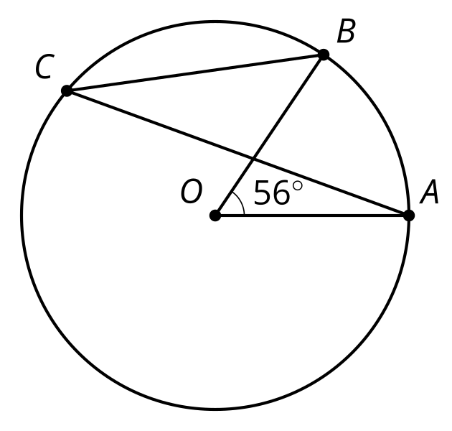
- Explain the difference between central and inscribed angles.
- What is the measure of the arc from $A$ to $B$ that does not pass through $C$?
- 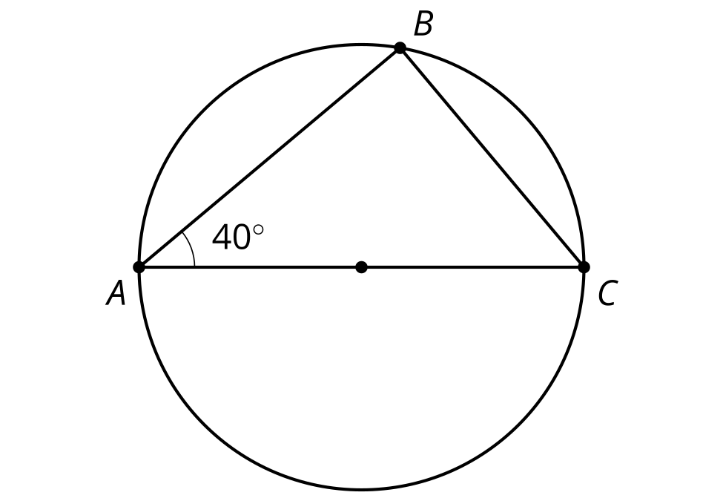
  - 160 degrees
  - 140 degrees
  - 100 degrees
  - 90 degrees
- Find the values of $x,y,$ and $z$.
- 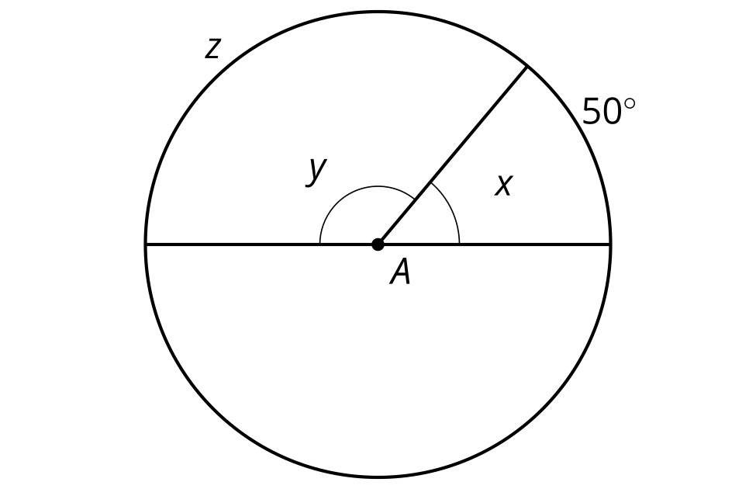
- (From Unit 7, Lesson 1.)
- Match the vocabulary term with the label.
- 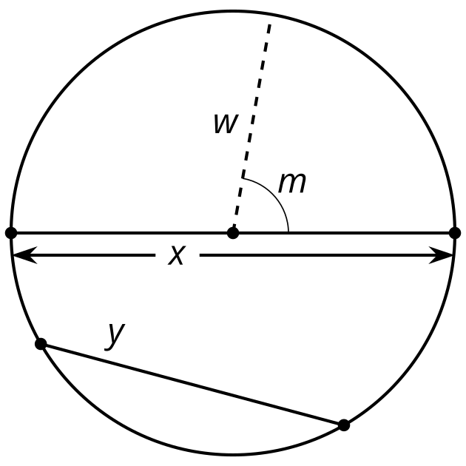
  - chord that is not a diameter
  - diameter
  - radius
  - central angle
  - m
  - w
  - x
  - y
- (From Unit 7, Lesson 1.)
- Triangle $ABC$ has vertices at $\left(\text{-}4,0\right),\left(\text{-}2,12\right),$ and $\left(12,0\right)$. What is the point of intersection of its medians?
  - $\left(4,0\right)$
  - $\left(5,6\right)$
  - $\left(2,4\right)$
  - $\left(4,2\right)$
- (From Unit 6, Lesson 16.)
- The rule $\left(x,y\right)→\left(y,\text{-}x\right)$ takes a line to a perpendicular line. Select another rule that takes a line to a perpendicular line.
  - $\left(x,y\right)→\left(\text{-}y,\text{-}x\right)$
  - $\left(x,y\right)→\left(2y,2x\right)$
  - $\left(x,y\right)→\left(\text{-}4y,4x\right)$
  - $\left(x,y\right)→\left(0.25y,\text{-}4\right)$
- (From Unit 6, Lesson 11.)
© CC BY 2019 by Illustrative Mathematics®

