Lesson 5: More Division
- Let’s divide.

Warm-up: Estimation Exploration: Large Quotient
$9,​953÷37$
Record an estimate that is:
too low | about right | too high

5.1: Elena’s Work
- Find the value of the quotient.
- 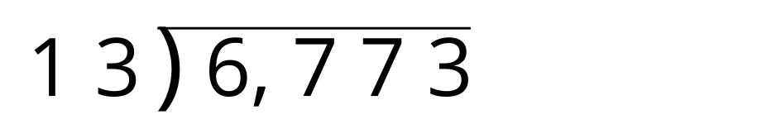
- Here is how Elena found the quotient. Is her answer reasonable?
- Explain or show your reasoning.
- 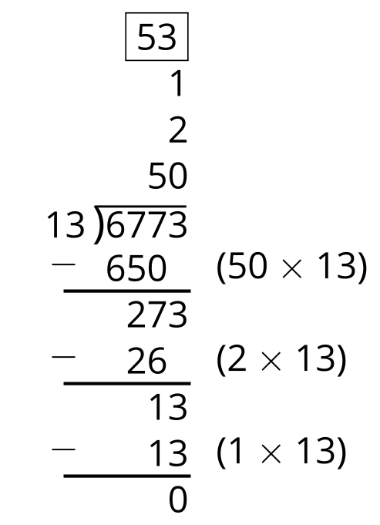
- What parts of the work do you agree with? Be prepared to explain your reasoning.
- What parts of the work do you disagree with? Be prepared to explain your reasoning.
- Look at your solution to problem 1. Is there anything you want to revise? Be prepared to explain.

5.2: Partial Quotients Practice
- Use partial quotients to find the value of one of the quotients. Be prepared to explain how you found the quotient.
- Partner A:
- 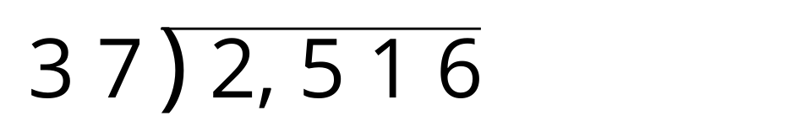
- Partner B:
- 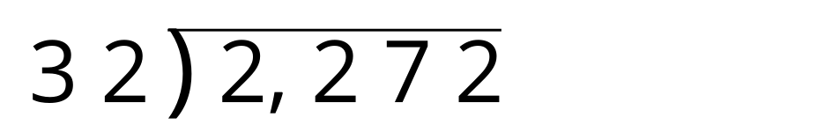
- Explain to your partner how you found the quotient in your problem.

Section Summary
Section Summary
We investigated some different ways to find products and quotients, making sure to estimate the value before calculating. For example, the product $49×68$ is about $50×70$ or $3,​500$. We looked at two different ways to show the newly composed units.
We also found quotients using partial products and saw that there are many different ways to do this.
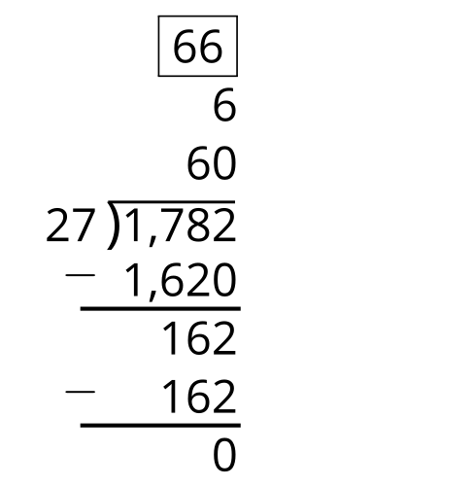
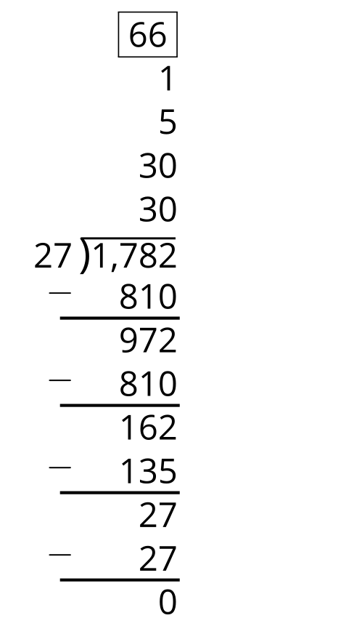
The first calculation uses only 2 products but the products are more challenging to calculate. The second calculation uses 4 products but they are easier to calculate.
© CC BY 2021 Illustrative Mathematics®

