Lesson 9: The Birds
- Let’s solve multiplication problems.

Warm-up: Notice and Wonder: For the Birds
What do you notice? What do you wonder?
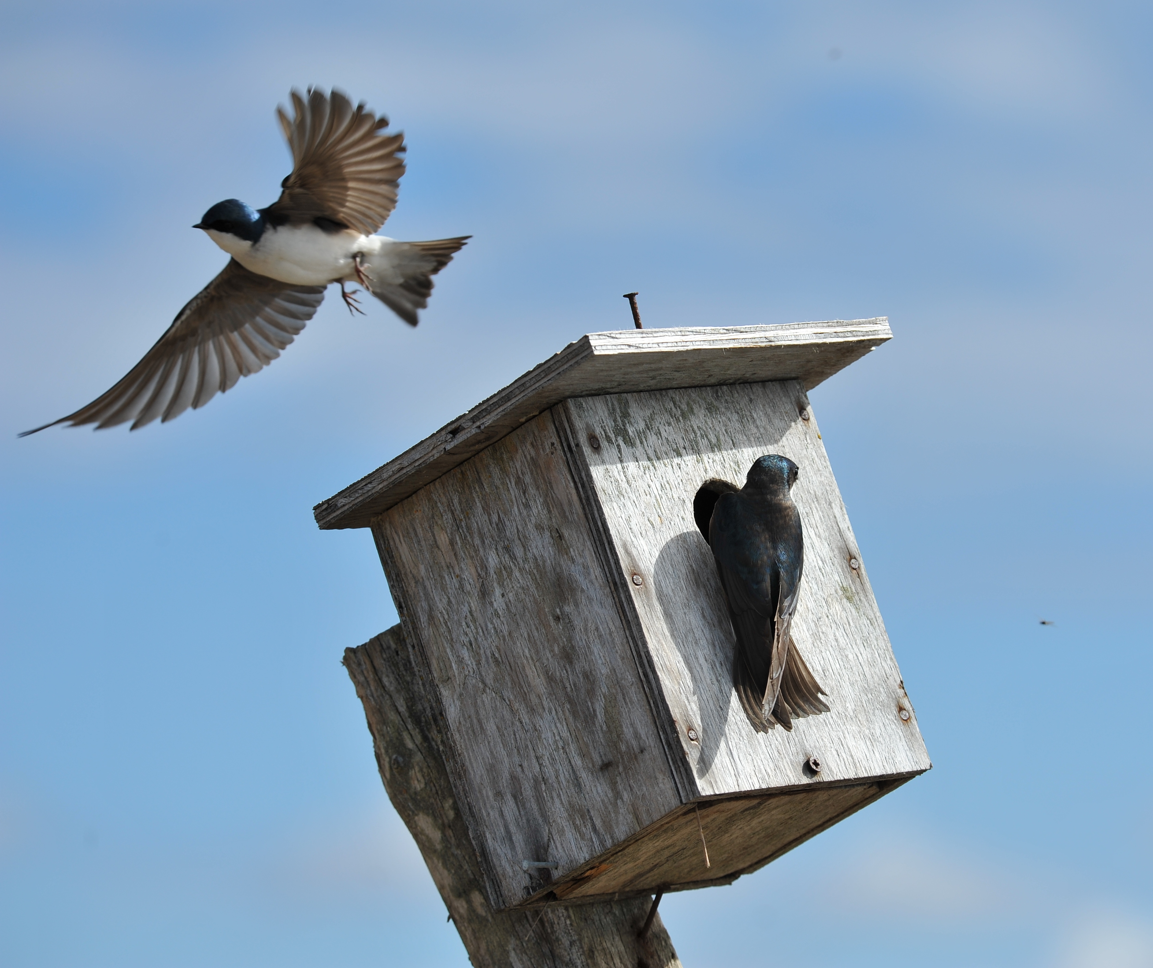

9.1: Home is Where the Bird Lives
Different types of birds use different types of houses. The table gives you the recommended side lengths for birdhouses of various species.
type of bird | side lengths of floor | height | volume estimate
chickadee | 4 in by 4 in | 6 to 10 in
wood duck | 10 in by 18 in | 10 to 24 in
barn owl | 10 in by 18 in | 15 to 18 in
red-headed woodpecker | 6 in by 6 in | 12 to 15 in
bluebird | 5 in by 5 in | 6 to 12 in
swallow | 6 in by 6 in | 6 to 8 in
Estimate a possible volume for each birdhouse. Be prepared to explain your reasoning.

9.2: What is the Volume?
Use the criteria from the table to determine the recommended range of volumes for each type of birdhouse.
type of bird | side lengths of floor | height | range of volume
chickadee | 4 in by 4 in | 6 to 10 in
wood duck | 10 in by 18 in | 10 to 24 in
barn owl | 10 in by 18 in | 15 to 18 in
red-headed woodpecker | 6 in by 6 in | 12 to 15 in
bluebird | 5 in by 5 in | 6 to 12 in
swallow | 6 in by 6 in | 6 to 8 in

Section Summary
Section Summary In this unit we found products of a three-digit number and a two-digit number. We first
represented the products with diagrams that help us break down the product by place value.
This diagram breaks up the product $412×32$ by place value. If we find and add up all of the partial products, we will get the product of $412×32$.
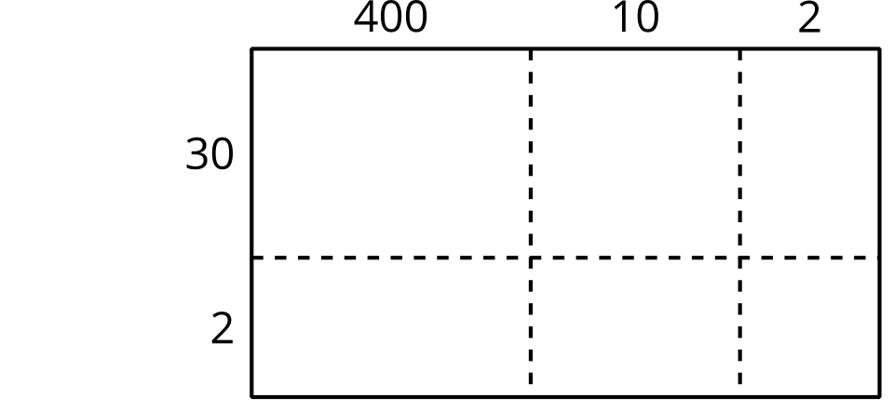
Then we learned a new algorithm to multiply numbers, the standard algorithm for multiplication.
We can see the partial products are organized in a different way. 824 represents the partial product for $2×412$ and 12,360 represents the partial product for $30×412$.
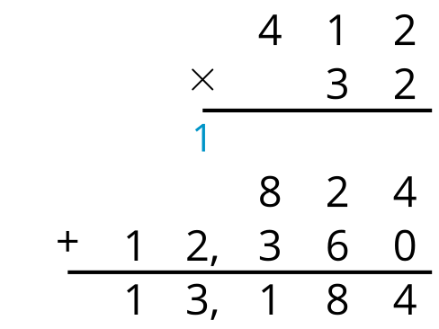
We noticed that sometimes we need to compose a new unit when we use the standard algorithm, and we represent that unit with notation. Sometimes, we may have to compose more than one new unit.
The 1 above the 1 in 216 represents the ten from the product $3×6$ and the 2 represents 2 hundreds from the product $40×6$.
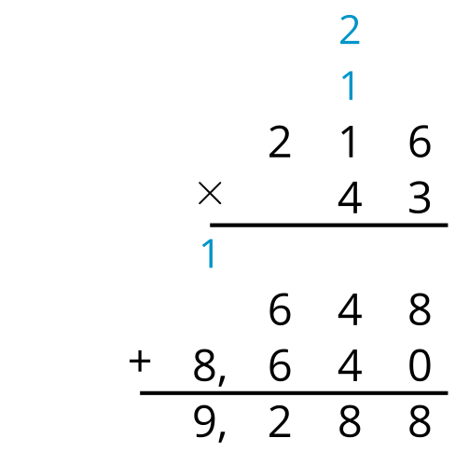
© CC BY 2021 Illustrative Mathematics®

