Lesson 16: Interpret Measurement Data
- Let’s represent and make sense of data in line plots.

Warm-up: Number Talk: Addition within 50
Find the value of each expression mentally.
- $15+5+1$
- $25+6$
- $16+7$
- $37+6$

16.1: The Plant Project
Use the data in this table to create a line plot.
Group B | plant heights (centimeters)
Andre | 33
Clare | 25
Diego | 27
Elena | 25
Han | 35
Jada | 33
Kiran | 26
Noah | 30
Priya | 26
Tyler | 33

16.2: Interpret Measurement Data on a Line Plot
The Plant Project
Answer the questions based on your line plot.
- What was the shortest plant height?
- What was the tallest plant height?
- What is the difference between the height of the tallest plant and the shortest plant? Write an equation to show how you know.
- 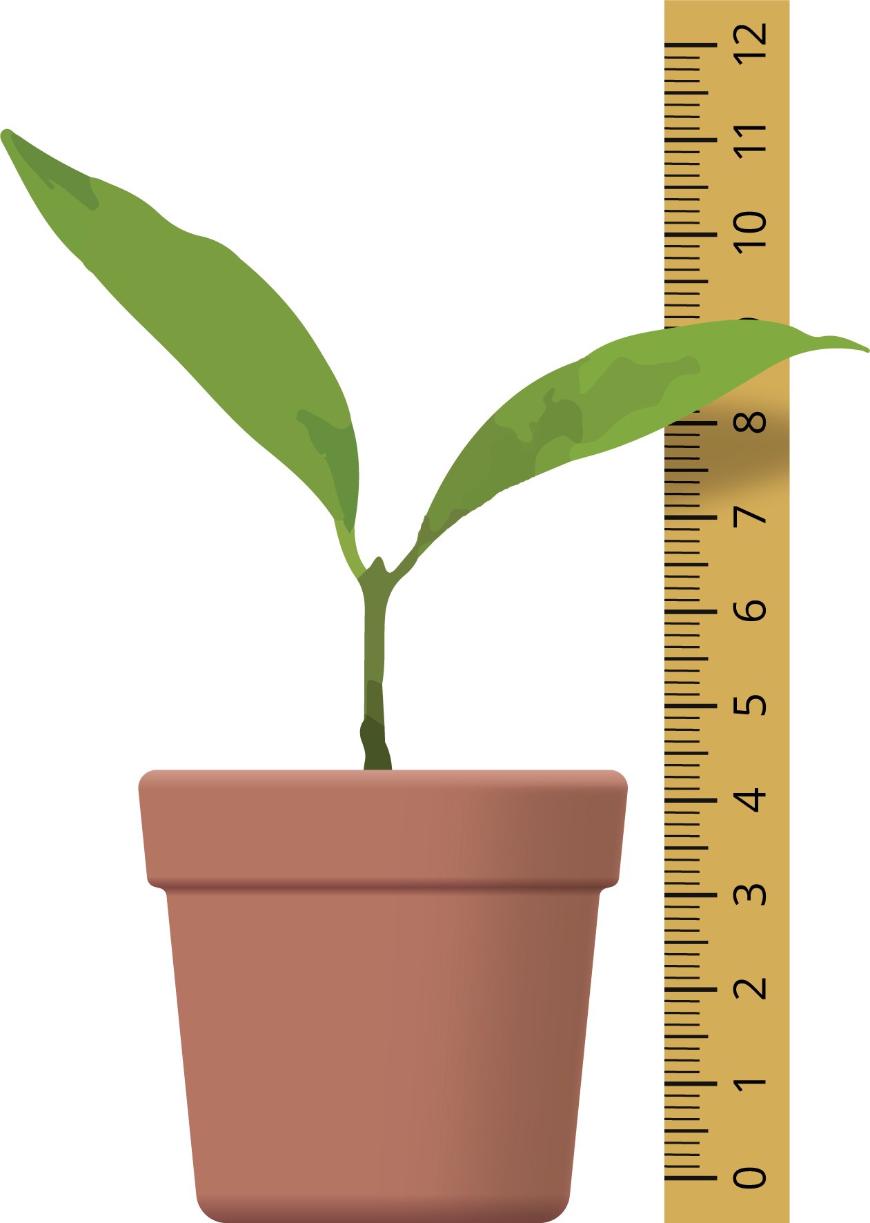
- Answer the questions based on Han’s line plot.
- 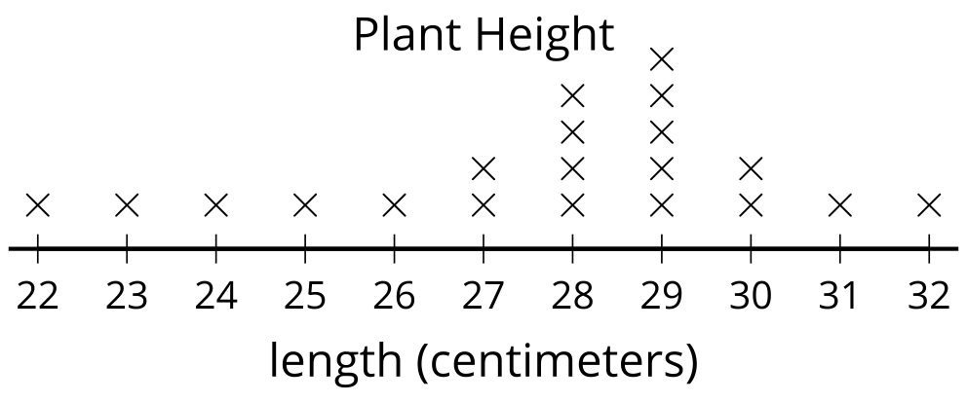
- Han looked at this line plot and said that the tallest plant was 29 centimeters. Do you agree with him? Why or why not?
- How many plants were measured in all?
- Write a statement based on Han’s line plot.

Section Summary
Section Summary In this section of the unit, we learned about a new kind of graph. A line plot is a way to show how many of each measurement using an x for each measurement. The line and the numbers on it represent the units used to measure. Line plots for length look like a ruler or parts of a tape measure. We made our own line plots and used them to answer questions about the data represented.
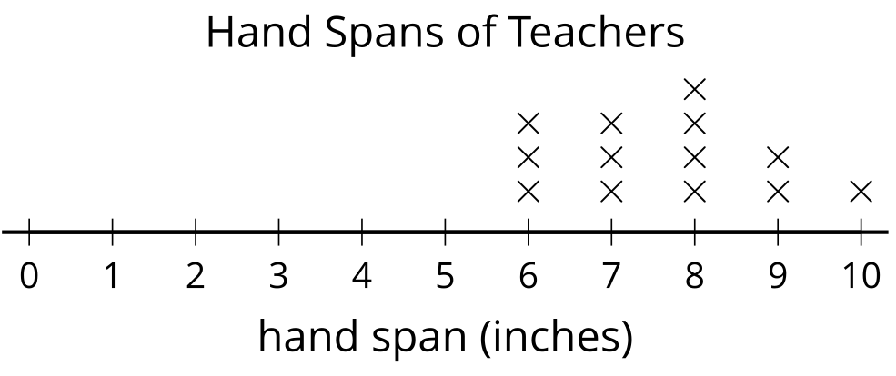
From this line plot, we learn that 4 teachers have a handspan of 8 inches because there are 4 Xs above the 8.
© CC BY 2021 Illustrative Mathematics®

