Unit 3 Lesson 15: Solve Story Problems with Three Numbers

WU How Many Do You See: 10-frames (Warm up)

Student Task Statement
How many do you see?
How do you see them?
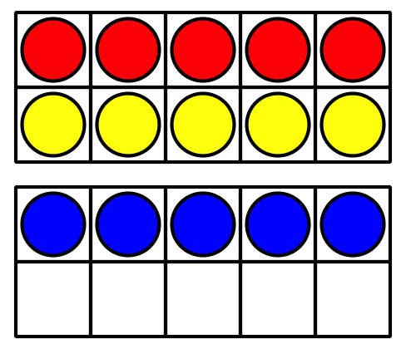
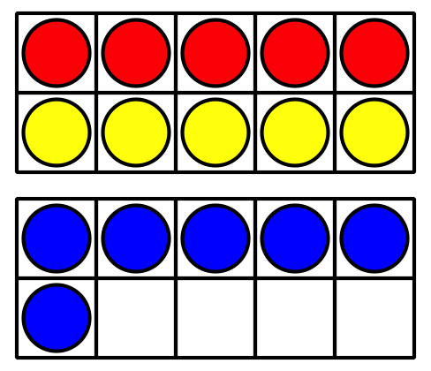
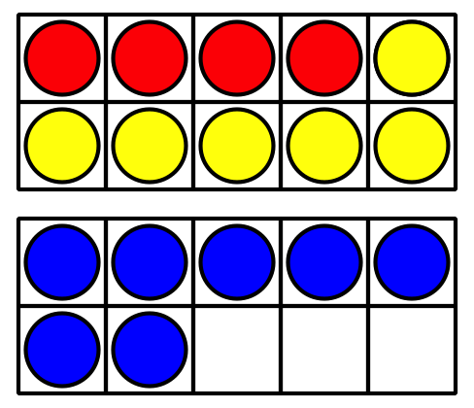

1 Louis Agassiz Fuertes’s Birds

Student Task Statement
7 blue birds fly in the sky.
8 brown birds sit in a tree.
3 baby birds sit in a nest.
How many birds are there altogether?
Show your thinking using objects, drawings, numbers, or words.
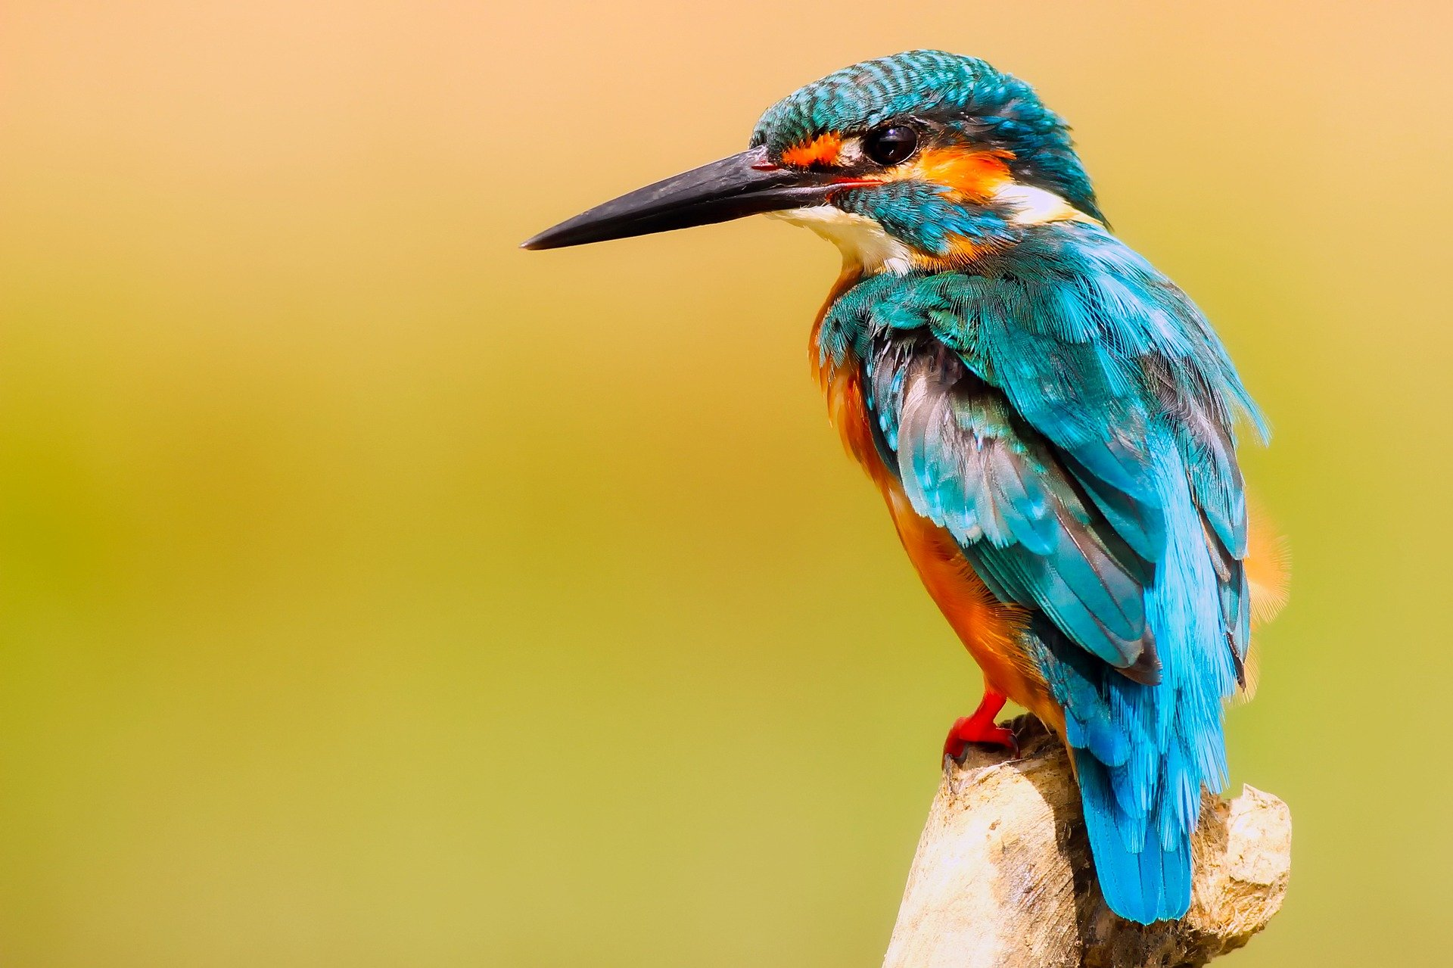
Equation: ________________________________

2 Fuertes’s Bird Cards

Student Task Statement
- Noah collected 3 bird picture cards.
Clare collected 4 cards.
Jada collected 7 cards.
How many cards did they collect altogether?
Show your thinking using drawings, numbers, or words.
- Equation: ________________________________
- Jada used her cards to name the birds she saw.
She saw 4 orioles.
She saw 2 goldfinches.
She saw 8 sparrows.
How many birds did Jada see?
Show your thinking using drawings, numbers, or words.
- Equation: ________________________________
- Write your own problem.
We see some birds.
We see 9 ________________________________.
We see 8 ________________________________.
We see 1 ________________________________.
How many birds do we see altogether?
Show your thinking using drawings, numbers, or words.
- Equation: ________________________________
- 10+6+4=aaaiaaai
- Show your thinking using drawings, numbers, or words.
- 5+9+5=aaaiaaai
- Show your thinking using drawings, numbers, or words.
© CC BY 2021 Illustrative Mathematics®

