Lesson 10: Drawing Triangles (Part 2)

10.1: Using a Compass to Estimate Length
- Draw a ${40}^{∘}$ angle.
- Use a compass to make sure both sides of your angle have a length of 5 centimeters.
- If you connect the ends of the sides you drew to make a triangle, is the third side longer or shorter than 5 centimeters? How can you use a compass to explain your answer?

10.2: Revisiting How Many Can You Draw?
- Draw as many different triangles as you can with each of these sets of measurements:
  - One angle measures ${40}^{∘}$, one side measures 4 cm, and one side measures 5 cm.
  - Two sides measure 6 cm, and one angle measures ${100}^{∘}$.
- Did either of these sets of measurements determine one unique triangle? How do you know?

10.3: Three Angles
- Draw as many different triangles as you can with each of these sets of measurements:
  - One angle measures ${50}^{∘}$, one measures ${60}^{∘}$, and one measures ${70}^{∘}$.
  - One angle measures ${50}^{∘}$, one measures ${60}^{∘}$, and one measures ${100}^{∘}$.
- Did either of these sets of measurements determine one unique triangle? How do you know?

Are you ready for more?
Using only a compass and the edge of a blank index card, draw a perfectly equilateral triangle. (Note! The tools are part of the challenge! You may not use a protractor! You may not use a ruler!)

Lesson 10 Summary
A triangle has six measures: three side lengths and three angle measures.
If we are given three measures, then sometimes, there is no triangle that can be made. For example, there is no triangle with side lengths 1, 2, 5, and there is no triangle with all three angles measuring ${150}^{∘}$.
Sometimes, only one triangle can be made. By this we mean that any triangle we make will be the same, having the same six measures. For example, if a triangle can be made with three given side lengths, then the corresponding angles will have the same measures. Another example is shown here: an angle measuring ${45}^{∘}$ between two side lengths of 6 and 8 units. With this information, one unique triangle can be made.
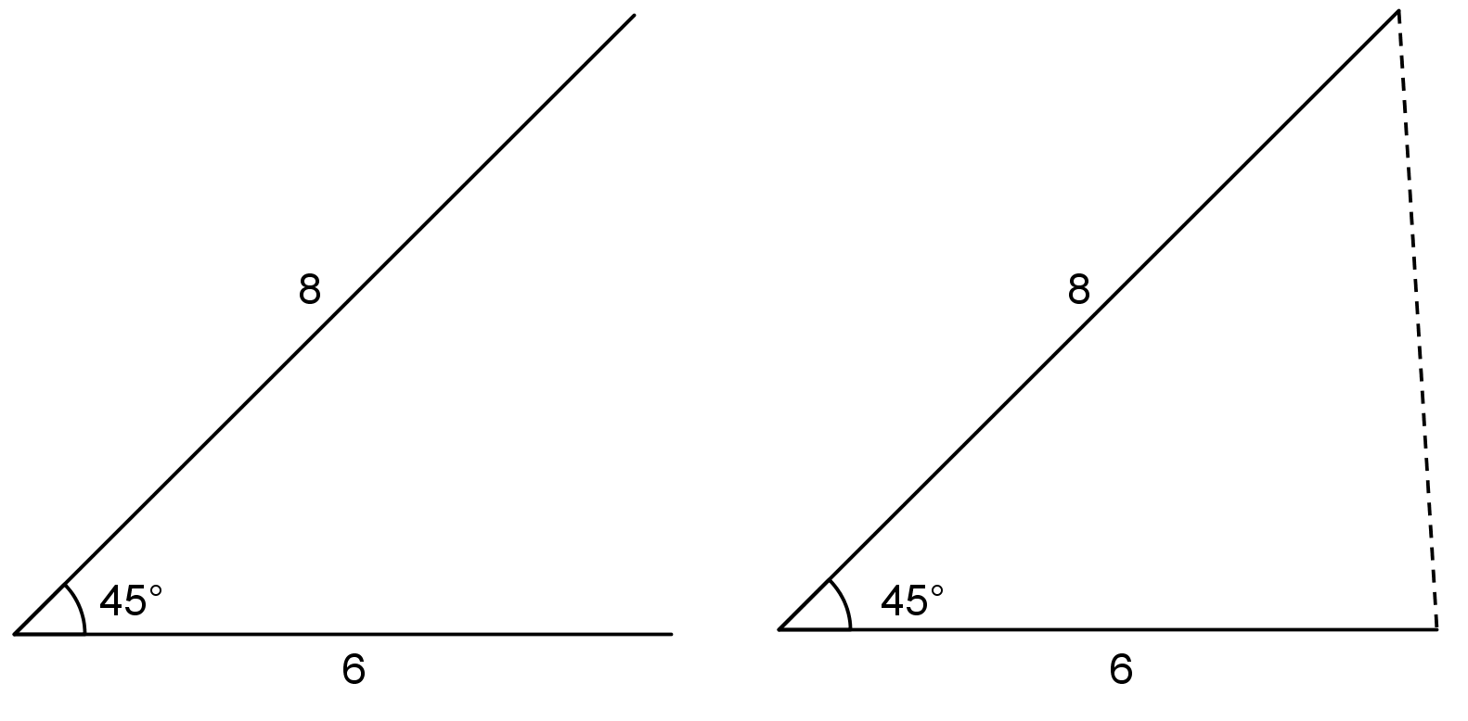
Sometimes, two or more different triangles can be made with three given measures. For example, here are two different triangles that can be made with an angle measuring ${45}^{∘}$ and side lengths 6 and 8. Notice the angle is not between the given sides.
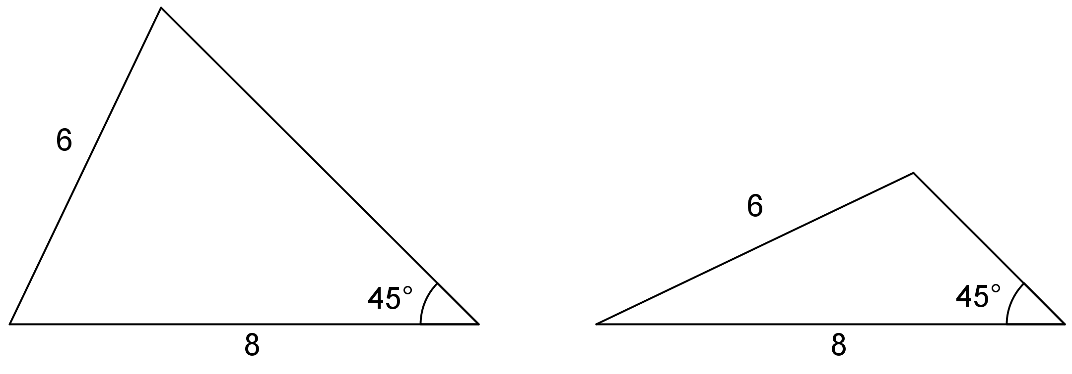
Three pieces of information about a triangle’s side lengths and angle measures may determine no triangles, one unique triangle, or more than one triangle. It depends on the information.
© CC BY Open Up Resources. Adaptations CC BY IM.

