Unit 5 Lesson 7: Adding and Subtracting to Solve Problems

1 Positive or Negative? (Warm up)

Student Task Statement
Without computing:
- Is the solution to $\text{-}2.7+x=\text{-}3.5$ positive or negative?
- Select all the expressions that are solutions to $\text{-}2.7+x=\text{-}3.5$.
  - $\text{-}3.5+2.7$
  - $3.5−2.7$
  - $\text{-}3.5−\left(\text{-}2.7\right)$
  - $\text{-}3.5−2.7$

2 Phone Inventory

Student Task Statement
A store tracks the number of cell phones it has in stock and how many phones it sells.
The table shows the inventory for one phone model at the beginning of each day last week. The inventory changes when they sell phones or get shipments of phones into the store.
 | inventory | change
Monday | 18 | -2
Tuesday | 16 | -5
Wednesday | 11 | -7
Thursday | 4 | -6
Friday | -2 | 20
- What do you think it means when the change is positive? Negative?
- What do you think it means when the inventory is positive? Negative?
- Based on the information in the table, what do you think the inventory will be at on Saturday morning? Explain your reasoning.
- What is the difference between the greatest inventory and the least inventory?

3 Solar Power

Student Task Statement
Han's family got a solar panel. Each month they get a credit to their account for the electricity that is generated by the solar panel. The credit they receive varies based on how sunny it is.
Current charges: $83.56
Solar Credit: -$6.75
Amount due: $76.81
Here is their electricity bill from January.
In January they used $83.56 worth of electricity and generated $6.75 worth of electricity.
- In July they were traveling away from home and only used $19.24 worth of electricity. Their solar panel generated $22.75 worth of electricity. What was their amount due in July?
- The table shows the value of the electricity they used and the value of the electricity they generated each week for a month. What amount is due for this month?
 | - used ($) | - generated ($)
- week 1 | - 13.45 | - -6.33
- week 2 | - 21.78 | - -8.94
- week 3 | - 18.12 | - -7.70
- week 4 | - 24.05 | - -5.36

- What is the difference between the value of the electricity generated in week 1 and week 2? Between week 2 and week 3?

4 Differences and Distances (Optional)

Student Task Statement
Plot these points on the coordinate grid: $A=\left(5,4\right),B=\left(5,\text{-}2\right),C=\left(\text{-}3,\text{-}2\right),D=\left(\text{-}3,4\right)$
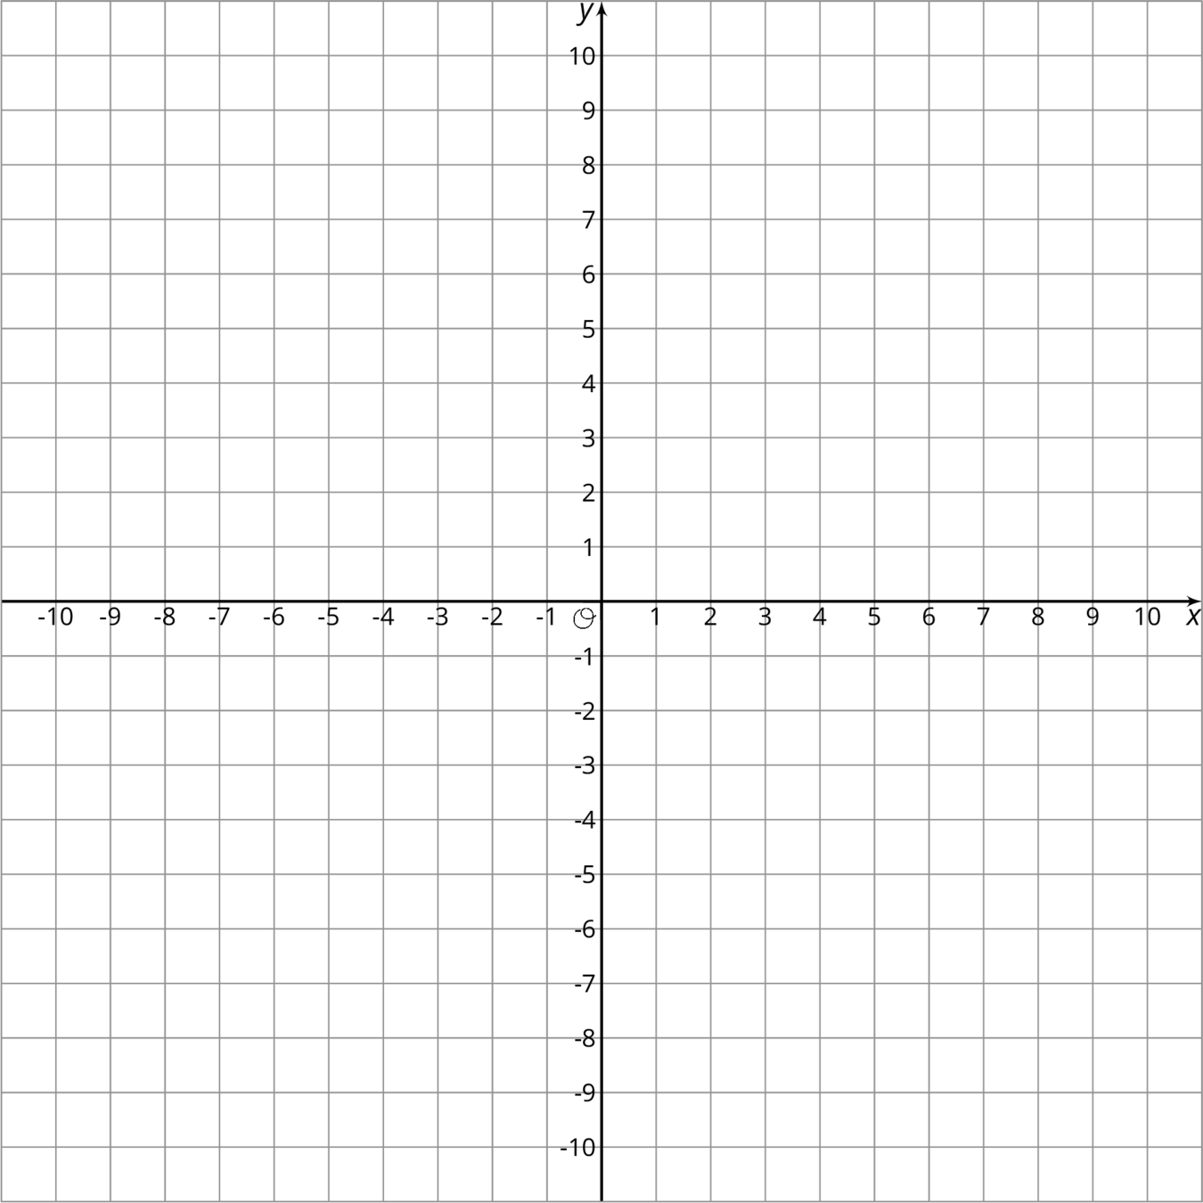
- What shape is made if you connect the dots in order?
- What are the side lengths of figure $ABCD$?
- What is the difference between the $x$-coordinates of $B$ and $C$?
- What is the difference between the $x$-coordinates of $C$ and $B$?
- How do the differences of the coordinates relate to the distances between the points?
© CC BY Open Up Resources. Adaptations CC BY IM.

