Unit 1 Lesson 16: Parallel Lines and the Angles in a Triangle

1 True or False: Computational Relationships (Warm up)

Student Task Statement
Is each equation true or false?
$62−28=60−30$
$3⋅\text{-}8=\left(2⋅\text{-}8\right)−8$
$\frac{16}{\text{-}2}+\frac{24}{\text{-}2}=\frac{40}{\text{-}2}$

2 Angle Plus Two

Images for Launch
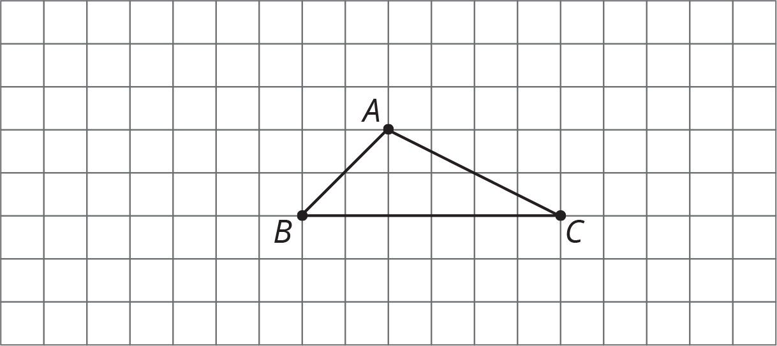

Student Task Statement
Here is triangle $ABC$.
- Rotate triangle $ABC$ ${180}^{∘}$ around the midpoint of side $AC$. Label the new vertex $D$.
- Rotate triangle $ABC$ ${180}^{∘}$ around the midpoint of side $AB$. Label the new vertex $E$.
- Look at angles $EAB$, $BAC$, and $CAD$. Without measuring, write what you think is the sum of the measures of these angles. Explain or show your reasoning.
- Is the measure of angle $EAB$ equal to the measure of any angle in triangle $ABC$? If so, which one? If not, how do you know?
- Is the measure of angle $CAD$ equal to the measure of any angle in triangle $ABC$? If so, which one? If not, how do you know?
- What is the sum of the measures of angles $ABC$, $BAC$, and $ACB$?

3 Every Triangle in the World

Student Task Statement
Here is $△ABC$. Line $DE$ is parallel to line $AC$.
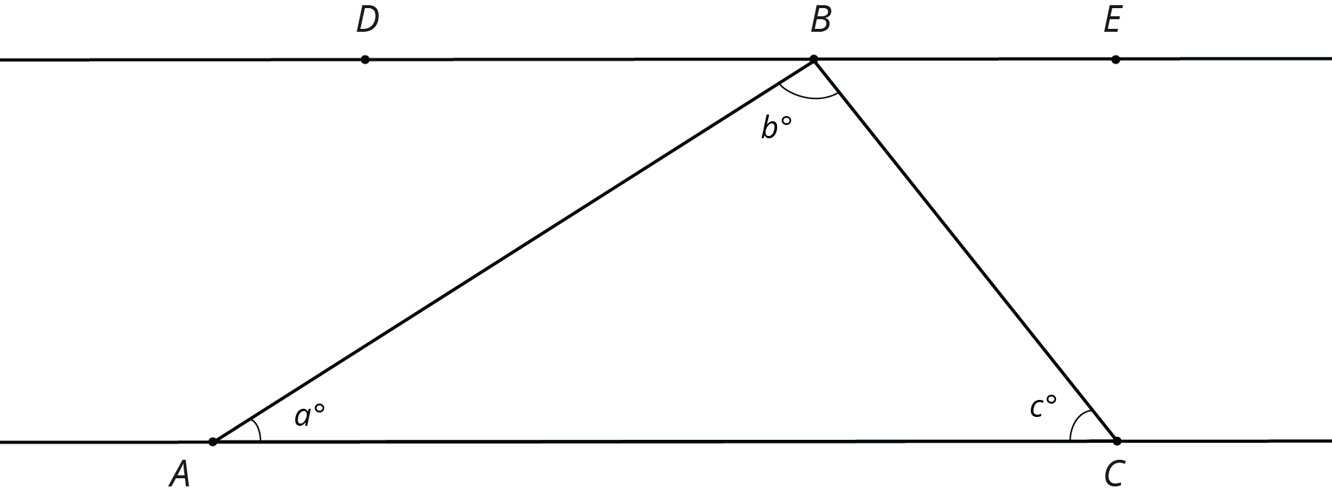
- What is $m∠DBA+b+m∠CBE$? Explain how you know.
- Use your answer to explain why $a+b+c=180$.
- Explain why your argument will work for any triangle: that is, explain why the sum of the angle measures in any triangle is ${180}^{∘}$.

4 Four Triangles Revisited (Optional)

Student Task Statement
This diagram shows a square $BDFH$ that has been made by images of triangle $ABC$ under rigid transformations.
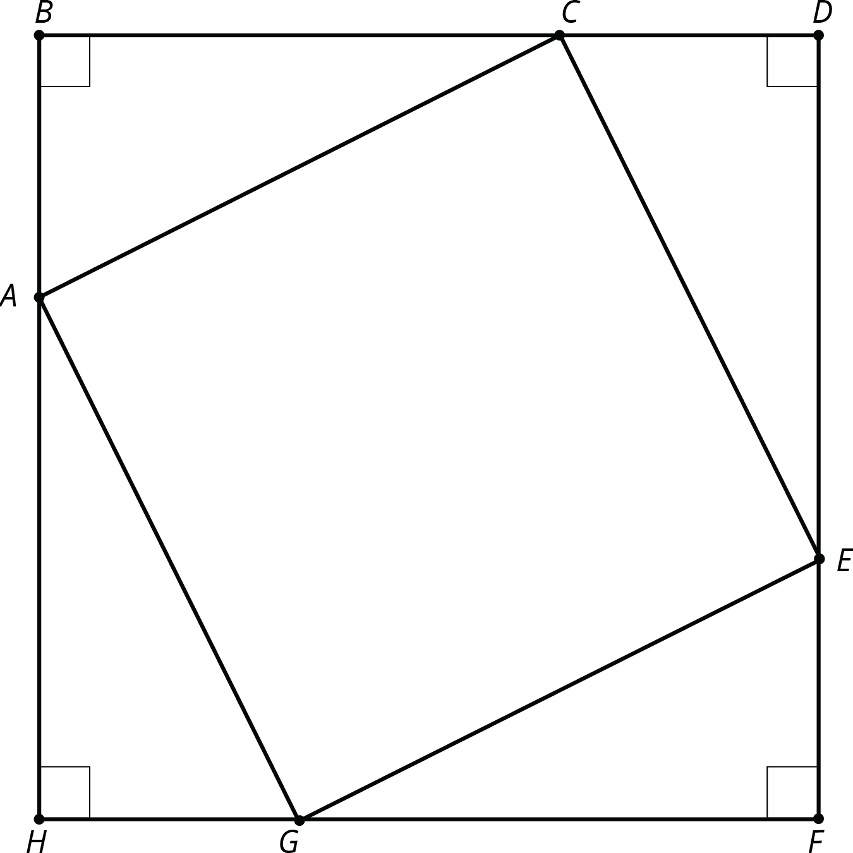
Given that angle $BAC$ measures 53 degrees, find as many other angle measures as you can.
© CC BY Open Up Resources. Adaptations CC BY IM.

