Unit 1 Lesson 7 Cumulative Practice Problems
- To decompose a quadrilateral into two identical shapes, Clare drew a dashed line as shown in the diagram.
- 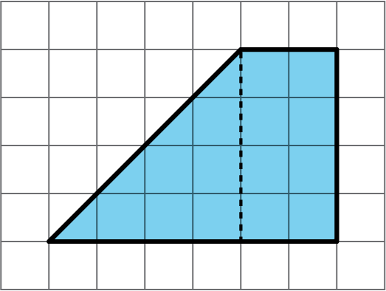
  - She said the that two resulting shapes have the same area. Do you agree? Explain your reasoning.
  - Did Clare partition the figure into two identical shapes? Explain your reasoning.
- Triangle R is a right triangle. Can we use two copies of Triangle R to compose a parallelogram that is not a square?
- 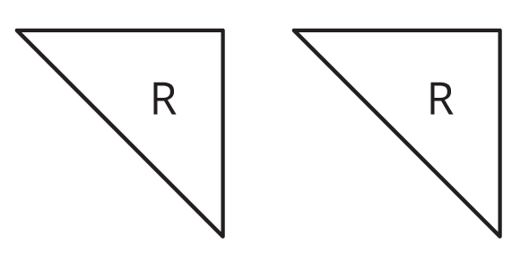
- If so, explain how or sketch a solution. If not, explain why not.
- Two copies of this triangle are used to compose a parallelogram. Which parallelogram cannot be a result of the composition? If you get stuck, consider using tracing paper.
- 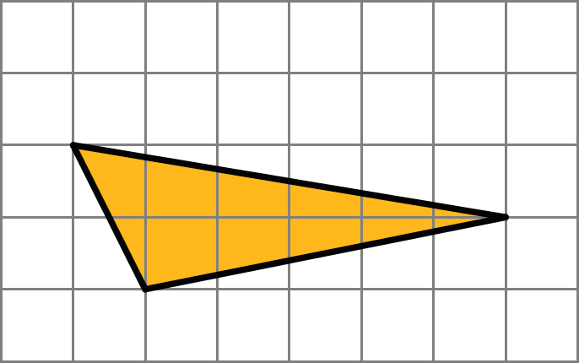
- 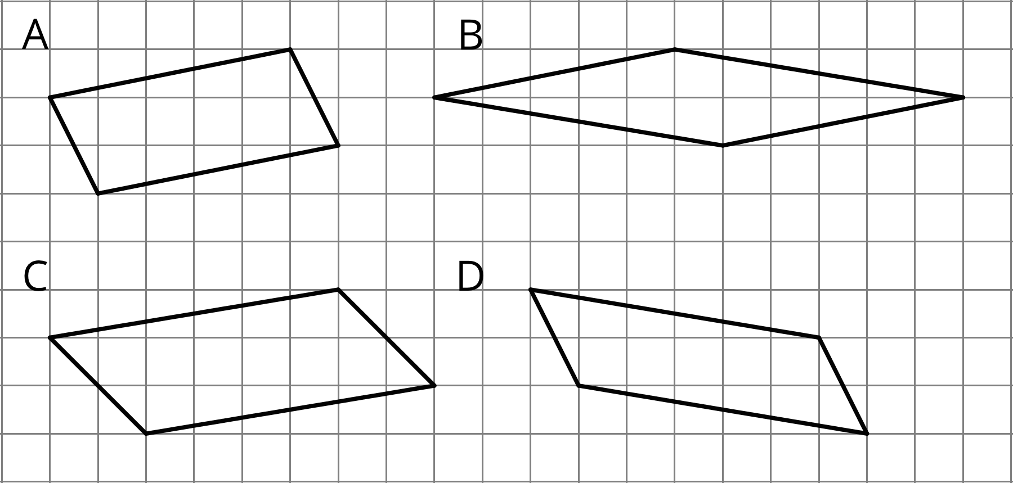
  - A
  - B
  - C
  - D
  - On the grid, draw at least three different quadrilaterals that can each be decomposed into two identical triangles with a single cut (show the cut line). One or more of the quadrilaterals should have non-right angles.
  - Identify the type of each quadrilateral.
  - A parallelogram has a base of 9 units and a corresponding height of $\frac{2}{3}$ units. What is its area?
  - A parallelogram has a base of 9 units and an area of 12 square units. What is the corresponding height for that base?
  - A parallelogram has an area of 7 square units. If the height that corresponds to a base is $\frac{1}{4}$ unit, what is the base?
- (From Unit 1, Lesson 6.)
- Select all the segments that could represent the height if side $n$ is the base.
- 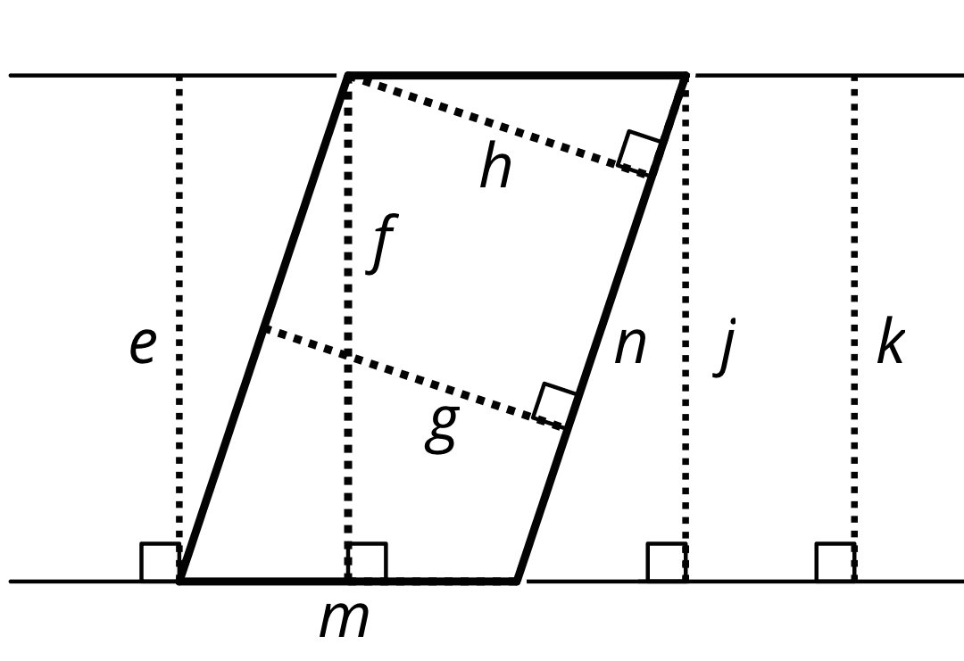
  - $e$
  - $f$
  - $g$
  - $h$
  - $m$
  - $n$
  - $j$
  - $k$
- (From Unit 1, Lesson 5.)
© CC BY Open Up Resources. Adaptations CC BY IM.

