Unit 5 Lesson 4: Find All the Ways

WU Choral Count: Count On (Warm up)

Student Task Statement

1 Patterns in Decompositions

Student Task Statement
expression: _________________________
expression: _________________________
expression: _________________________
expression: _________________________
expression: _________________________
expression: _________________________

2 Find All the Ways

Student Task Statement
Find all the different ways you can break apart 7 into 2 parts.
Show your thinking using objects, drawings, numbers, or words.

3 Centers: Choice Time

Student Task Statement
Choose a center.
What's Behind My Back?
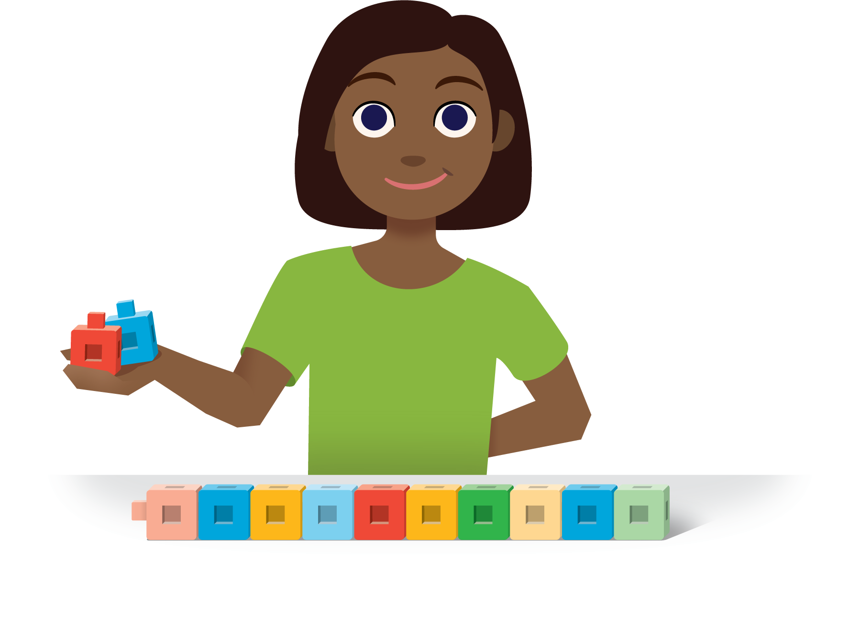
Check it Off
Bingo
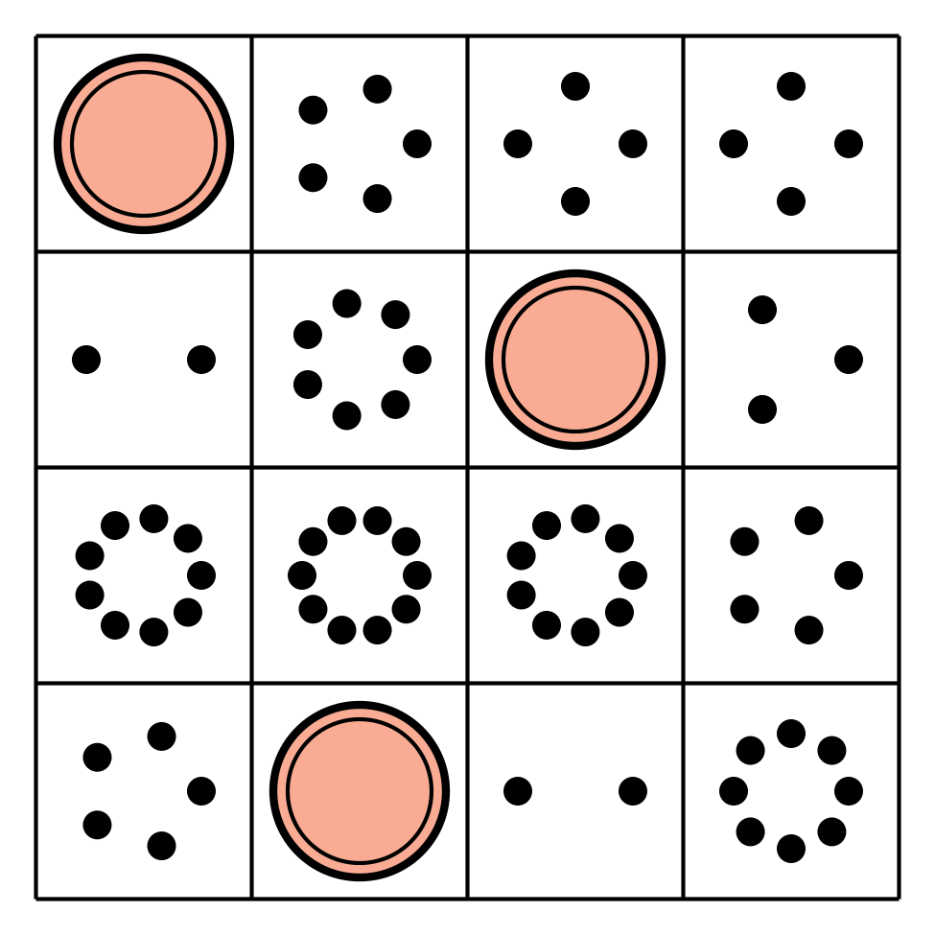
Find the Value of
Expressions
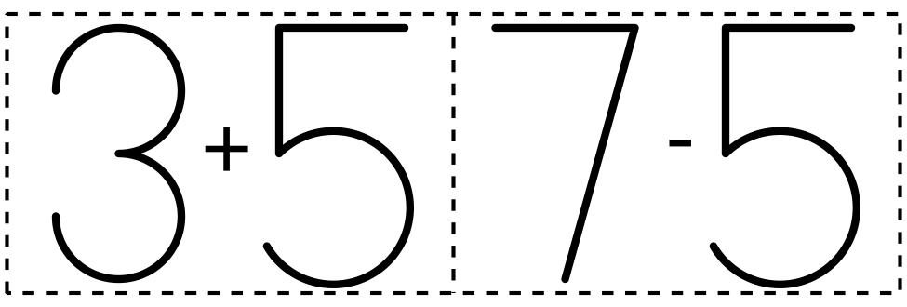
Shake and Spill
© CC BY 2021 Illustrative Mathematics®

