Unit 7 Lesson 9: Compare Capacity

WU Choral Count: Count by 10 (Warm up)

Student Task Statement

1 Capacity of Cups

Student Task Statement

2 Which Cup Can Hold More Water?

Student Task Statement

3 Centers: Choice Time

Student Task Statement
Choose a center.
Counting Collections
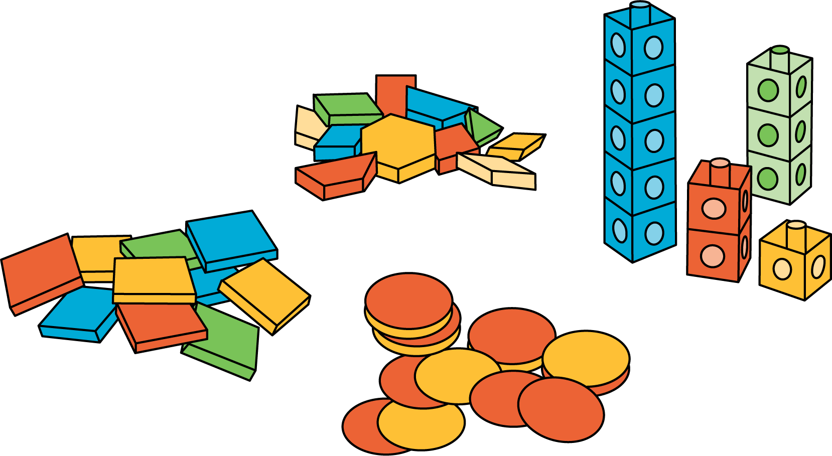
Match Mine
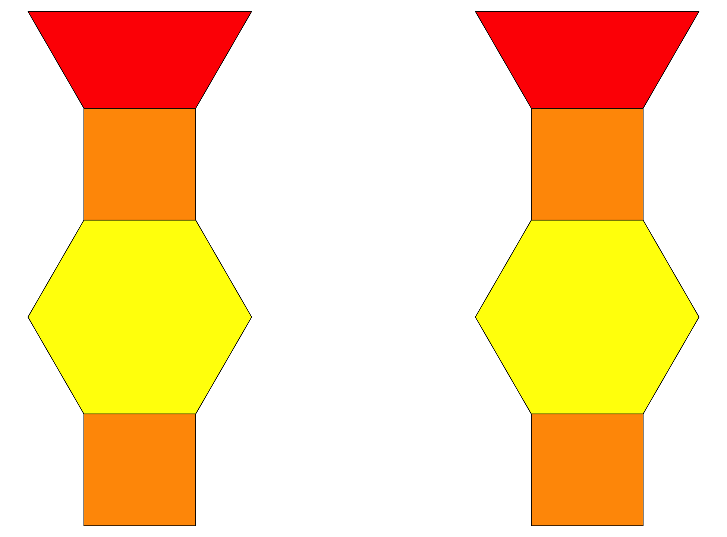
Shake and Spill
© CC BY 2021 Illustrative Mathematics®

