Lesson 4: Find All the Ways
- Let’s find all the ways to break apart a number.

4.1: Patterns in Decompositions
expression: _________________________
expression: _________________________
expression: _________________________
expression: _________________________
expression: _________________________
expression: _________________________

4.2: Find All the Ways
Find all the different ways you can break apart 7 into 2 parts.
Show your thinking using objects, drawings, numbers, or words.

4.3: Centers: Choice Time
Choose a center.
What's Behind My Back?
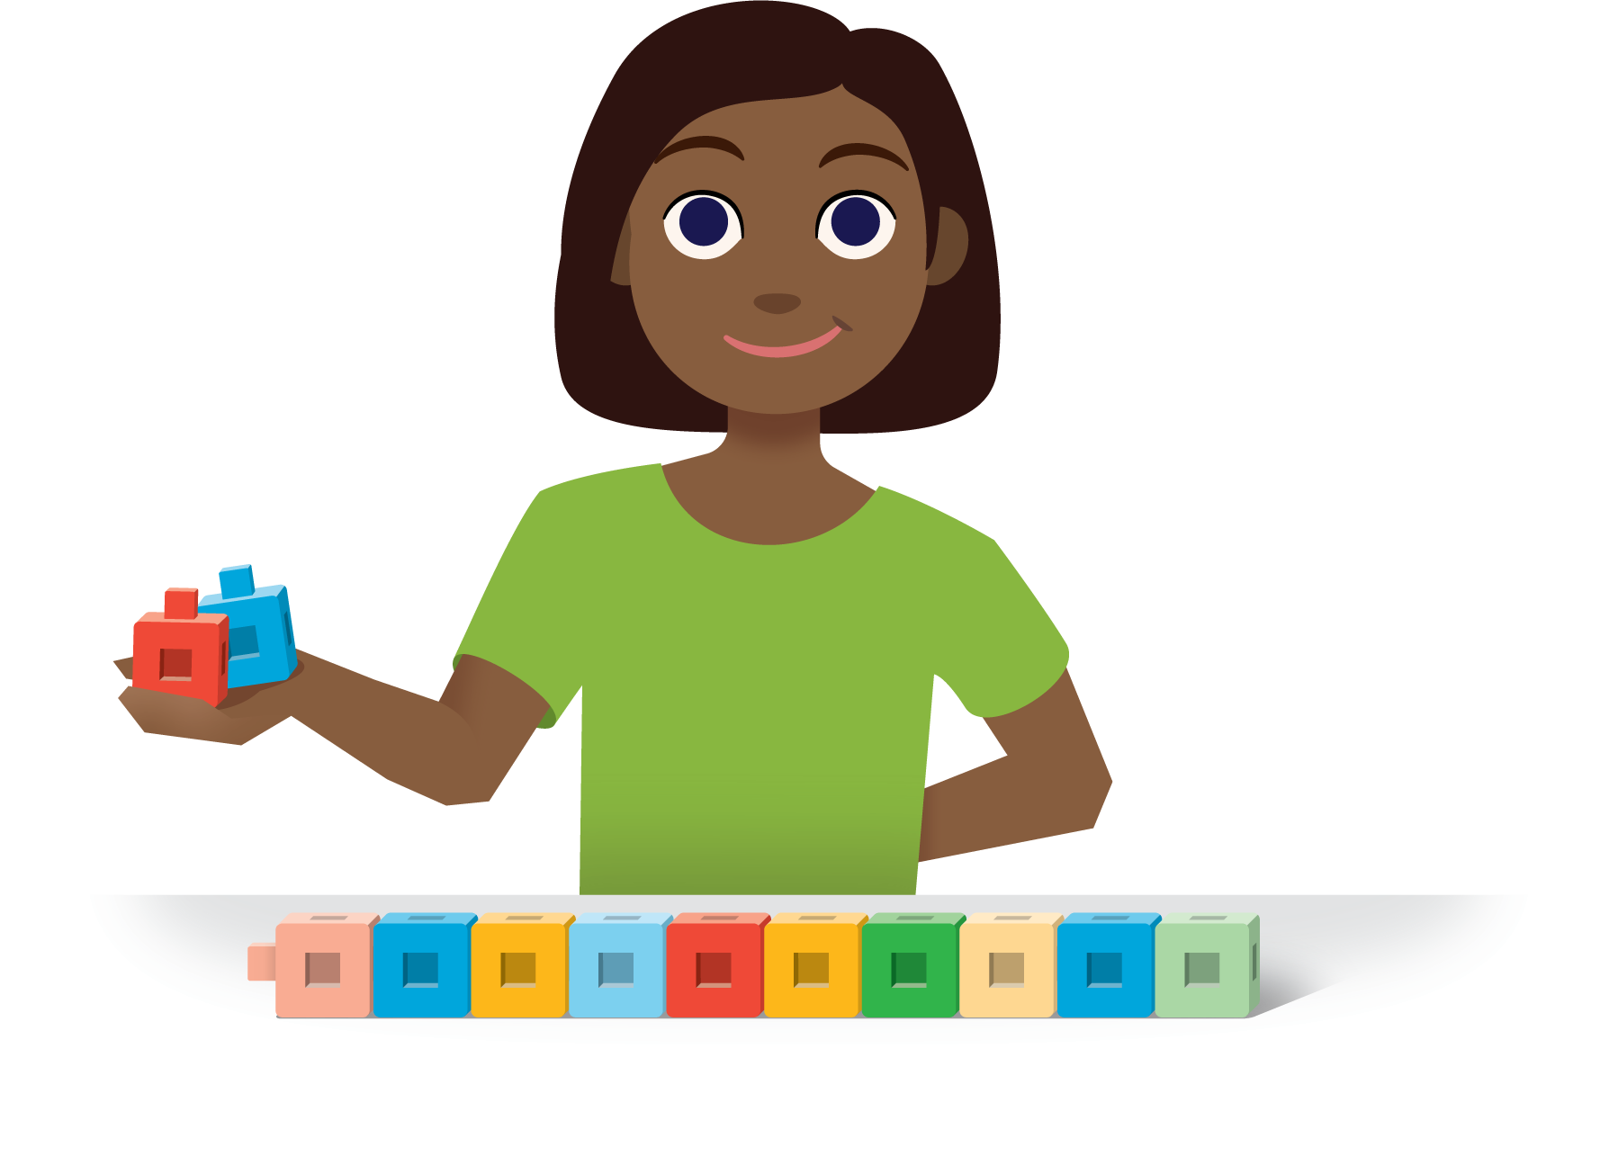
Check it Off
Bingo
Find the Value of
Expressions
Shake and Spill
© CC BY 2021 Illustrative Mathematics®

