Unit 1 Lesson 5: Coordinate Moves

1 Translating Coordinates (Warm up)

Student Task Statement
Select all of the translations that take Triangle T to Triangle U. There may be more than one correct answer.
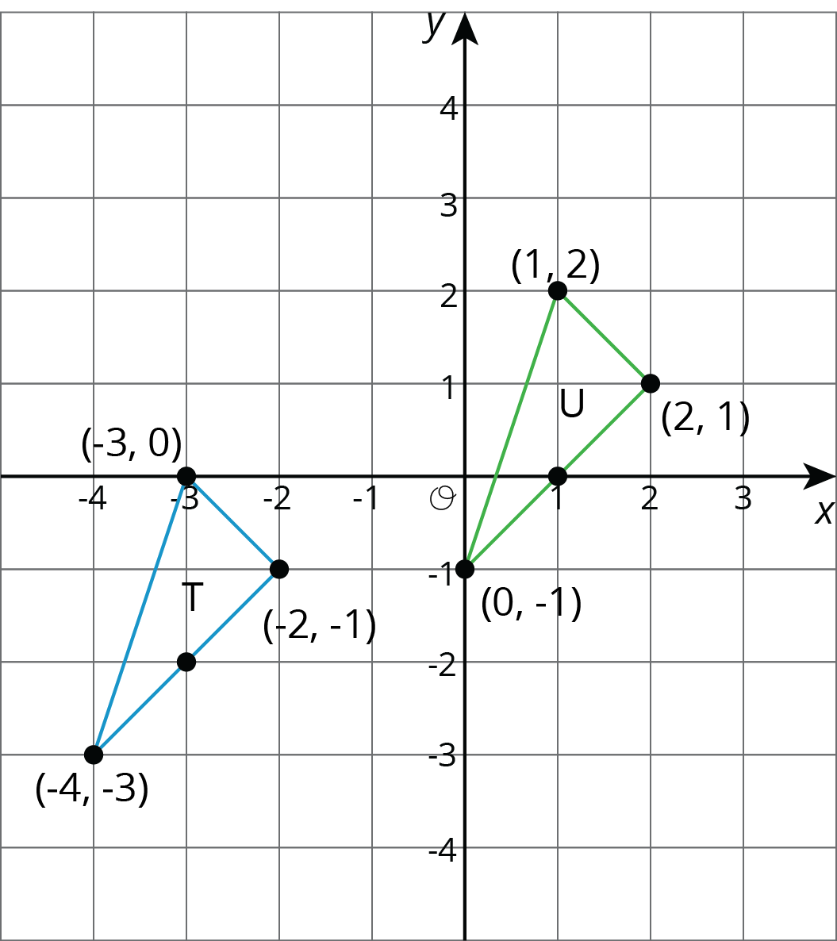
- Translate $(\text{-}3,0)$ to $(1,2)$.
- Translate $(2,1)$ to $(\text{-}2,\text{-}1)$.
- Translate $(\text{-}4,\text{-}3)$ to $(0,\text{-}1)$.
- Translate $(1,2)$ to $(2,1)$.

Activity Synthesis
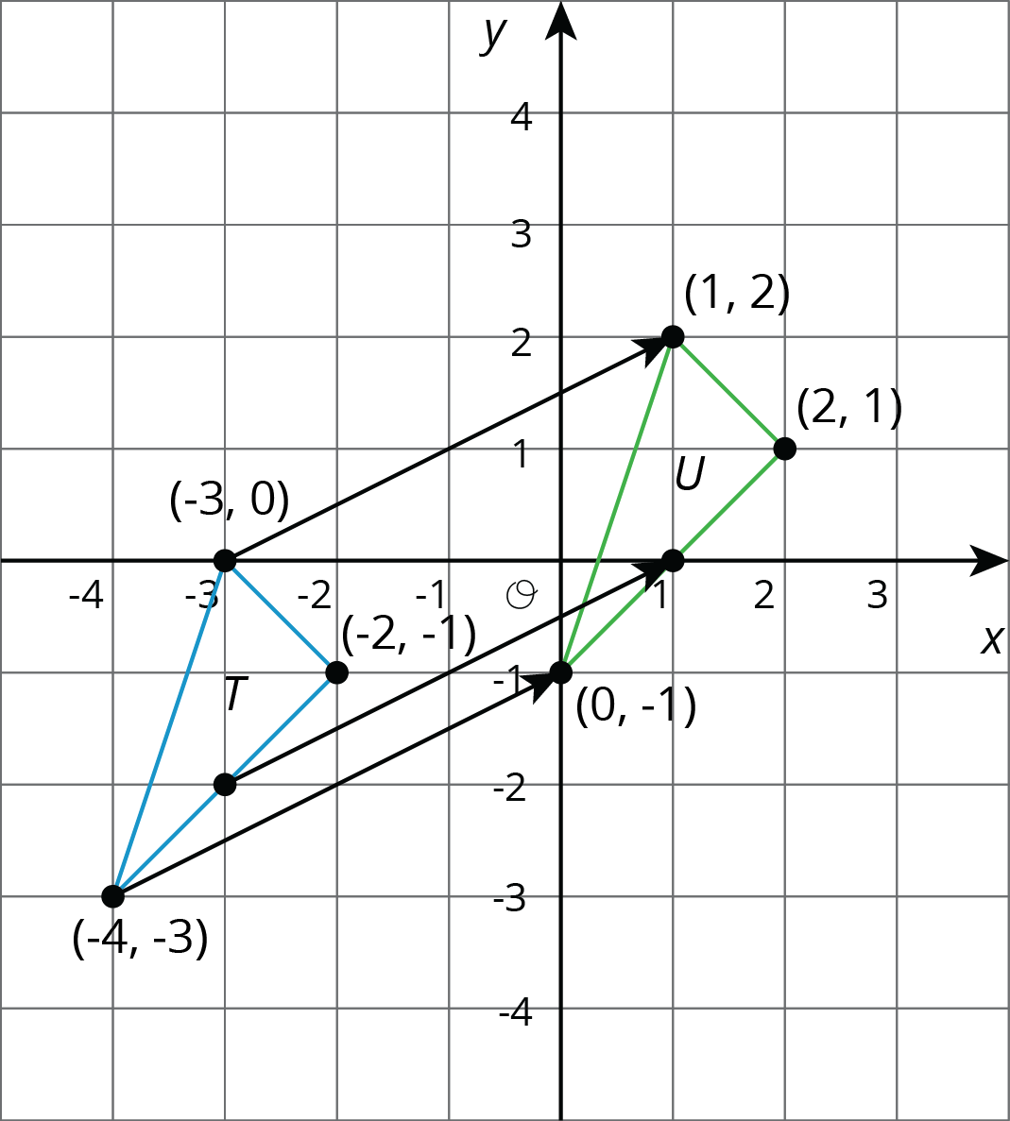

2 Reflecting Points on the Coordinate Plane

Student Task Statement
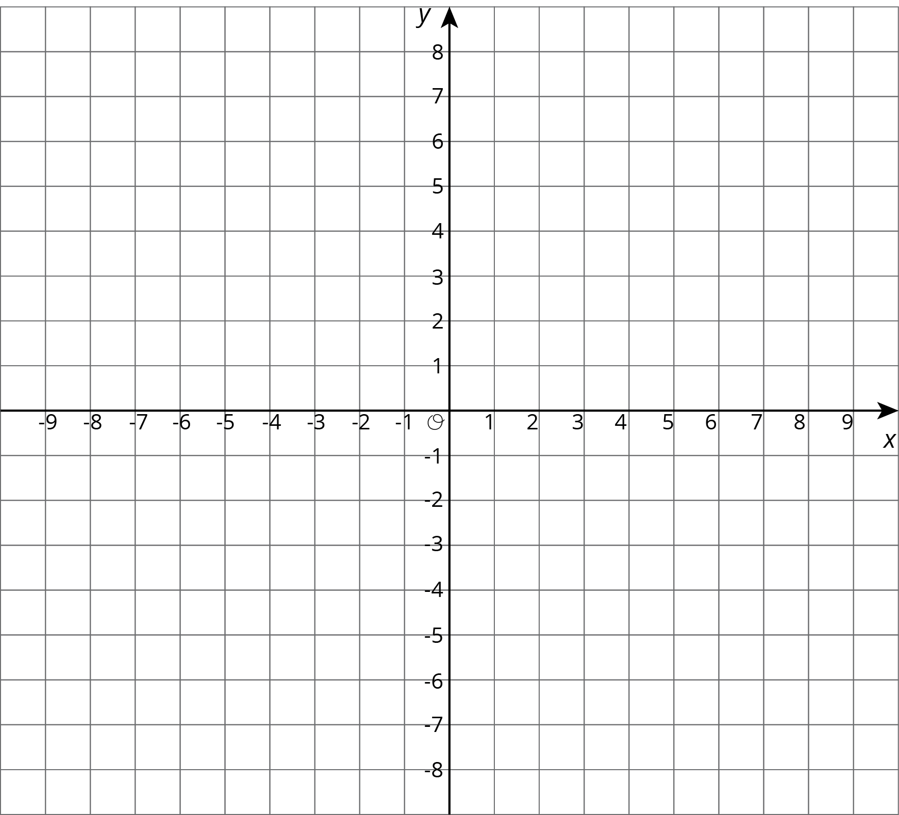
- Here is a list of points $\begin{matrix}A & =(0.5,4) & B & =(\text{-}4,5) & C & =(7,\text{-}2) & D & =(6,0) & E & =(0,\text{-}3) \\ & & & & & & & & & \end{matrix}$ On the coordinate plane:
  - Plot each point and label each with its coordinates.
  - Using the $x$-axis as the line of reflection, plot the image of each point.
  - Label the image of each point with its coordinates.
  - Include a label using a letter. For example, the image of point $A$ should be labeled $A^{′}$.
- If the point $(13,10)$ were reflected using the $x$-axis as the line of reflection, what would be the coordinates of the image? What about $(13,\text{-}20)$? $(13,570)$? Explain how you know.
- The point $R$ has coordinates $(3,2)$.
  - Without graphing, predict the coordinates of the image of point $R$ if point $R$ were reflected using the $y$-axis as the line of reflection.
  - Check your answer by finding the image of $R$ on the graph.
  - 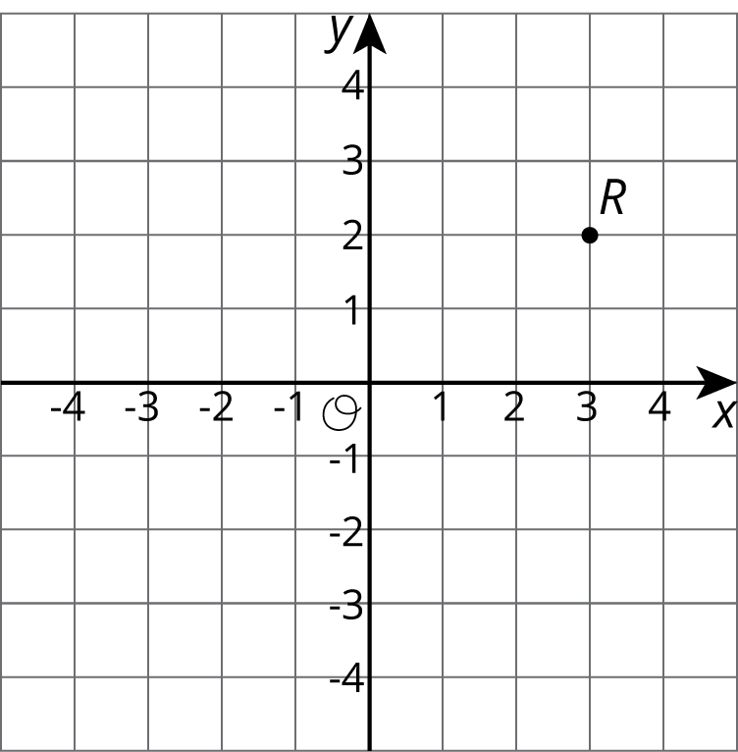
  - Label the image of point $R$ as $R^{′}$.
  - What are the coordinates of $R^{′}$?
- Suppose you reflect a point using the $y$-axis as line of reflection. How would you describe its image?

Activity Synthesis

3 Transformations of a Segment

Student Task Statement
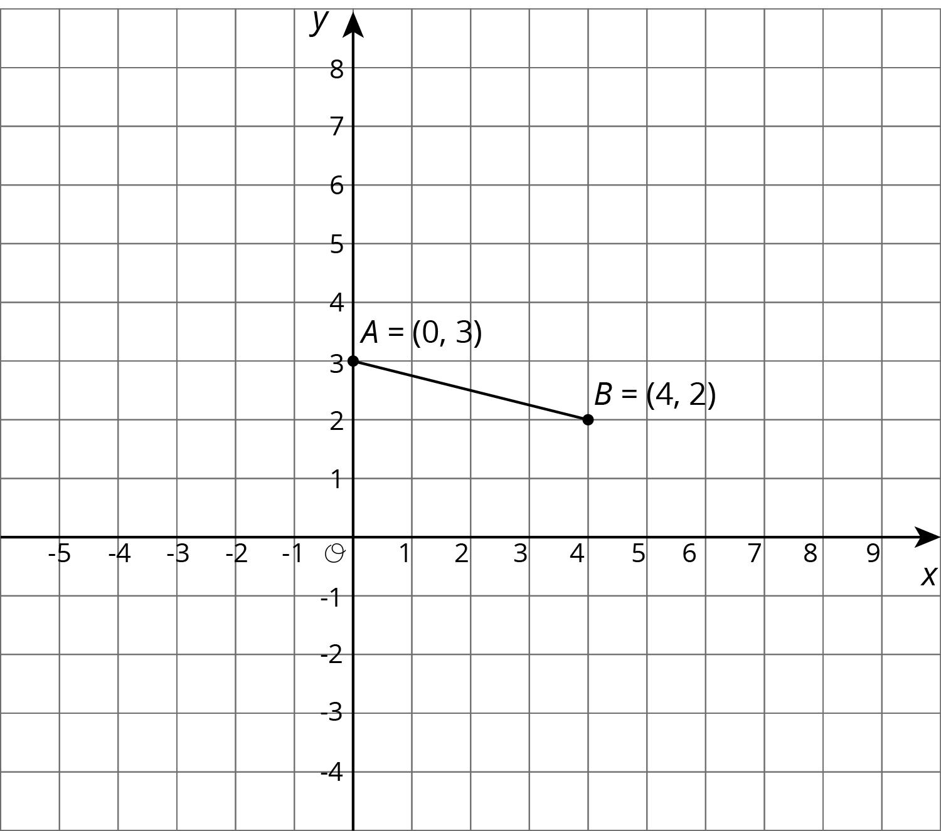
Apply each of the following transformations to segment $AB$.
- Rotate segment $AB$ 90 degrees counterclockwise around center $B$. Label the image of $A$ as $C$. What are the coordinates of $C$?
- Rotate segment $AB$ 90 degrees counterclockwise around center $A$. Label the image of $B$ as $D$. What are the coordinates of $D$?
- Rotate segment $AB$ 90 degrees clockwise around $(0,0)$. Label the image of $A$ as $E$ and the image of $B$ as $F$. What are the coordinates of $E$ and $F$?
- Compare the two 90-degree counterclockwise rotations of segment $AB$. What is the same about the images of these rotations? What is different?
© CC BY Open Up Resources. Adaptations CC BY IM.

