Lesson 6: Revisit Volume
- Let’s solve problems about volume.

Warm-up: Estimation Exploration: Sugar Cubes
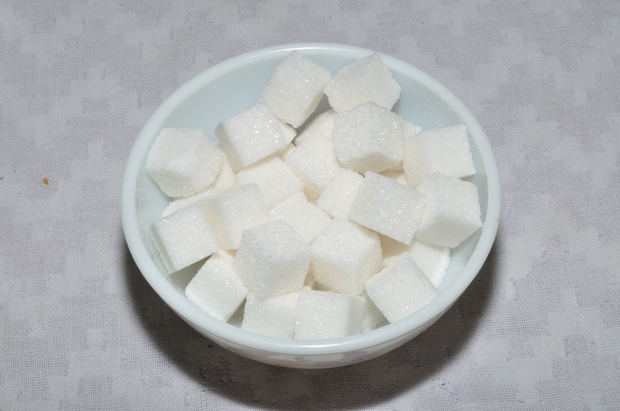
How many cubes are in the bowl?
Record an estimate that is:
too low | about right | too high

6.1: 126 Cubes
A company packages 126 sugar cubes in each box. The box is a rectangular prism.
- What are some possible ways they could pack the cubes?
- How would you choose to pack the cubes? Explain or show your reasoning.
- The side lengths of the box are about $1\frac{7}{8}$ inches by $3\frac{3}{4}$ inches by $4\frac{3}{8}$ inches. What can we say about how the sugar cubes are packed?

6.2: Colossal Structures Old and New
- The base of the Great Pyramid of Egypt is a square. One side length of the base is 230 meters. The pyramid is 140 meters tall. If the pyramid was shaped like a rectangular prism, what would the volume of the prism be?
- 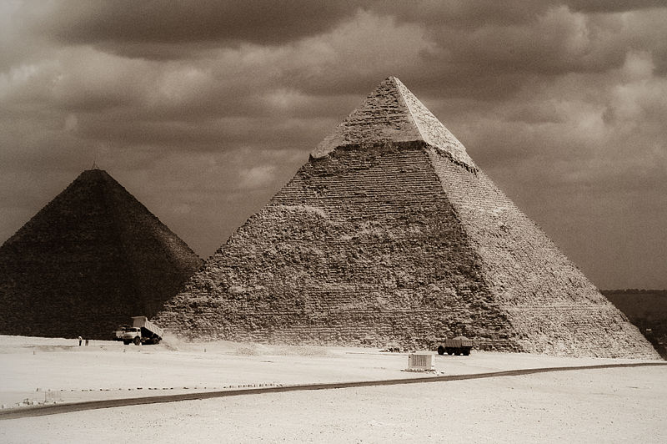
- The Empire State Building is in New York City. The base is 129 meters by 59 meters. The building is 373 meters tall. Estimate the volume of the Empire State Building.
- 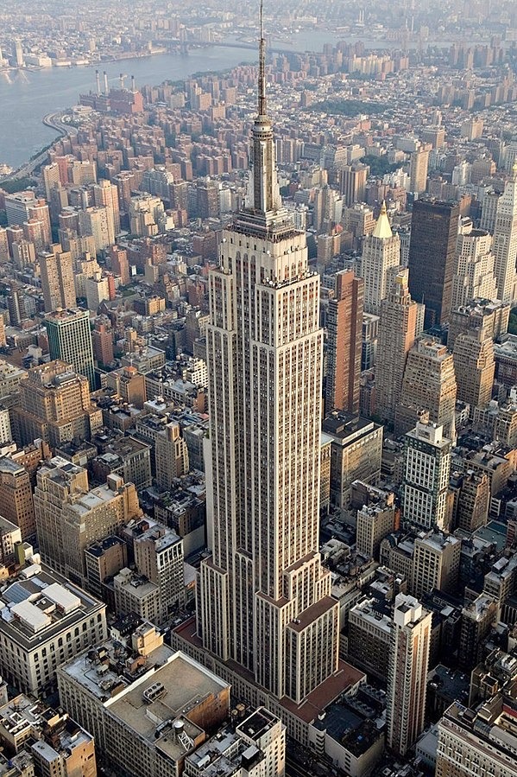
- Which do you think is larger, the Great Pyramid ​​​​​​or the Empire State Building? Explain or show your reasoning.
© CC BY 2021 Illustrative Mathematics®

