Lesson 10: World’s Record Folk Dance
- Let’s explore division with multi-digit numbers.

Warm-up: How Many Do You See: World Record Event
How many do you see? How do you see them?
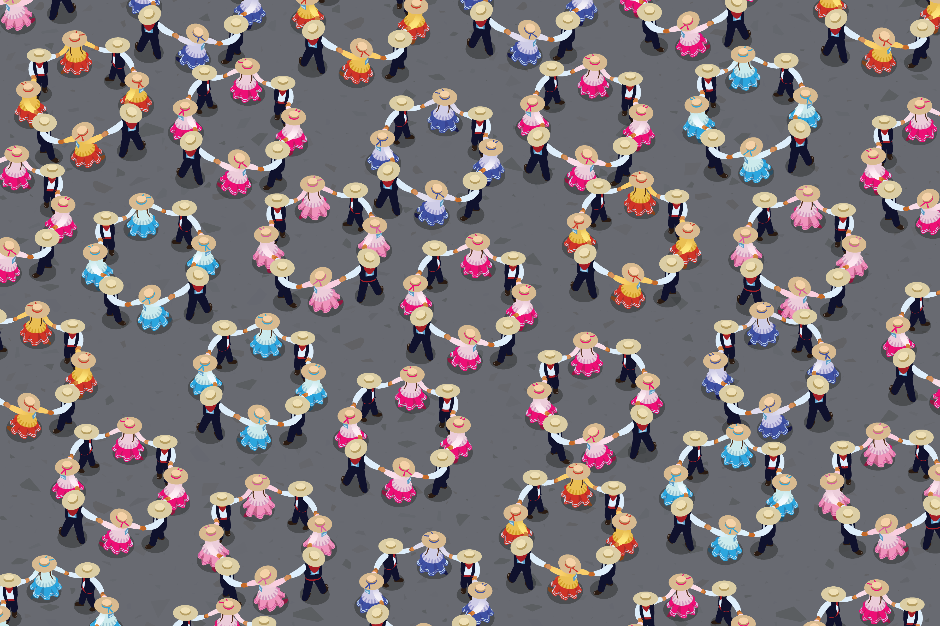

10.1: How Many Groups of 8 Dancers?
There were 4,704 people at the record breaking folk dance in Peru. How many groups of 8 dancers were there? Explain or show your thinking.

10.2: More Groups of Dancers
- 4,704 people participate in the Peruvian folk dance. They need to be organized into groups of 4.
  - Write a division expression to represent the situation.
  - How many groups of 4 will there be? Explain or show your thinking.
  - Compare your work with your partner’s. What is the same? What is different?
- 4,704 people participate in the Peruvian folk dance. They need to be organized into groups of 2.
  - Write a division expression to represent the situation.
  - How many groups of 2 will there be? Explain or show your thinking.
  - Compare your work with your partner’s. What is the same? What is different?
© CC BY 2021 Illustrative Mathematics®

