Lesson 17: Center Day 3
- Let's measure to create line plots and add and subtract within 100.

Warm-up: Number Talk: Subtract from a Multiple of 10
Find the value of each expression mentally.
- $60−10$
- $60−11$
- $60−21$
- $70−32$

17.2: Centers: Choice Time
Choose a center.
Estimate and Measure
Number Puzzles
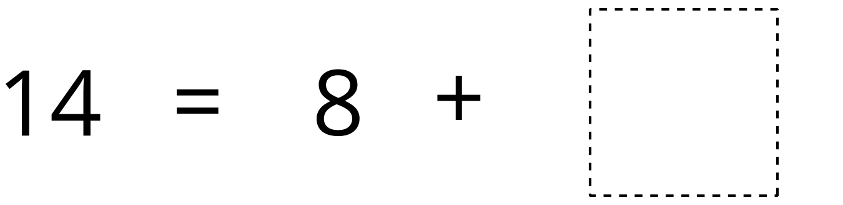
Target Measurements
© CC BY 2021 Illustrative Mathematics®

