Unit 3 Lesson 16: Add Three Numbers

WU Number Talk: Related Expressions (Warm up)

Student Task Statement
Find the value of each expression mentally.
- $7+10$
- $7+2+8$
- $10+9$
- $4+9+6$

1 Match Expressions

Student Task Statement
Draw a line to match expressions with the same value.
expressions with 3 numbers
10+3 expression
- $4+6+8$
- $3+6+7$
- $9+1+1$
- $8+4+2$
- $5+5+9$
- $7+3+3$
- $5+10+5$
- $4+7+6$
- $9+5+1$
- $1+10+1$
$10+1$
$10+2$
$10+3$
$10+4$
$10+5$
$10+6$
$10+7$
$10+8$
$10+9$
$10+10$
If you have time: Write another expression with 3 numbers. 2 of the numbers should make 10.
Ask your partner to think of the matching 10+aaaiaaai expression.

2 Is the Equation True?

Student Task Statement
Determine whether each equation is true or false.
Be ready to explain your reasoning in a way that others will understand.
- $7+3+4=10+4$
- 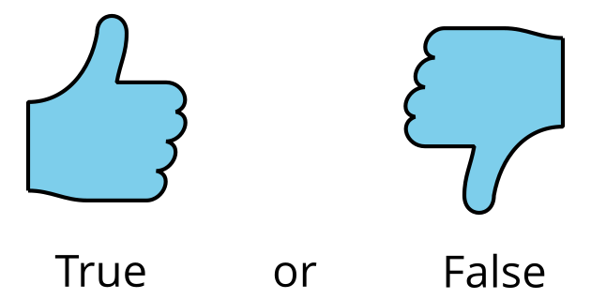
- $6+5+4=15+10$
- $9+10=9+10+1$
- $3+7+8=8+10$
- $5+10+5=10+10$
If you have time:
- Make any false equations true.
- Write 1 equation that is true and 1 that is false.
Switch with your partner.

3 Write Expressions

Student Task Statement
Write a 10+3 expression that has the same value as each expression.
- $5+7+5$
- $3+7+6$
- $1+9+9$
- $4+8+6$
- $8+10+2$
If you have time, write as many expressions as you can with 3 numbers that are equal to $10+5$.
© CC BY 2021 Illustrative Mathematics®

