Lesson 18: Lots of Fractions to Add
- Let’s add tenths and hundredths again, more than two at a time.

Warm-up: Number Talk: A Bunch of Numbers
Find the value of each expression mentally.
- $54+2+18$
- $61+104+39$
- $25+63+75+7$
- $50+106+19+101$

18.1: Stack Centavos and Pesos
Diego and Lin each have a small collection of Mexican coins.
The table shows the thickness of different coins in centimeters (cm) and how many of each Diego and Lin have.
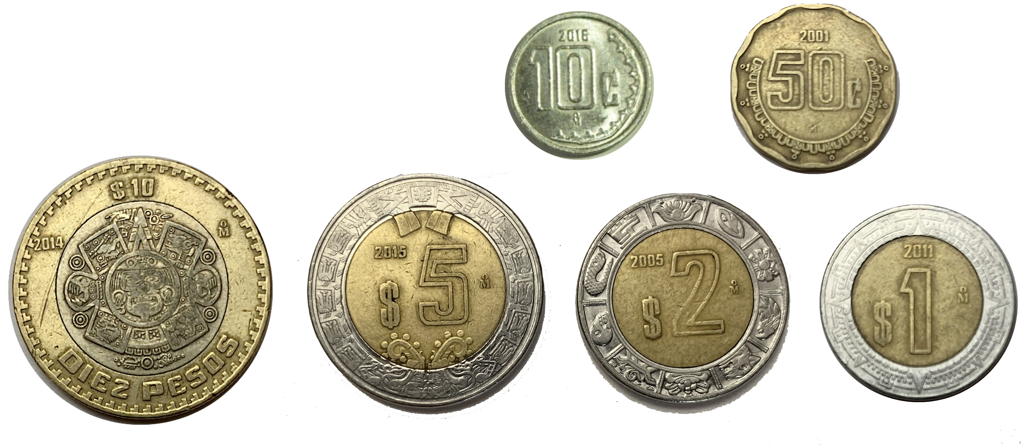
coin value | thickness in cm | Diego | Lin
1 centavo | $\frac{12}{100}$ | 3 | 1
10 centavos | $\frac{22}{100}$ | 0 | 1
1 peso | $\frac{16}{100}$ | 0 | 1
2 pesos | $\frac{14}{100}$ | 0 | 1
5 pesos | $\frac{2}{10}$ | 1 | 1
20 pesos | $\frac{25}{100}$ | 2 | 1
- If Diego and Lin each stack their centavo coins, whose stack would be taller? Show your reasoning.
- If they each stack their peso coins, whose stack would be taller? Show your reasoning.
- If they each stack all their coins, whose stack would be taller? Show your reasoning.
- If they combine their coins to make a single stack, would it be more than 2 centimeters tall? Show your reasoning.

18.2: More Than Two Fractions
Find the value of at least 3 of the expressions. Show your reasoning.
- $\frac{2}{100}+\frac{13}{10}+\frac{1}{10}+\frac{8}{100}$
- $\frac{50}{10}+\frac{16}{100}+\frac{2}{10}$
- $\frac{3}{10}+\frac{4}{100}+\frac{7}{10}+\frac{26}{100}$
- $\frac{4}{100}+3\frac{2}{10}+1\frac{5}{10}$
- $1\frac{1}{10}+5\frac{2}{100}+\frac{78}{100}$
- $2\frac{7}{10}+\frac{2}{100}+\frac{8}{10}$

Section Summary
Section Summary
In this section, we learned more ways to add fractions and to solve problems that involve adding, subtracting, and multiplying fractions.
We started by adding tenths and hundredths, using what we know about equivalent fractions. For example, to find the sum of $\frac{4}{10}$ and $\frac{30}{100}$, we can:
- Write $\frac{4}{10}$ as $\frac{40}{100}$, and then find $\frac{40}{100}+\frac{30}{100}$, or
- Write $\frac{30}{100}$ as $\frac{3}{10}$, and then find $\frac{4}{10}+\frac{3}{10}$.
We learned that when adding a few fractions, it may help to rearrange or group them. For instance:
- $\frac{6}{100}+\frac{2}{10}+\frac{74}{100}$ can be rearranged as $\frac{6}{100}+\frac{74}{100}+\frac{2}{10}$.
- Next, the hundredths can be added first, giving $\frac{80}{100}+\frac{2}{10}$.
- Then, we can write an equivalent fraction for $\frac{80}{100}$ and find $\frac{8}{10}+\frac{2}{10}$, or write an equivalent fraction for $\frac{2}{10}$ and find $\frac{80}{100}+\frac{20}{100}$.
© CC BY 2021 Illustrative Mathematics®

