Lesson 7: Connecting Representations of Functions
Let’s connect tables, equations, graphs, and stories of functions.

7.1: Which are the Same? Which are Different?
Here are three different ways of representing functions. How are they alike? How are they different?
$y=2x$
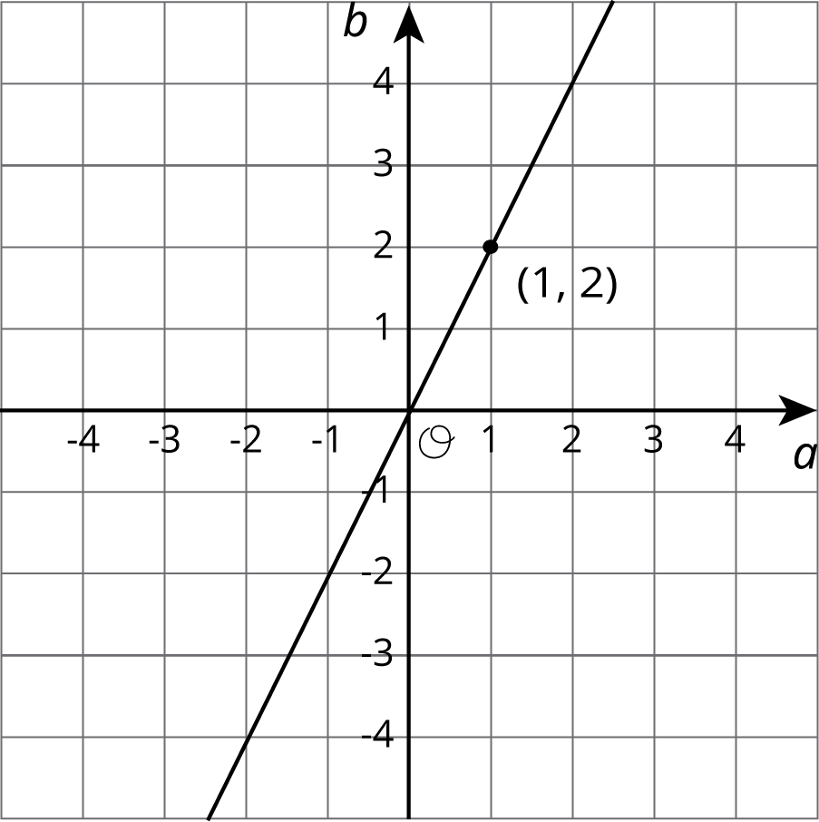
$p$ | -2 | -1 | 0 | 1 | 2 | 3
$q$ | 4 | 2 | 0 | -2 | -4 | -6

7.2: Comparing Temperatures
The graph shows the temperature between noon and midnight in City A on a certain day.
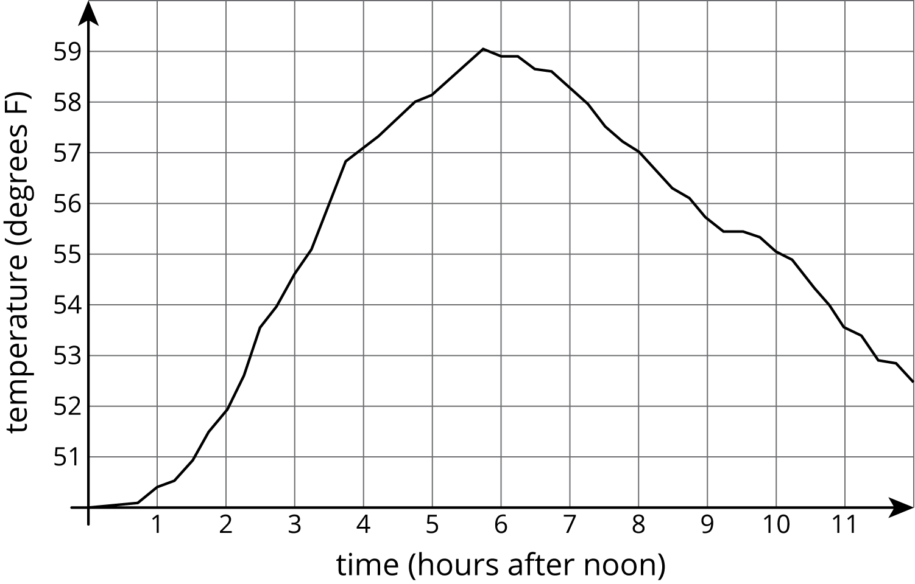
The table shows the temperature, $T$, in degrees Fahrenheit, for $h$ hours after noon, in City B.
$h$ | 1 | 2 | 3 | 4 | 5 | 6
$T$ | 82 | 78 | 75 | 62 | 58 | 59
- Which city was warmer at 4:00 p.m.?
- Which city had a bigger change in temperature between 1:00 p.m. and 5:00 p.m.?
- How much greater was the highest recorded temperature in City B than the highest recorded temperature in City A during this time?
- Compare the outputs of the functions when the input is 3.

7.3: Comparing Volumes
The volume, $V$, of a cube with edge length $s$ cm is given by the equation $V=s^{3}$.
The volume of a sphere is a function of its radius (in centimeters), and the graph of this relationship is shown here.
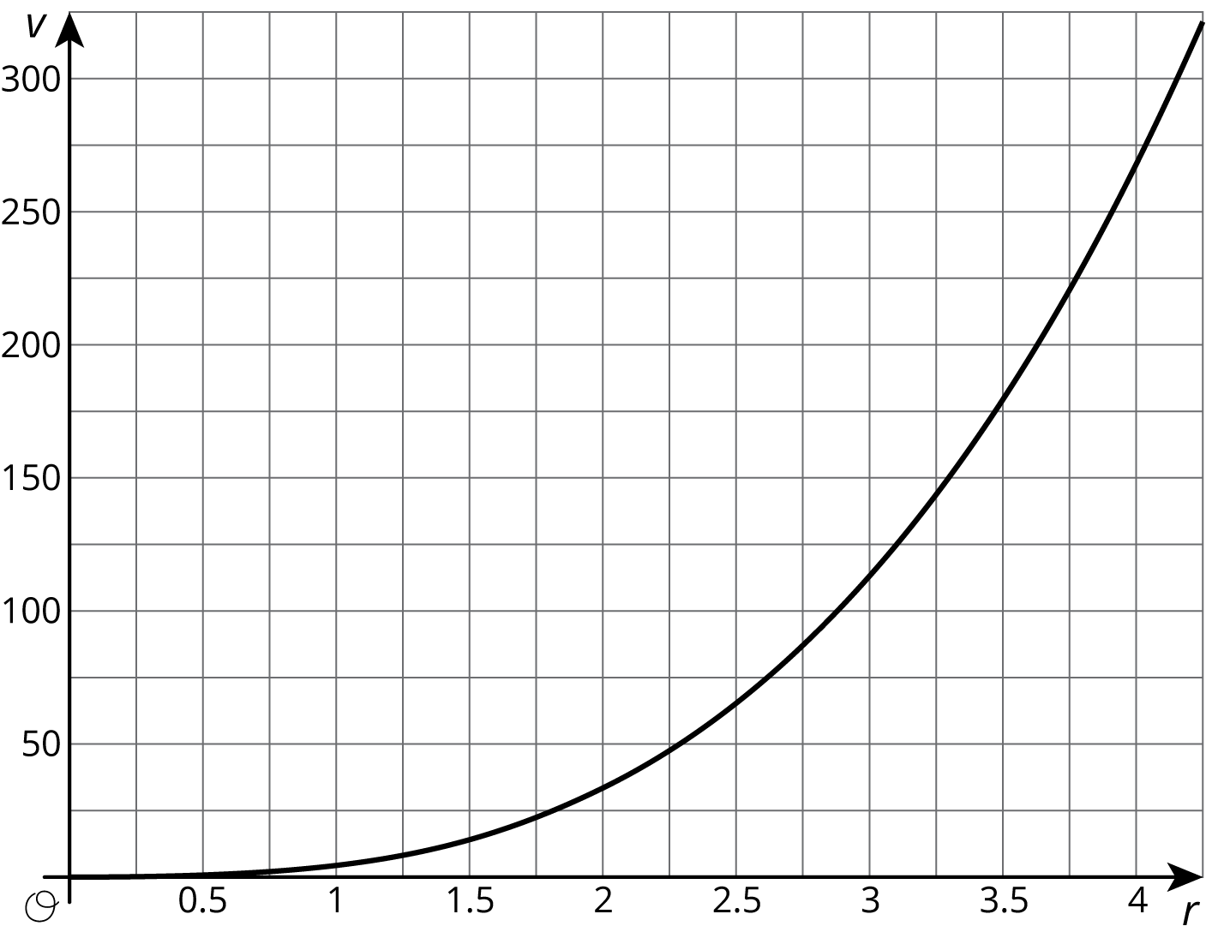
- Is the volume of a cube with edge length $s=3$ greater or less than the volume of a sphere with radius 3?
- If a sphere has the same volume as a cube with edge length 5, estimate the radius of the sphere.
- Compare the outputs of the two volume functions when the inputs are 2.

Are you ready for more?
Estimate the edge length of a cube that has the same volume as a sphere with radius 2.5.

7.4: It’s Not a Race
Elena’s family is driving on the freeway at 55 miles per hour.
Andre’s family is driving on the same freeway, but not at a constant speed. The table shows how far Andre's family has traveled, $d$, in miles, every minute for 10 minutes.
$t$ | 1 | 2 | 3 | 4 | 5 | 6 | 7 | 8 | 9 | 10
$d$ | 0.9 | 1.9 | 3.0 | 4.1 | 5.1 | 6.2 | 6.8 | 7.4 | 8 | 9.1
- How many miles per minute is 55 miles per hour?
- Who had traveled farther after 5 minutes? After 10 minutes?
- How long did it take Elena’s family to travel as far as Andre’s family had traveled after 8 minutes?
- For both families, the distance in miles is a function of time in minutes. Compare the outputs of these functions when the input is 3.

Lesson 7 Summary
Functions are all about getting outputs from inputs. For each way of representing a function—equation, graph, table, or verbal description—we can determine the output for a given input.
Let's say we have a function represented by the equation $y=3x+2$ where $y$ is the dependent variable and $x$ is the independent variable. If we wanted to find the output that goes with 2, we can input 2 into the equation for $x$ and finding the corresponding value of $y$. In this case, when $x$ is 2, $y$ is 8 since $3⋅2+2=8$.
If we had a graph of this function instead, then the coordinates of points on the graph are the input-output pairs. So we would read the $y$-coordinate of the point on the graph that corresponds to a value of 2 for $x$. Looking at the graph of this function here, we can see the point $\left(2,8\right)$ on it, so the output is 8 when the input is 2.
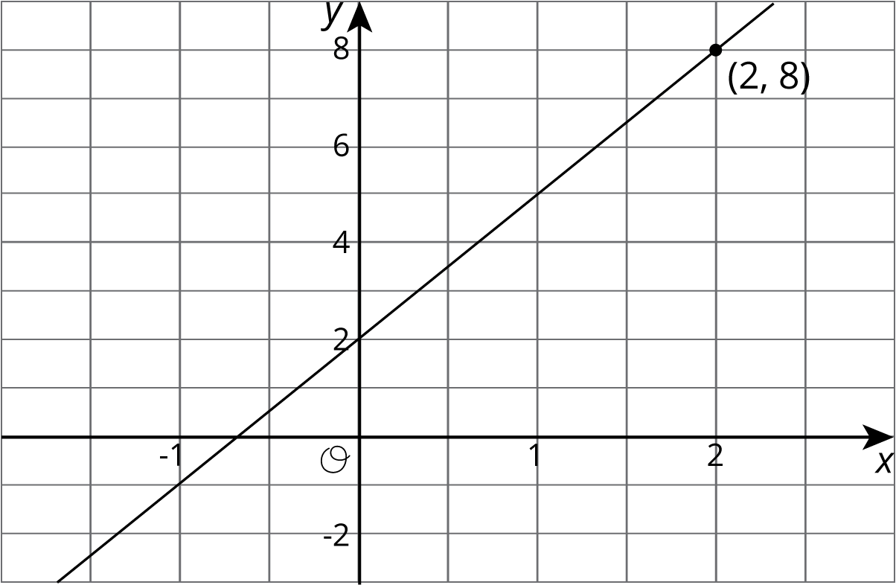
A table representing this function shows the input-output pairs directly (although only for select inputs).
$x$ | -1 | 0 | 1 | 2 | 3
$y$ | -1 | 2 | 5 | 8 | 11
Again, the table shows that if the input is 2, the output is 8.
© CC BY Open Up Resources. Adaptations CC BY IM.

