Unit 1 Lesson 9: Polygons

1 Which One Doesn’t Belong: Bases and Heights (Warm up)

Student Task Statement
Which one doesn't belong?
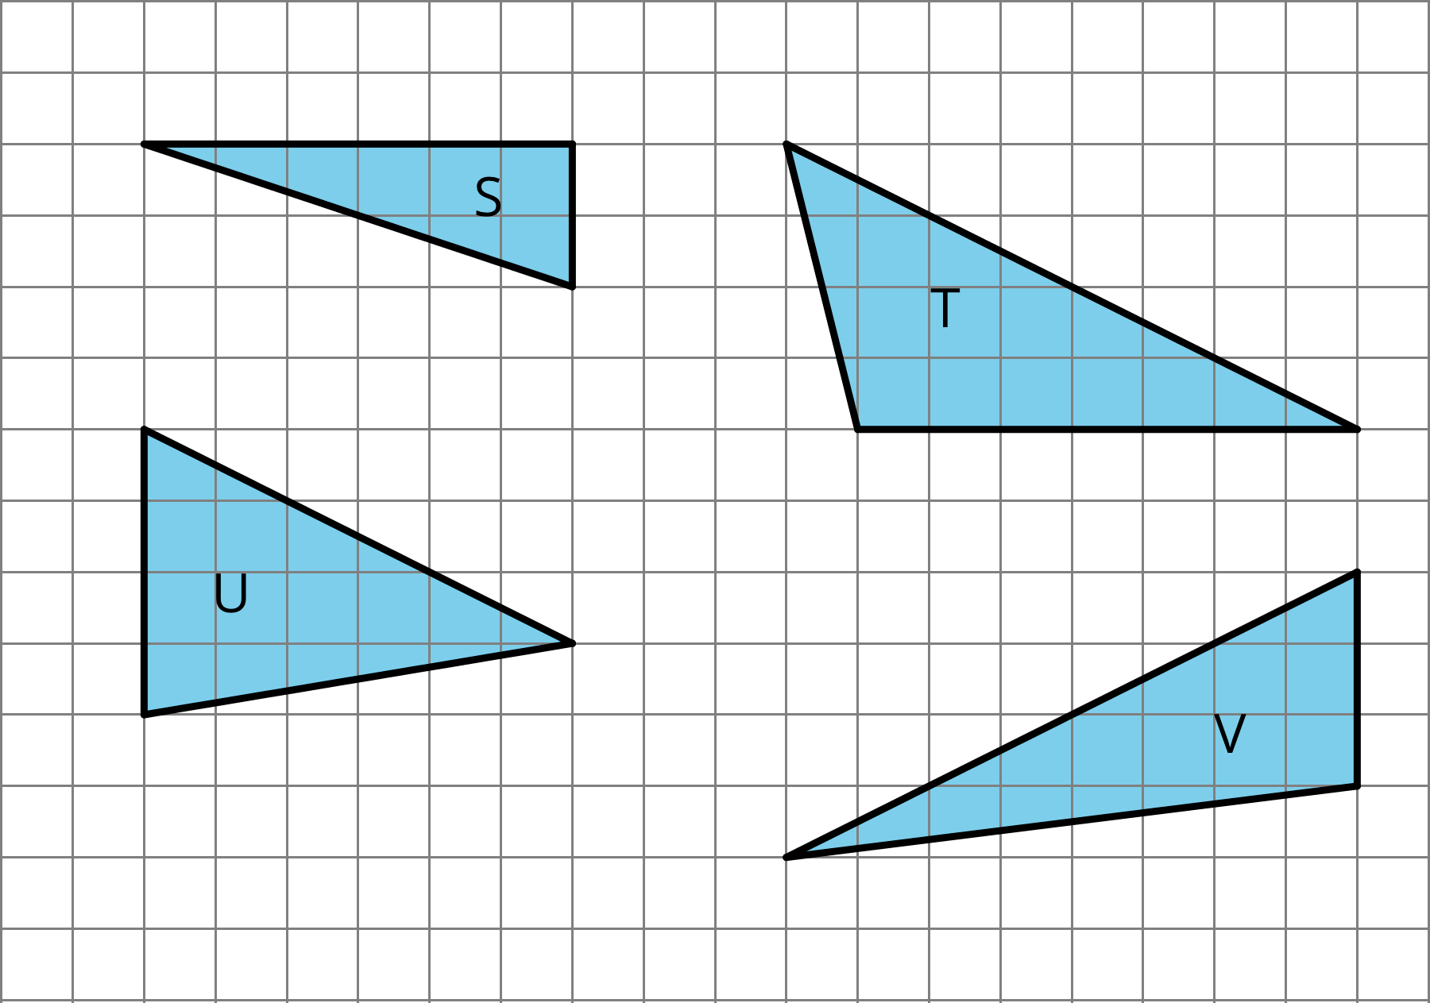

2 What Are Polygons?

Student Task Statement
Here are five polygons:
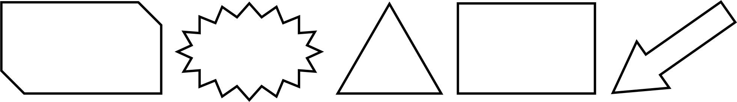
Here are six figures that are not polygons:
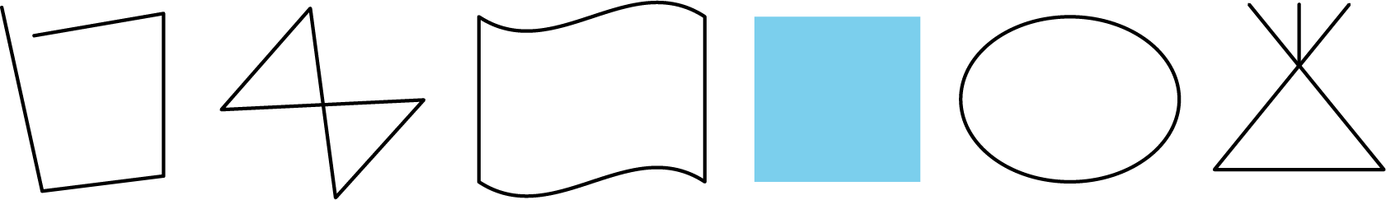

- Circle the figures that are polygons.
- 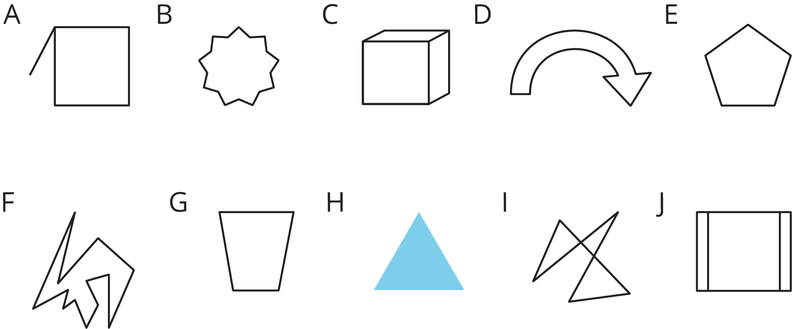
- What do the figures you circled have in common? What characteristics helped you decide whether a figure was a polygon?

3 Quadrilateral Strategies

Student Task Statement
Find the area of two quadrilaterals of your choice. Show your reasoning.
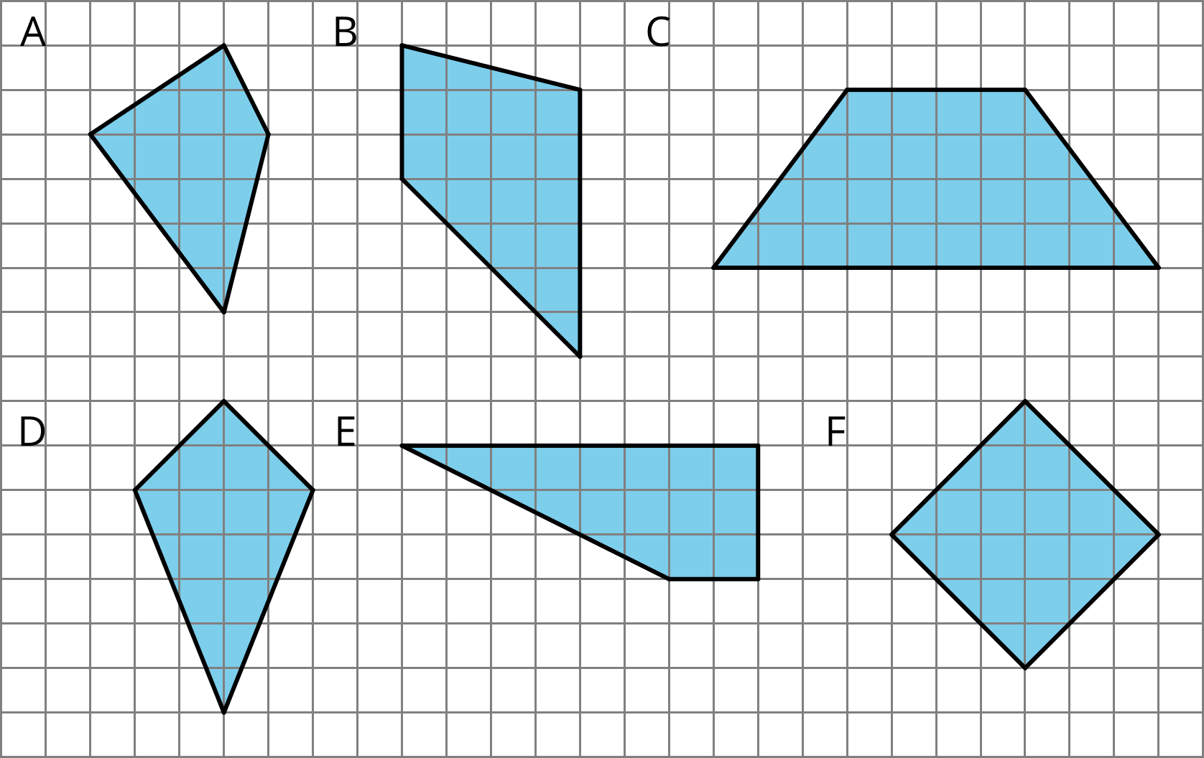

4 Pinwheel (Optional)

Student Task Statement
Find the area of the shaded region in square units. Show your reasoning.
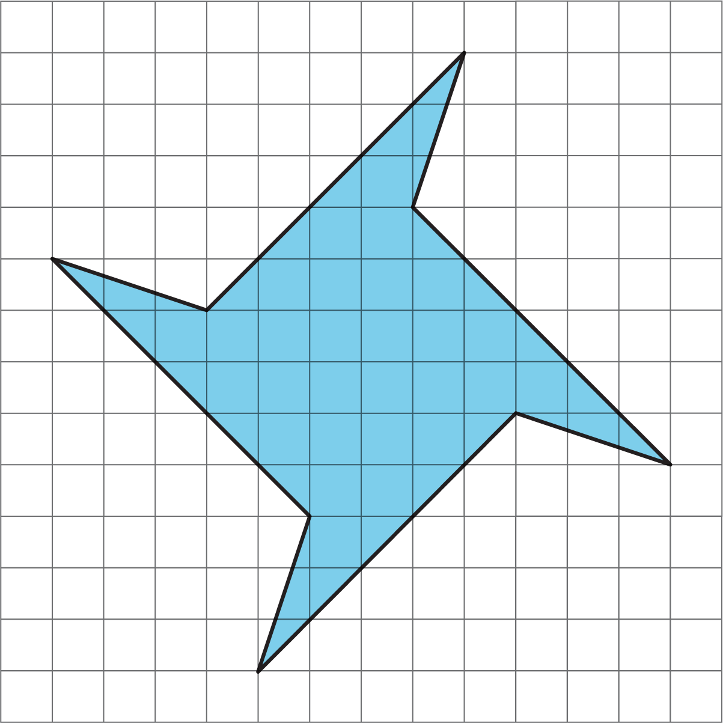

Images for Activity Synthesis
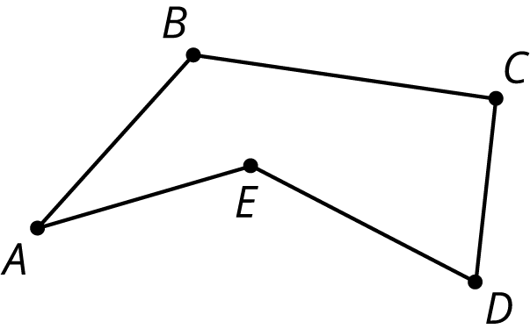
© CC BY Open Up Resources. Adaptations CC BY IM.

