Lesson 12 Practice Problems
- One inch is around $2\frac{11}{20}$ centimeters.
- 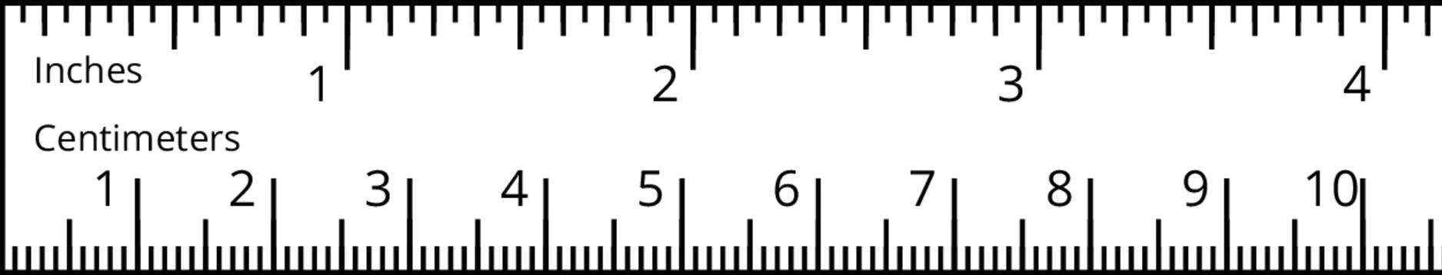
  - How many centimeters long is 3 inches? Show your reasoning.
  - What fraction of an inch is 1 centimeter? Show your reasoning.
  - What question can be answered by finding $10÷2\frac{11}{20}$ in this situation?
- A zookeeper is $6\frac{1}{4}$ feet tall. A young giraffe in his care is $9\frac{3}{8}$ feet tall.
  - How many times as tall as the zookeeper is the giraffe?
  - What fraction of the giraffe’s height is the zookeeper’s height?
- A rectangular bathroom floor is covered with square tiles that are $1\frac{1}{2}$ feet by $1\frac{1}{2}$ feet. The length of the bathroom floor is $10\frac{1}{2}$ feet and the width is $6\frac{1}{2}$ feet.
  - How many tiles does it take to cover the length of the floor?
  - How many tiles does it take to cover the width of the floor?
- The Food and Drug Administration (FDA) recommends a certain amount of nutrient intake per day called the “daily value.” Food labels usually show percentages of the daily values for several different nutrients—calcium, iron, vitamins, etc.
- Consider the problem: In $\frac{3}{4}$ cup of oatmeal, there is $\frac{1}{10}$ of the recommended daily value of iron. What fraction of the daily recommended value of iron is in 1 cup of oatmeal?
- Write a multiplication equation and a division equation to represent the question. Then find the answer and show your reasoning.
- (From Unit 4, Lesson 11.)
- What fraction of $\frac{1}{2}$ is $\frac{1}{3}$? Draw a tape diagram to represent and answer the question. Use graph paper if needed.
- (From Unit 4, Lesson 7.)
- Noah says, “There are $2\frac{1}{2}$ groups of $\frac{4}{5}$ in 2.” Do you agree with him? Draw a tape diagram to show your reasoning. Use graph paper, if needed.
- (From Unit 4, Lesson 6.)
© CC BY Open Up Resources. Adaptations CC BY IM.

