Lesson 10: Here Comes the Sum
- Let’s play some games to practice adding fractions.

Warm-up: Number Talk: Adding Fractions
Find the value of each expression mentally.
- $\frac{2}{12}+\frac{1}{6}$
- $\frac{2}{6}+\frac{1}{2}$
- $\frac{1}{3}+\frac{1}{2}$
- $\frac{1}{3}+\frac{3}{2}$

10.1: Greatest Sum
Use the directions to play Greatest Sum with a partner.
- Spin the spinner.
- Each player writes the number that was spun in an empty box for Round 1. Be sure your partner cannot see your paper.
- Once a number is written down, it cannot be changed.
- Continue spinning and writing numbers in the empty boxes until all 4 boxes have been filled.
- Find the sum.
- The person with the greater sum wins the round.
- After all 4 rounds, the player who won the most rounds wins the game.
- If there is a tie, players add the sums from all 4 rounds and the highest total sum wins the game.
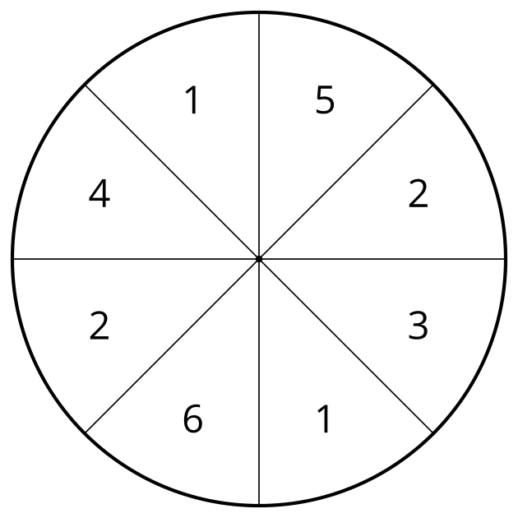
Round 1
1111111111 + 1111111111 =
Round 2
1111111111 + 1111111111 =
Round 3
1111111111 + 1111111111 =
Round 4
1111111111 + 1111111111 =
Total sum of all 4 rounds:

10.2: Smallest Sum
Use the directions to play Smallest Sum with a partner.
- Spin the spinner.
- Each player writes the number that was spun in an empty box for Round 1. Be sure your partner cannot see your paper.
- Once a number is written down, it cannot be changed.
- Continue spinning and writing numbers in the empty boxes until all 4 boxes have been filled.
- Find the sum.
- The person with the lesser sum wins the round.
- After all 4 rounds, the player who won the most rounds wins the game.
- If there is a tie, players add the sums from all 4 rounds and the lesser total sum wins the game.
Round 1
1111111111 + 1111111111 =
Round 2
1111111111 + 1111111111 =
Round 3
1111111111 + 1111111111 =
Round 4
1111111111 + 1111111111 =
Total sum of all 4 rounds:
© CC BY 2021 Illustrative Mathematics®

