Lesson 14: Practice an Algorithm Using Partial Quotients
- Let’s practice using an algorithm using partial quotients.

Warm-up: Which One Doesn’t Belong: Different Ways
Which one doesn't belong?
A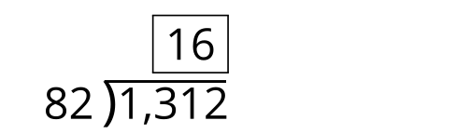
B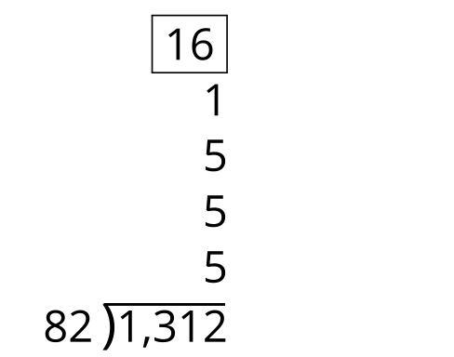
C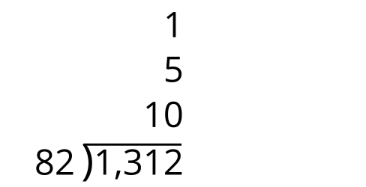
D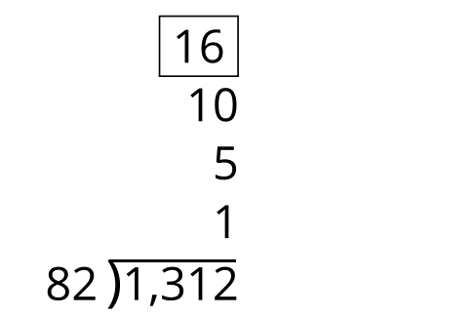

14.1: Find the Mistake
For each problem, describe where you see an error in the calculation. Then find the correct whole number quotient.
1.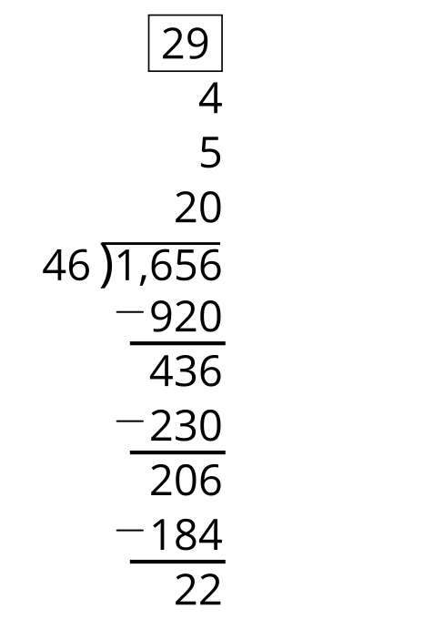
2.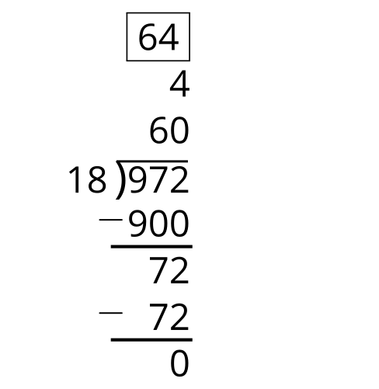
3.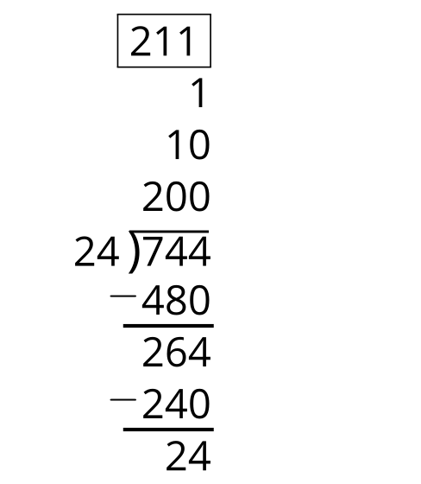

14.2: Practice Problems
Find the value of each expression. Then check in with a partner to review your work.
1.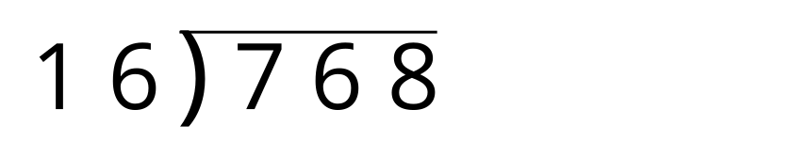

2.
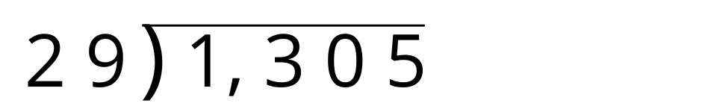
3.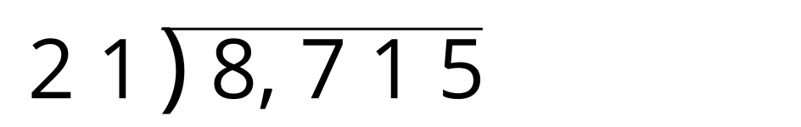
4.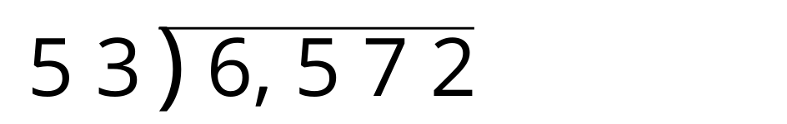
© CC BY 2021 Illustrative Mathematics®

