Unit 3 Lesson 20: A Trip to the Zoo

WU Number Talk: Using 10+4 (Warm up)

Student Task Statement
Find the value of each expression mentally.
- $8+2+4$
- $8+6$
- $7+3+6$
- $7+9$

1 How Many Reptiles?

Student Task Statement
Jada went to the zoo with her family.
They went to the reptile exhibit and saw 8 snakes, 7 iguanas, and 5 frogs.
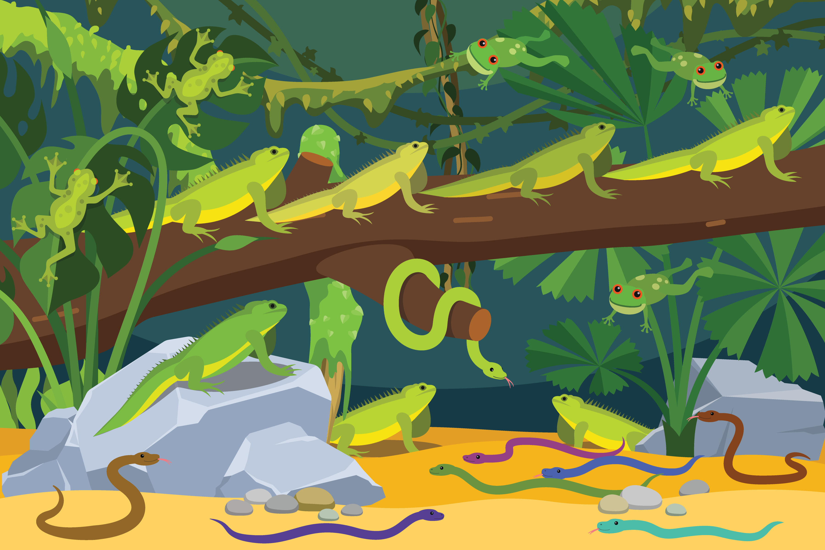
How many reptiles did Jada's family see?
Show your thinking using drawings, numbers, or words.

2 Zoo Exhibits

Student Task Statement
- In the bird exhibit, Jada saw 3 herons, 6 hawks, and 7 hummingbirds.
How many birds did Jada see?
Show your thinking using drawings, numbers, or words.
- Next Jada went to the large cat exhibit.
There were 8 lions, 4 tigers, and 3 cheetahs.
How many large cats were there?
Show your thinking using drawings, numbers, or words.
- Finally, Jada went to the petting zoo.
She petted 8 goats, 7 sheep, and 4 pigs.
How many animals did Jada pet?
Show your thinking using drawings, numbers, or words.
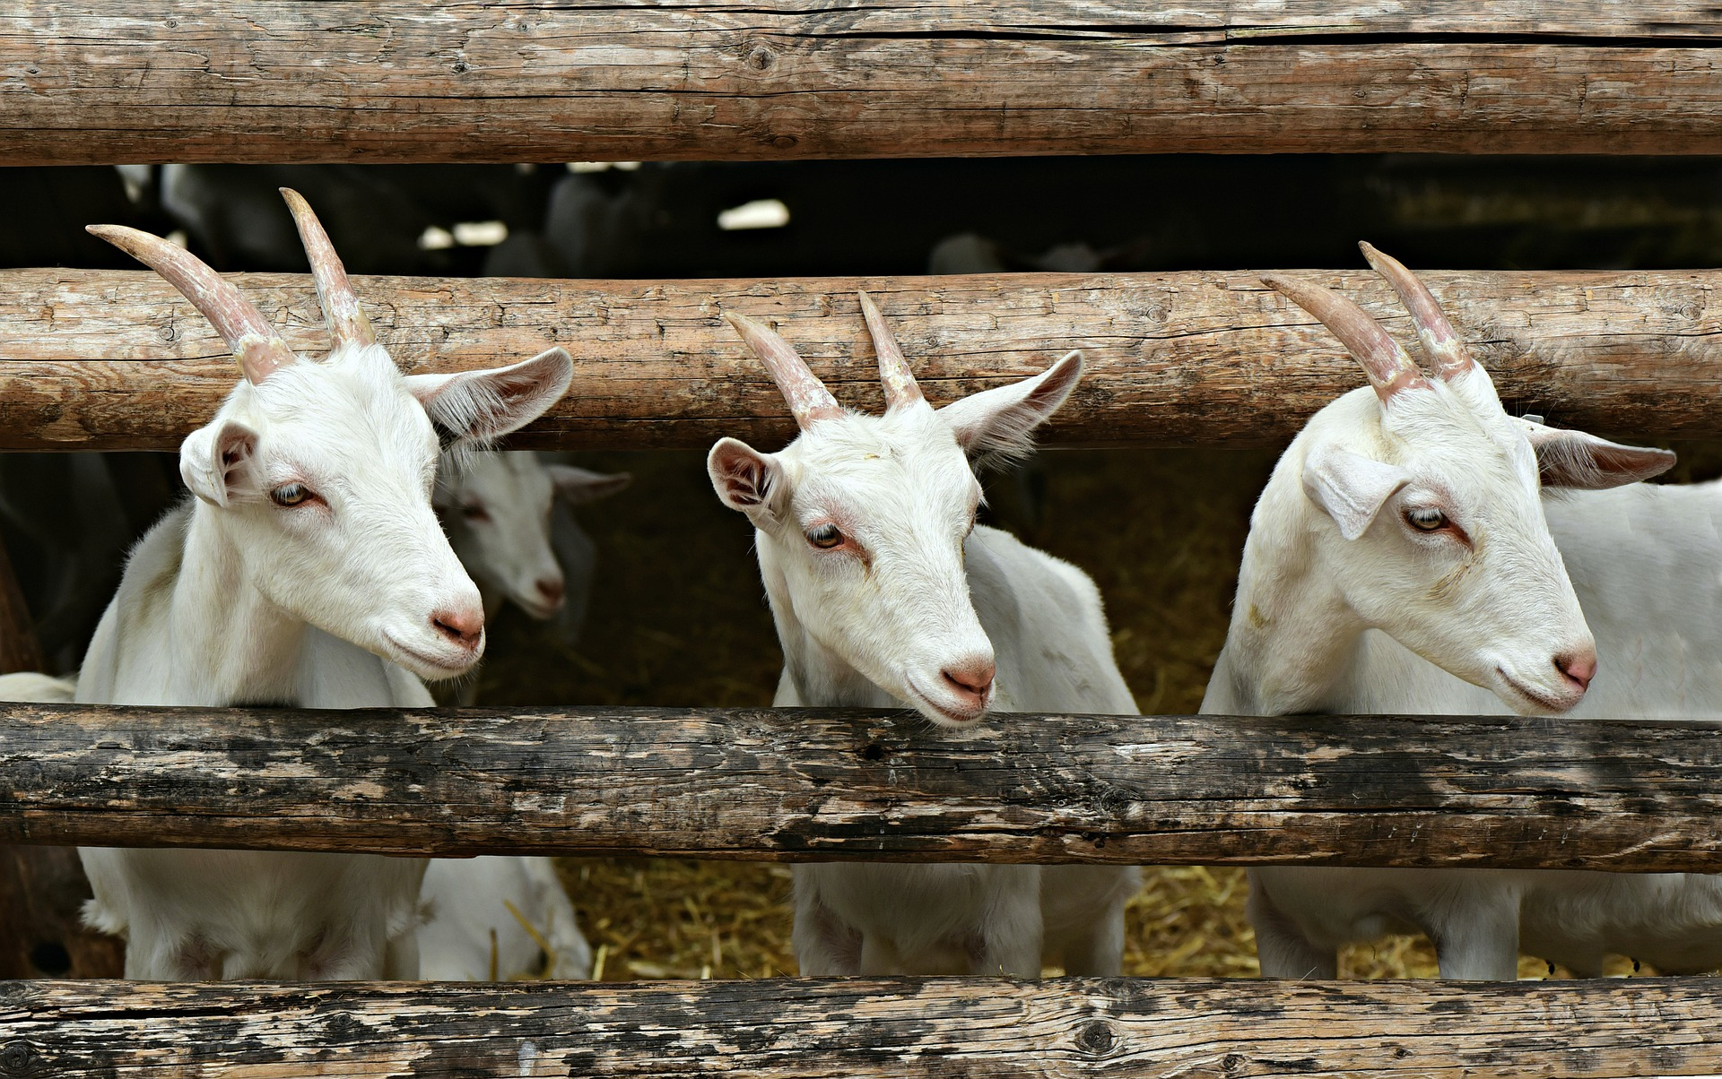
© CC BY 2021 Illustrative Mathematics®

