Unit 2 Lesson 9: Add and Subtract Within 100

WU Which One Doesn’t Belong: Tens and Ones (Warm up)

Student Task Statement
Which one doesn’t belong?
A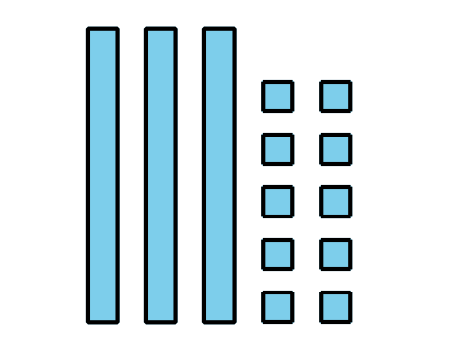
B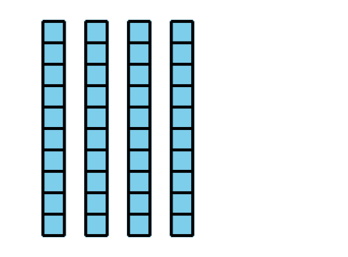
C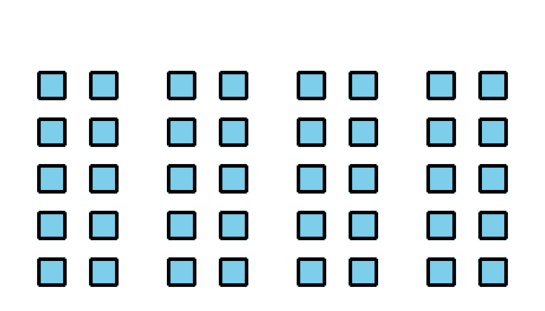
D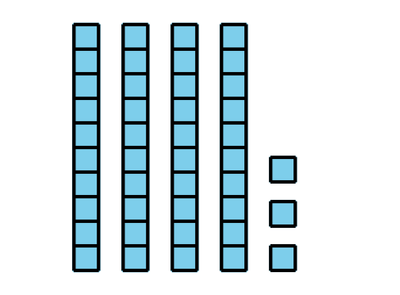

1 Sort and Find the Value

Student Task Statement
- Match each expression to a base-ten diagram.
- Choose 1 addition expression and find the value of the sum.
- Choose 1 subtraction expression and find value of the difference.

2 Add or Subtract

Student Task Statement
Find the value of each expression. Show your thinking. Use blocks if it helps.
- $27+47$
- $55−27$
- $36+38$
- $82−39$
© CC BY 2021 Illustrative Mathematics®

