Lesson 6: Different Square Units (Part 1)

Standards Alignments
Addressing | 3.MD.C.6

Teacher-facing Learning Goals
- Describe square units based on different linear units of measurement.
- Use square inches and square centimeters to measure the area of a rectangle.

Student-facing Learning Goals
- Let’s learn about different units we can use to measure area.

Lesson Purpose
The purpose of this lesson is for students to learn that there are different units that can be used to measure area, specifically square centimeters and square inches.
In previous lessons, students learned the meaning of area and measured area in square units. In this lesson, students work with standard units of area, based on linear measurement units they worked with in grade 2. Students consider the difference in size between the same amount of square inches and square centimeters, then they measure the area of a rectangle with both square inches and square centimeters.

Access for:

Students with Disabilities
- Action and Expression (Activity 2)

English Learners
- MLR8 (Activity 1)

Instructional Routines
MLR2 Collect and Display (Activity 2), Notice and Wonder (Warm-up)

Materials to Gather
- Patty paper: Activity 2
- Rulers (whole units): Activity 1
- Scissors: Activity 2

Materials to Copy
- Same Rectangle, Different Units (groups of 2): Activity 1
- Same Rectangle, Different Units (groups of 2): Activity 2

Lesson Timeline
Warm-up | 10 min
Activity 1 | 15 min
Activity 2 | 20 min
Lesson Synthesis | 10 min
Cool-down | 5 min

Teacher Reflection Question
What question do you wish you had asked today? When and why should you have asked it?

Cool-down
(to be completed at the end of the lesson) 5min
Which Square?

Standards Alignments
Addressing | 3.MD.C.6

Student-facing Task Statement
Here is a rectangle.
Here are 2 different squares you could use to tile.
A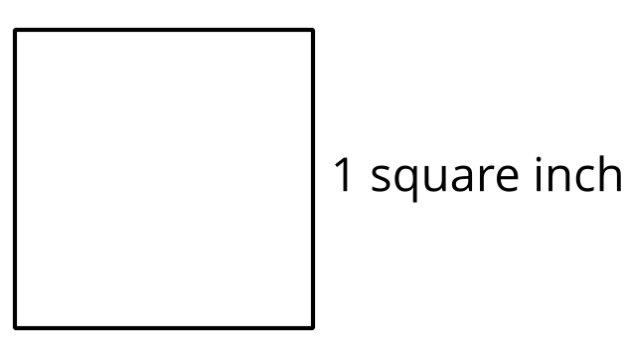
B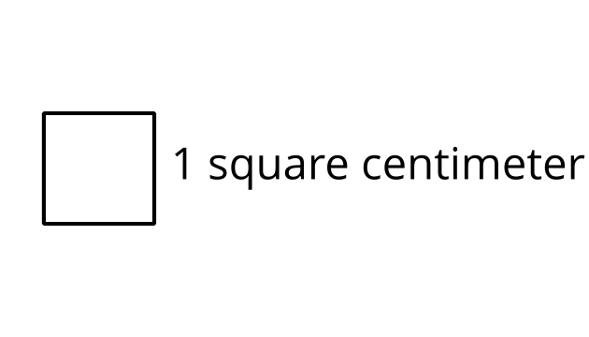
Which square would allow you to tile the rectangle with the fewest number of squares? Explain your reasoning.

Student Responses
Sample response: A, because it’s larger than B, so it wouldn’t take as many squares to fill the rectangle as with B.

