Unit 5 Lesson 12: Hours, Minutes, and Seconds

WU What Do You Know about 1 Hour? (Warm up)

Student Task Statement
What do you know about 1 hour?

1 Mai’s School Day

Student Task Statement
The table shows how Mai spends the time she is awake on a school day.
activity | hours | minutes
morning routine | 1
getting to school | $\frac{1}{2}$
time at school | 8
getting home from school | $\frac{3}{4}$
homework and reading | $1\frac{1}{2}$
playing and family time | 2
bedtime routine | $\frac{1}{4}$
- Complete the table to show how many minutes Mai spends on each activity. Be prepared to explain or show your reasoning.
- How many hours does Mai spend at school? How many minutes is that? Explain or show how you know.
- How many minutes does Mai sleep on a school night? Explain or show your reasoning.

2 Precious Minutes and Seconds

Student Task Statement
Diego set a timer to make sure that things are not done for too long or too short an amount of time.
activity | minutes | seconds
brushing teeth | 2
showering | 3
heating a cup of milk in the microwave | $\frac{1}{2}$
break during homework time | 5
quick workout | 10
daily reading | 30
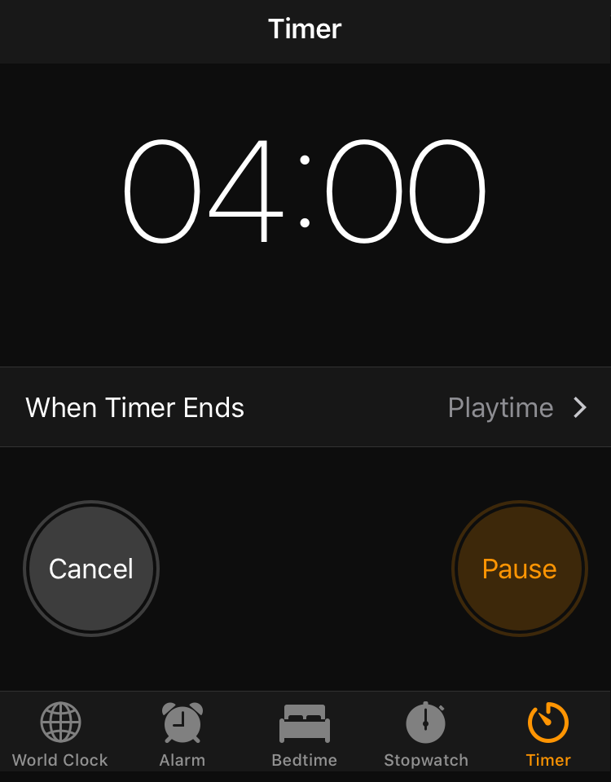
- Complete the table with the number of seconds for each activity. Be prepared to explain your reasoning.
- Diego noticed that on a television channel, commercial breaks are often between $1\frac{1}{2}$ and $2\frac{1}{2}$ minutes long each. How long are they in seconds? Explain or show your reasoning.
- Diego’s workout starts with 4 minutes of warm-up and stretching, followed by 100 seconds of jumping jacks.
- If he works out for 10 minutes exactly, how many more seconds are left in his workout?
© CC BY 2021 Illustrative Mathematics®

