Lesson 18: Divide with Partial Quotients

Standards Alignments
Addressing | 4.NBT.B.6, 4.OA.A.3

Teacher-facing Learning Goals
- Analyze ways of using and recording partial quotients to divide multi-digit numbers.

Student-facing Learning Goals
- Let’s analyze and use an algorithm that uses partial quotients.

Lesson Purpose
The purpose of this lesson is to introduce students to ways to record partial quotients when dividing multi-digit numbers.
Previously, students have found quotients by decomposing a dividend and finding the quotient for each decomposed part until all of the dividend is divided. They have also reasoned in terms of multiplication—adding partial products until they reach the value of the dividend—and in terms of place value. They have also used area diagrams and base-ten diagrams—among other representations—to support their reasoning.
In this lesson, students use partial quotients and a couple of ways to record them systematically—by writing a series of equations, and by using an algorithm that uses partial quotients.

Access for:

Students with Disabilities
- Action and Expression (Activity 2)

English Learners
- MLR8 (Activity 1)

Instructional Routines
Number Talk (Warm-up)

Materials to Gather
- Base-ten blocks: Activity 1

Lesson Timeline
Warm-up | 10 min
Activity 1 | 20 min
Activity 2 | 15 min
Lesson Synthesis | 10 min
Cool-down | 5 min

Teacher Reflection Question
Today’s lesson encouraged small-group collaboration. How did students interact with each other’s ideas today in the work? Who was heard in their group? Who was not heard? How can you ensure in future small-group collaborations that all student’s voices are heard?

Cool-down
(to be completed at the end of the lesson) 5min
Subtract Groups

Standards Alignments
Addressing | 4.NBT.B.6

Student-facing Task Statement
Priya and Tyler use different methods to find $430÷5$. Their work is incomplete. Complete Priya’s and Tyler’s work.
Priya's work
300÷5=100÷5=30÷5= 430÷5¯ =000000¯
Tyler's work
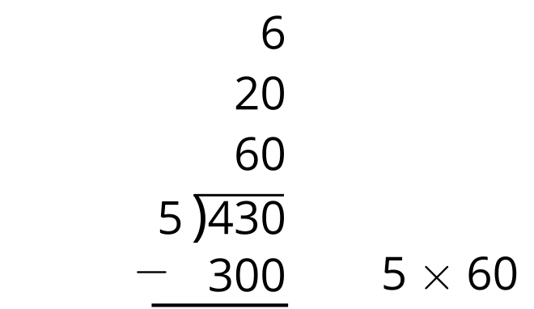
What is the value of $430÷5$?

Student Responses
86. Sample reasoning: 300 is 60 groups of 5, 100 is 20 groups of 5, and 30 is 6 groups of 5. Adding the groups of 5—the 60, 20, and 6—gives the quotient.
Priya's work
300÷5=60100÷5=2030÷5=6 430÷5¯ =86000000¯
Tyler's work
