Unit 8 Lesson 9: Symmetry in Action

WU Which One Doesn’t Belong: Figures (Warm up)

Student Task Statement
Which one doesn’t belong?
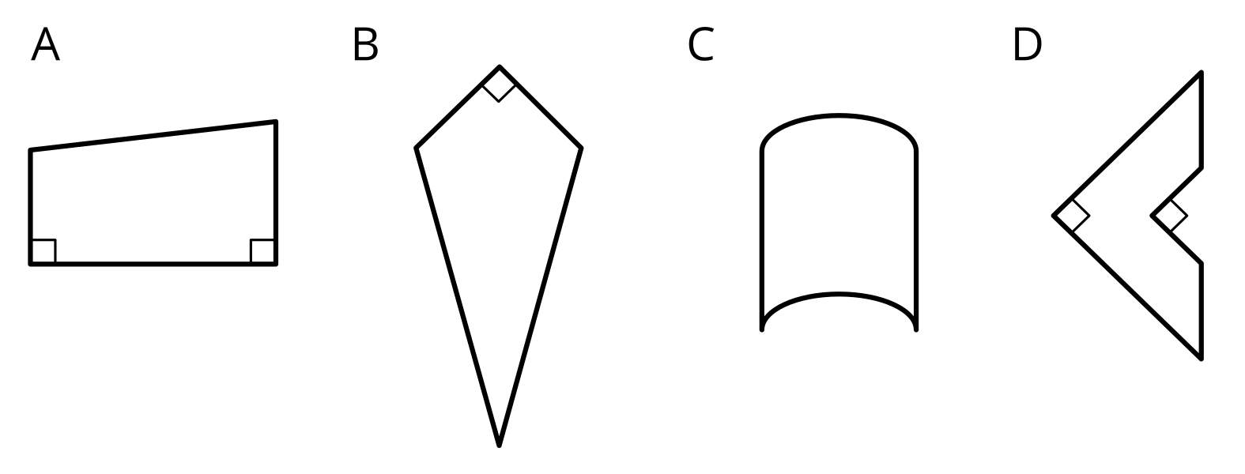

1 Before and After

Student Task Statement
- Mai has a piece of paper. She can get two different shapes by folding the paper along a line of symmetry. What is the shape of the paper before it was folded?
- 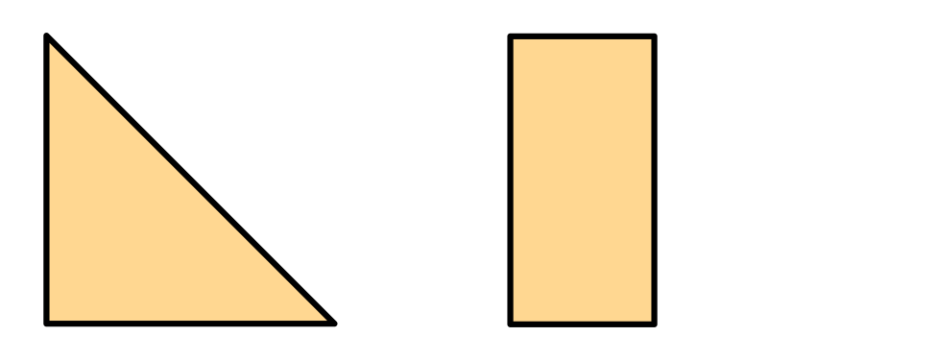
- Diego folded a piece of paper once along a line of symmetry and got this right triangle.
- Which shapes could the paper have before it was folded? Explain or show how you know.
- 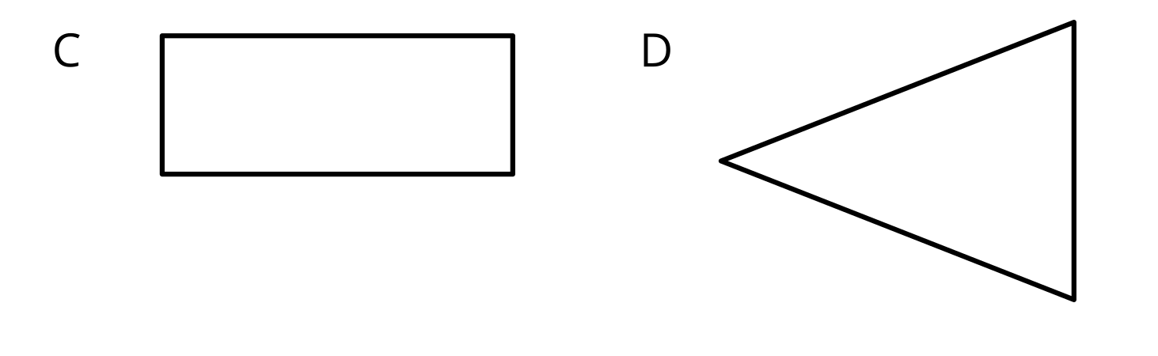
- 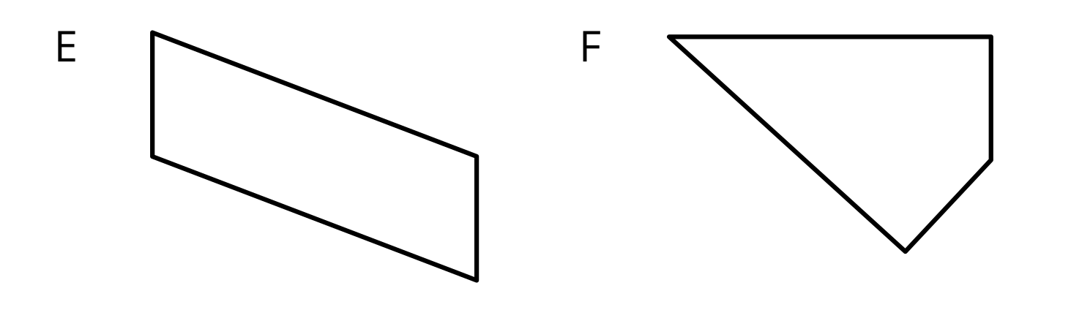

2 Before and After, Perimeter Edition

Student Task Statement
- Jada folded a piece of paper along a line of symmetry and got this rectangle.
- 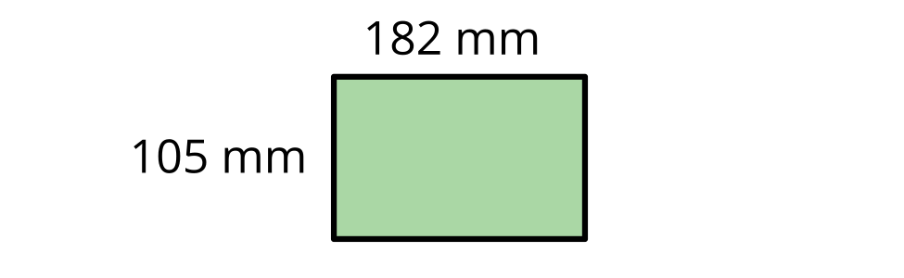
  - What could the paper look like before being folded? Draw one or more sketches.
  - Write an expression for the perimeter of the unfolded paper.
- Kiran folded a piece of paper twice—each time along a line of symmetry—and got the same rectangle as Jada did.
- Show that each expression could represent the perimeter of the paper Kiran folded.
  - $\left(4×182\right)+\left(4×105\right)$
  - $\left(2×182\right)+\left(8×105\right)$
  - $\left(8×182\right)+\left(2×105\right)$

Images for Activity Synthesis
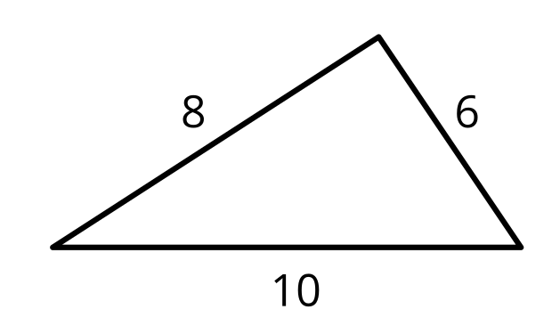
© CC BY 2021 Illustrative Mathematics®

