Unit 1 Lesson 12 Cumulative Practice Problems
- What is the surface area of this rectangular prism?
- 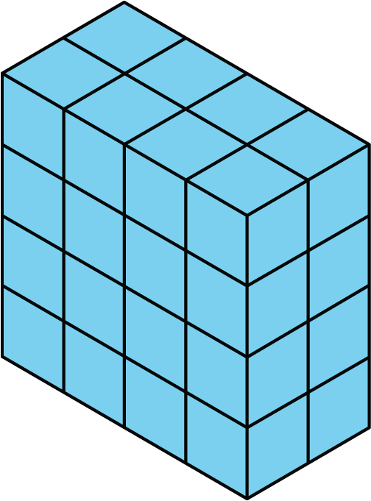
  - 16 square units
  - 32 square units
  - 48 square units
  - 64 square units
- Which description can represent the surface area of this trunk?
- 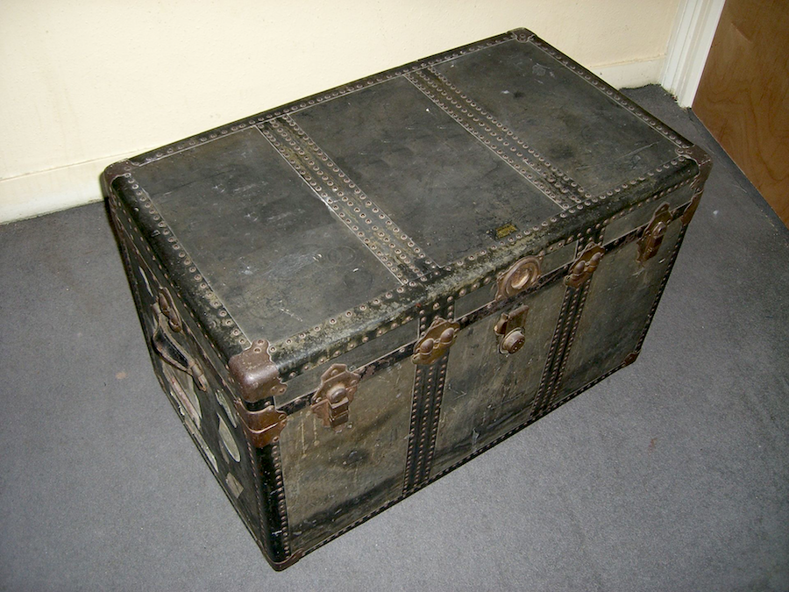
  - The number of square inches that cover the top of the trunk.
  - The number of square feet that cover all the outside faces of the trunk.
  - The number of square inches of horizontal surface inside the trunk.
  - The number of cubic feet that can be packed inside the trunk.
- Which figure has a greater surface area?
- 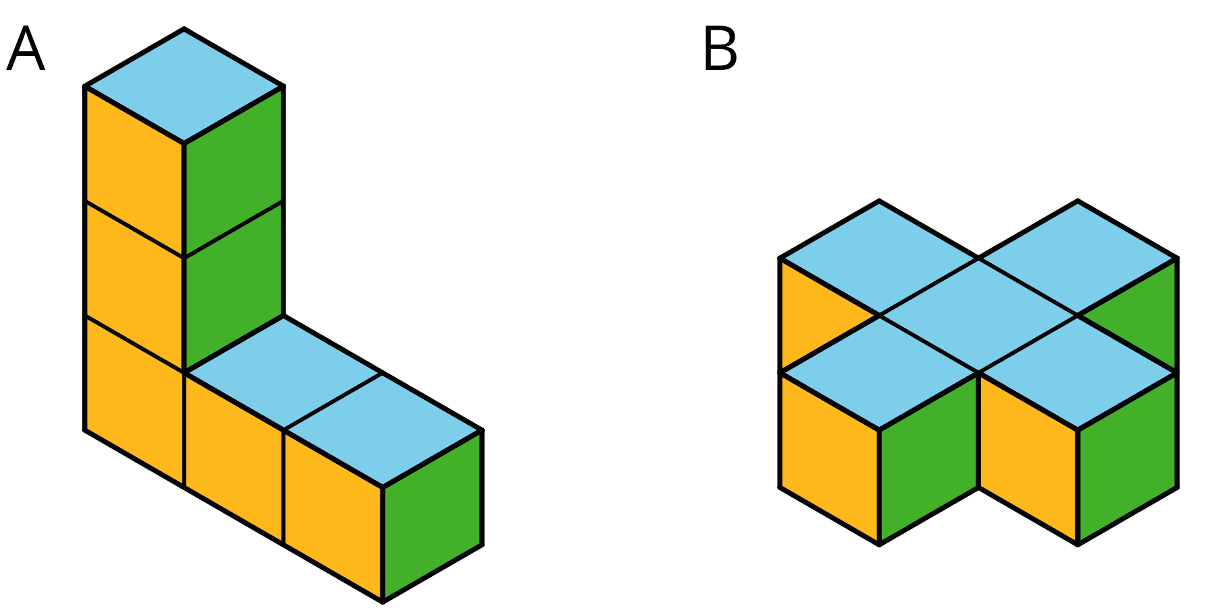
- A rectangular prism is 4 units high, 2 units wide, and 6 units long. What is its surface area in square units? Explain or show your reasoning.
- Draw an example of each of these triangles on the grid.
  - A right triangle with an area of 6 square units.
  - An acute triangle with an area of 6 square units.
  - An obtuse triangle with an area of 6 square units.
- (From Unit 1, Lesson 9.)
- Find the area of triangle $MOQ$ in square units. Show your reasoning.
- 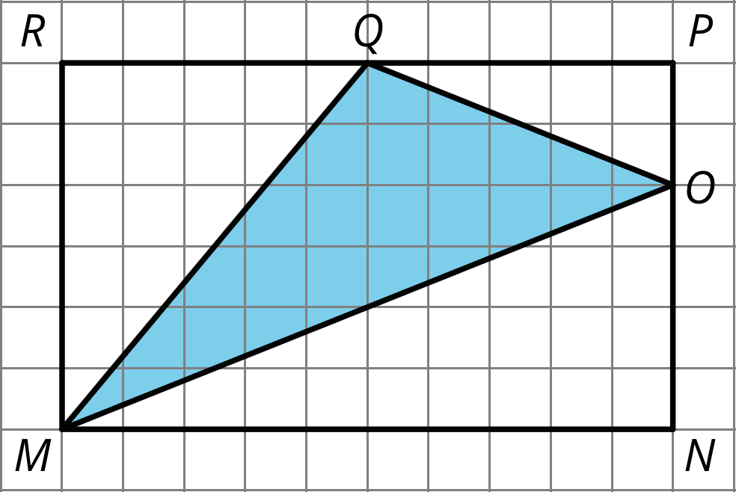

- (From Unit 1, Lesson 10.)
- Find the area of this shape. Show your reasoning.
- 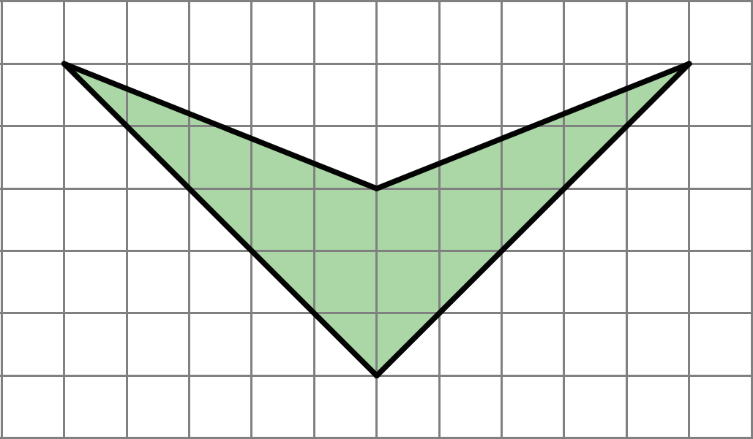
- (From Unit 1, Lesson 3.)
© CC BY Open Up Resources. Adaptations CC BY IM.

