Unit 5 Lesson 5: Put Together

WU Notice and Wonder: Numberless Story Problem (Warm up)

Student Task Statement
What do you notice?
What do you wonder?
Elena was shopping at the market with her grandfather.
Elena chose some mangoes.
Her grandfather chose some pineapples.
How many pieces of fruit did they choose?

1 Fruit at the Market

Student Task Statement
Elena was shopping at the market with her grandfather.
Elena chose 4 mangoes.
Her grandfather chose 2 pineapples.
How many pieces of fruit did they choose?
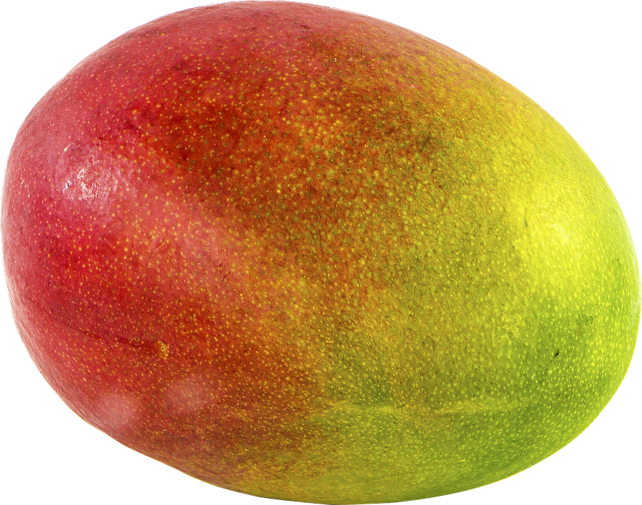
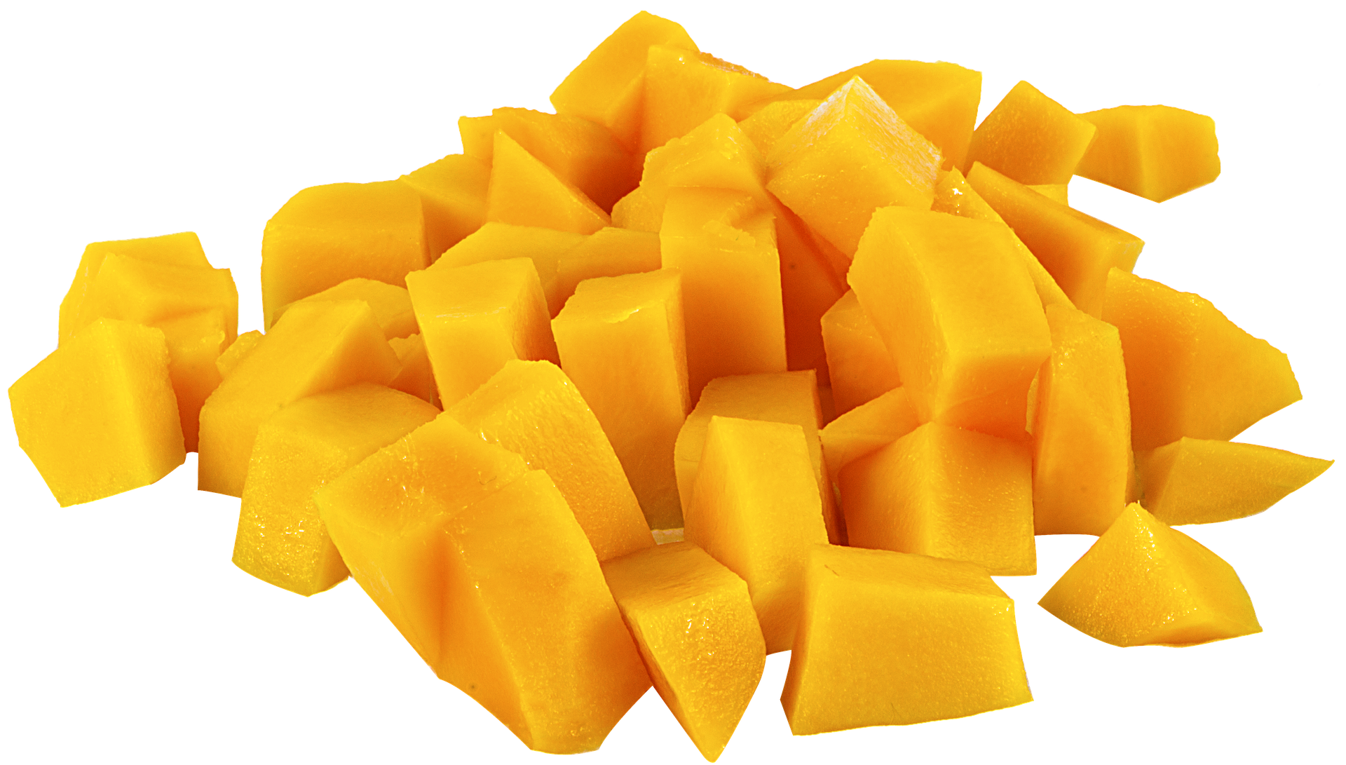
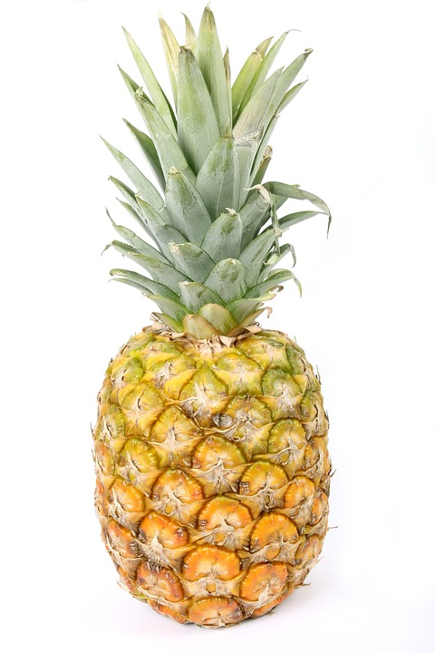

2 A Bear with Berries

Student Task Statement
A bear was searching for berries to eat in the forest.
He ate 3 blueberries.
He ate 6 raspberries.
How many berries did the bear eat?
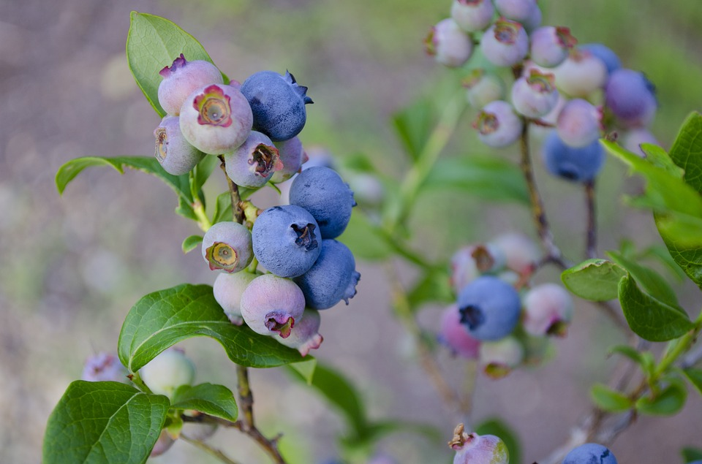
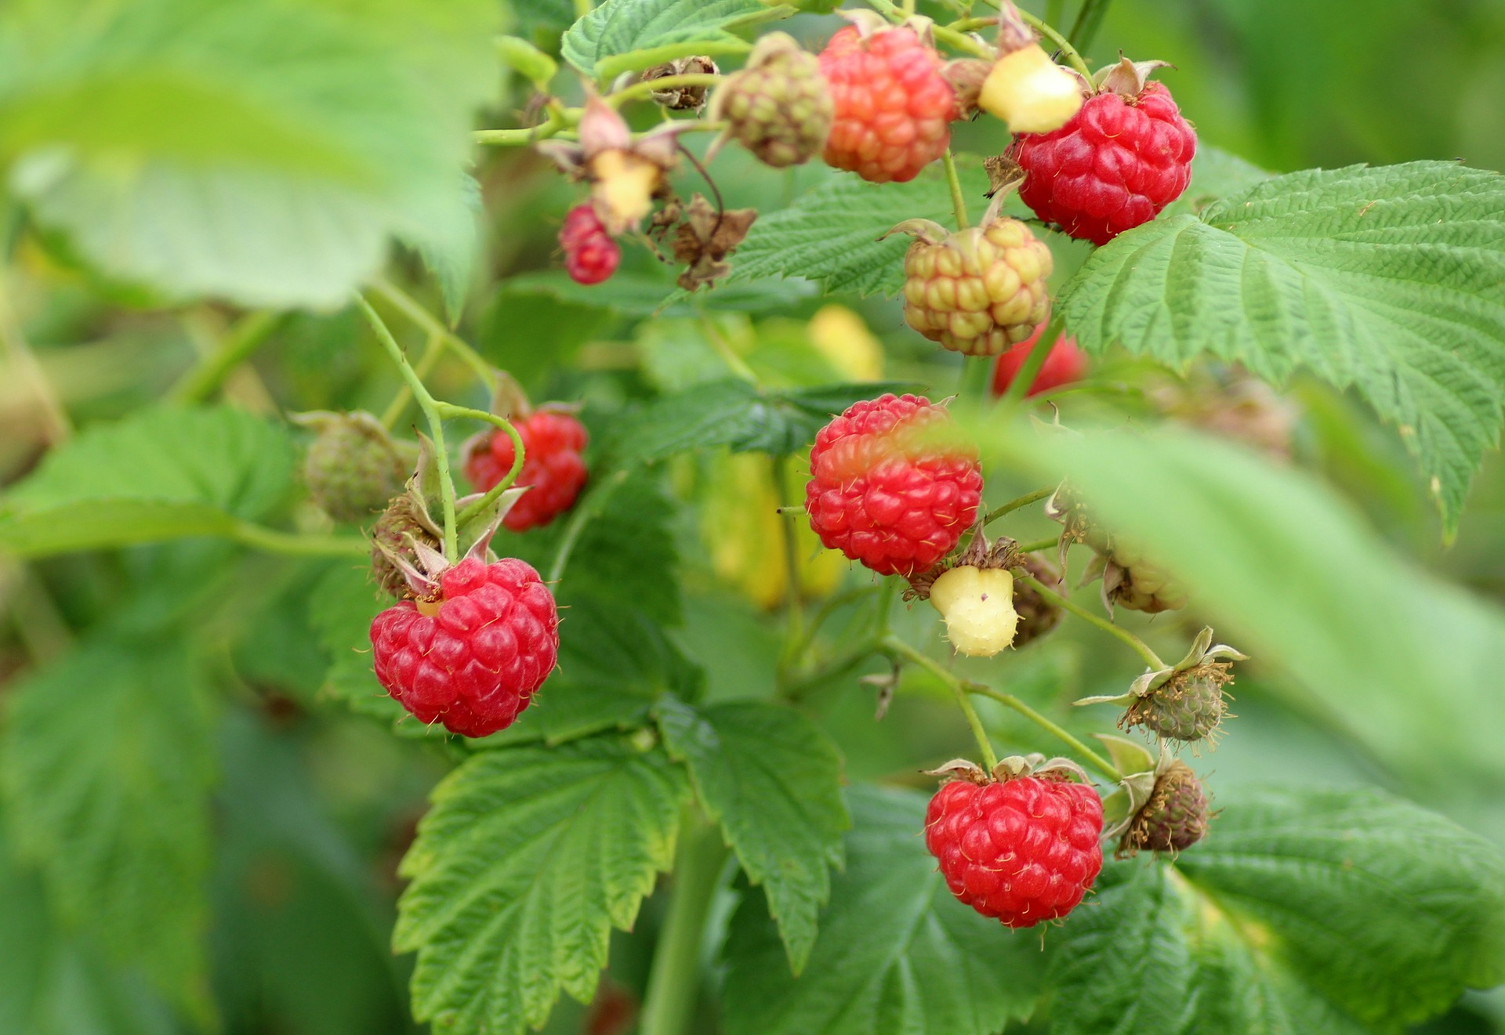

3 Introduce Make or Break Apart Numbers, Numbers to 9

Student Task Statement
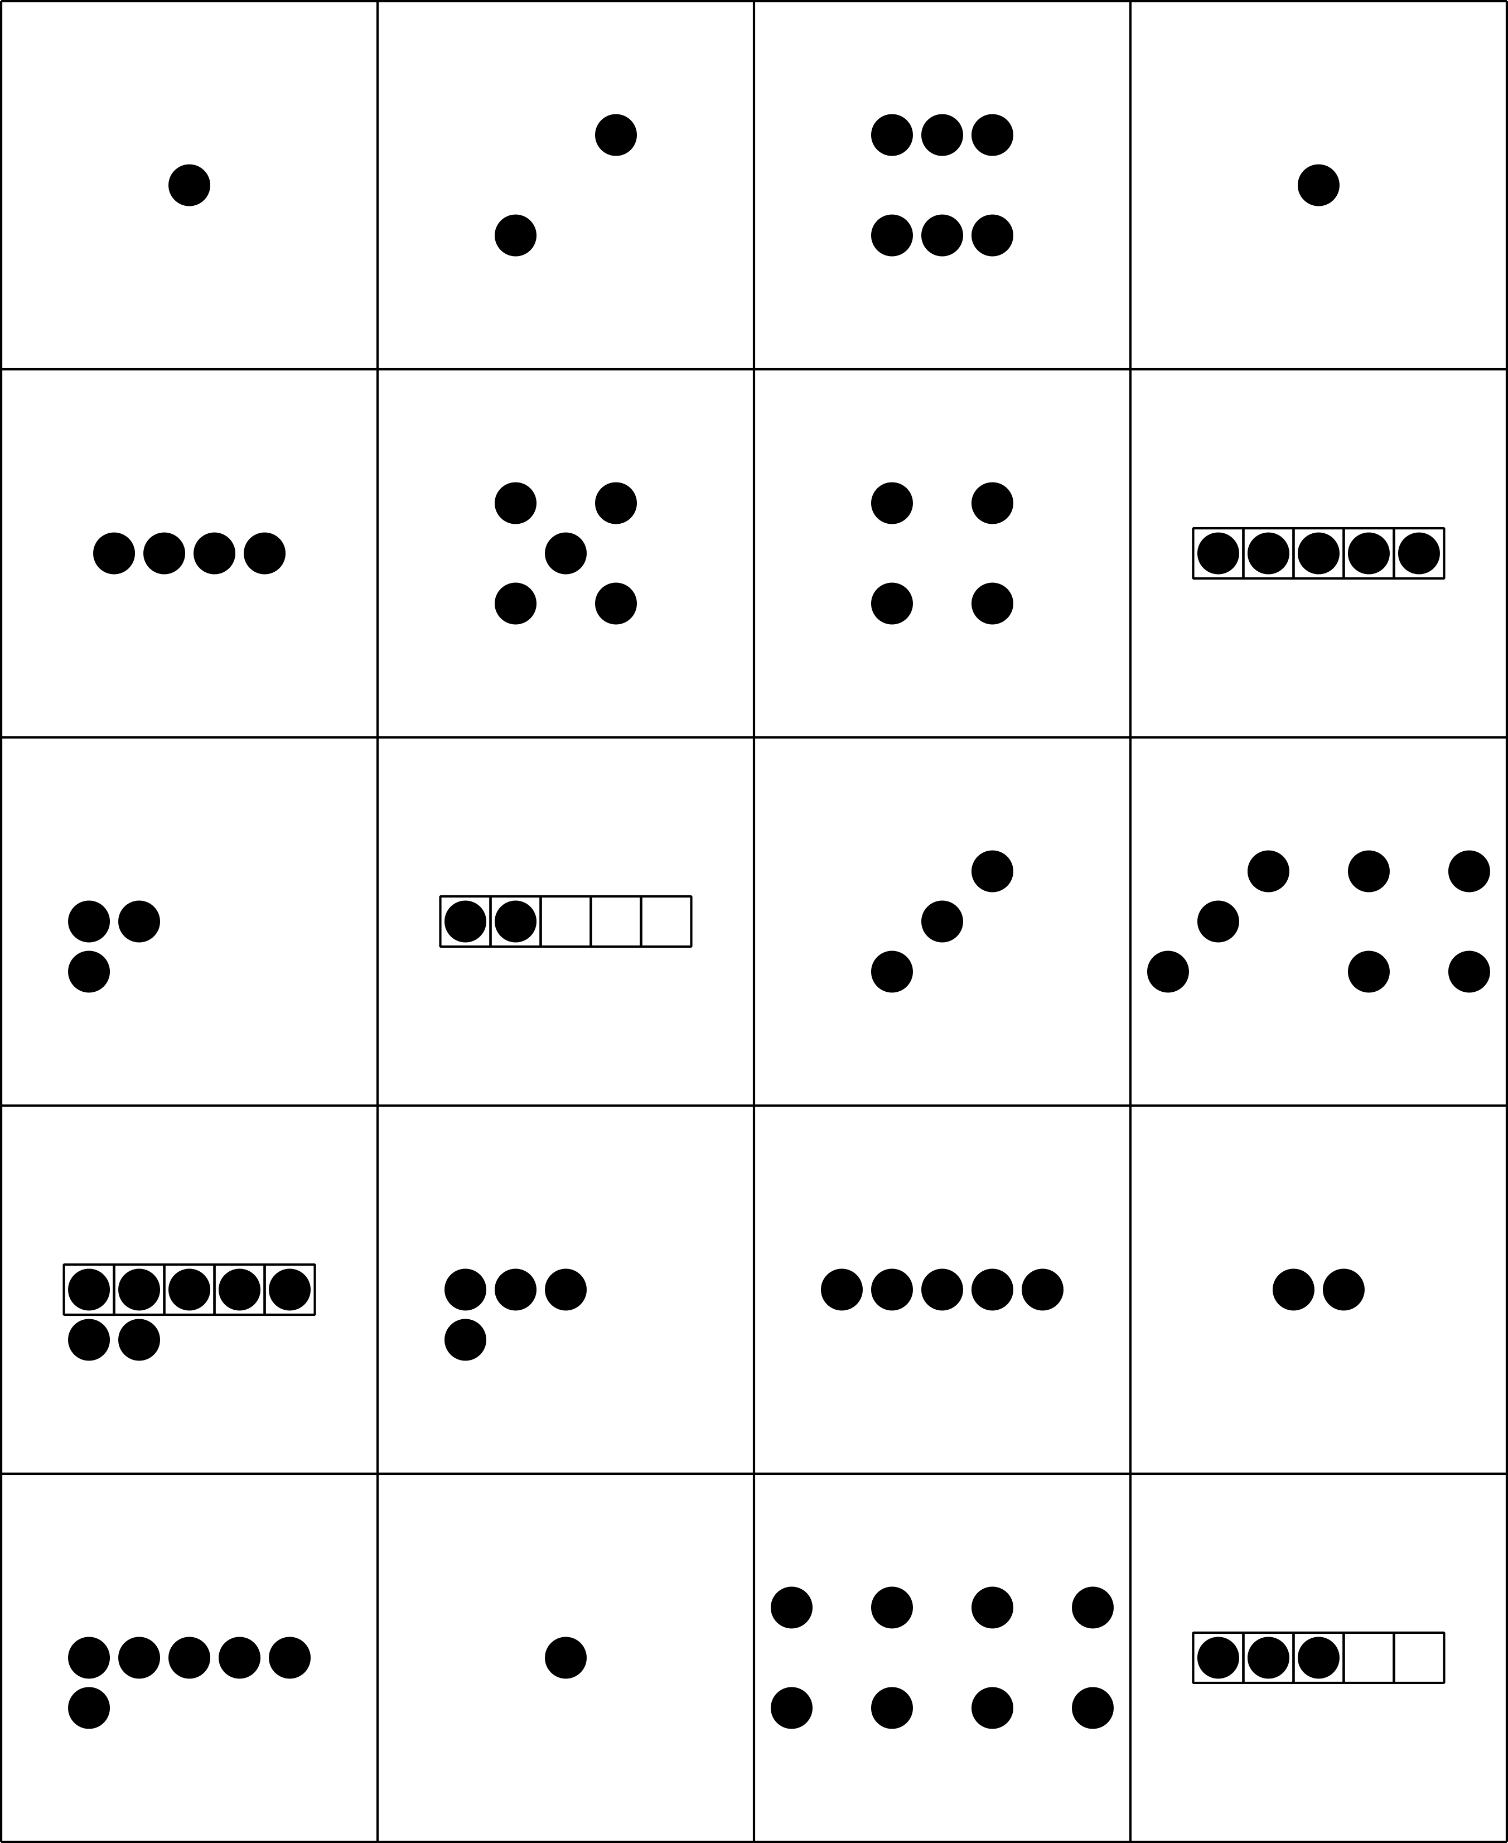
Choose a center.
What’s Behind My Back?
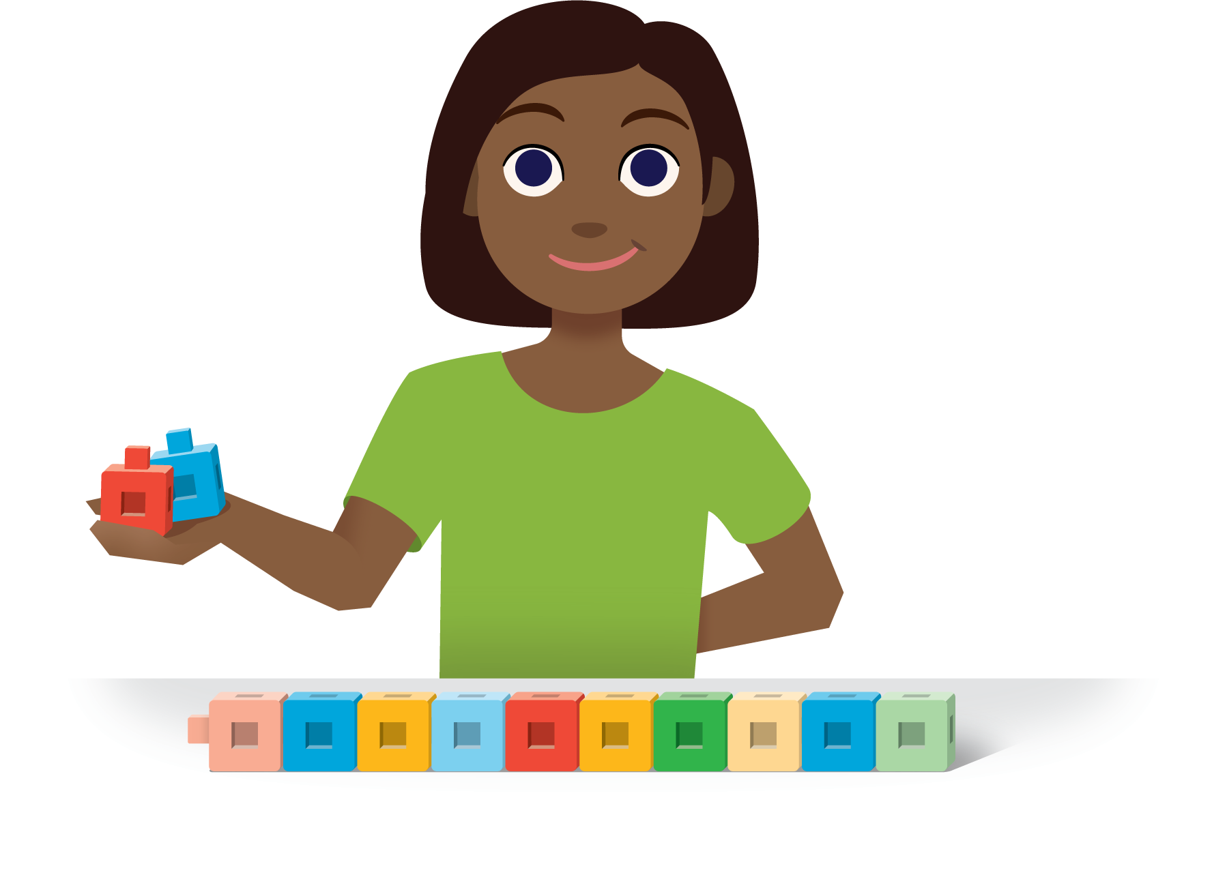
5-frames
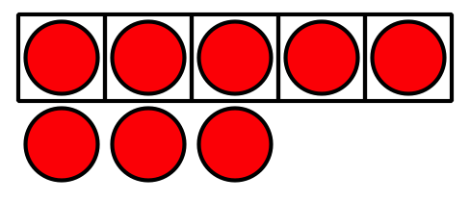
Make or Break Apart Numbers
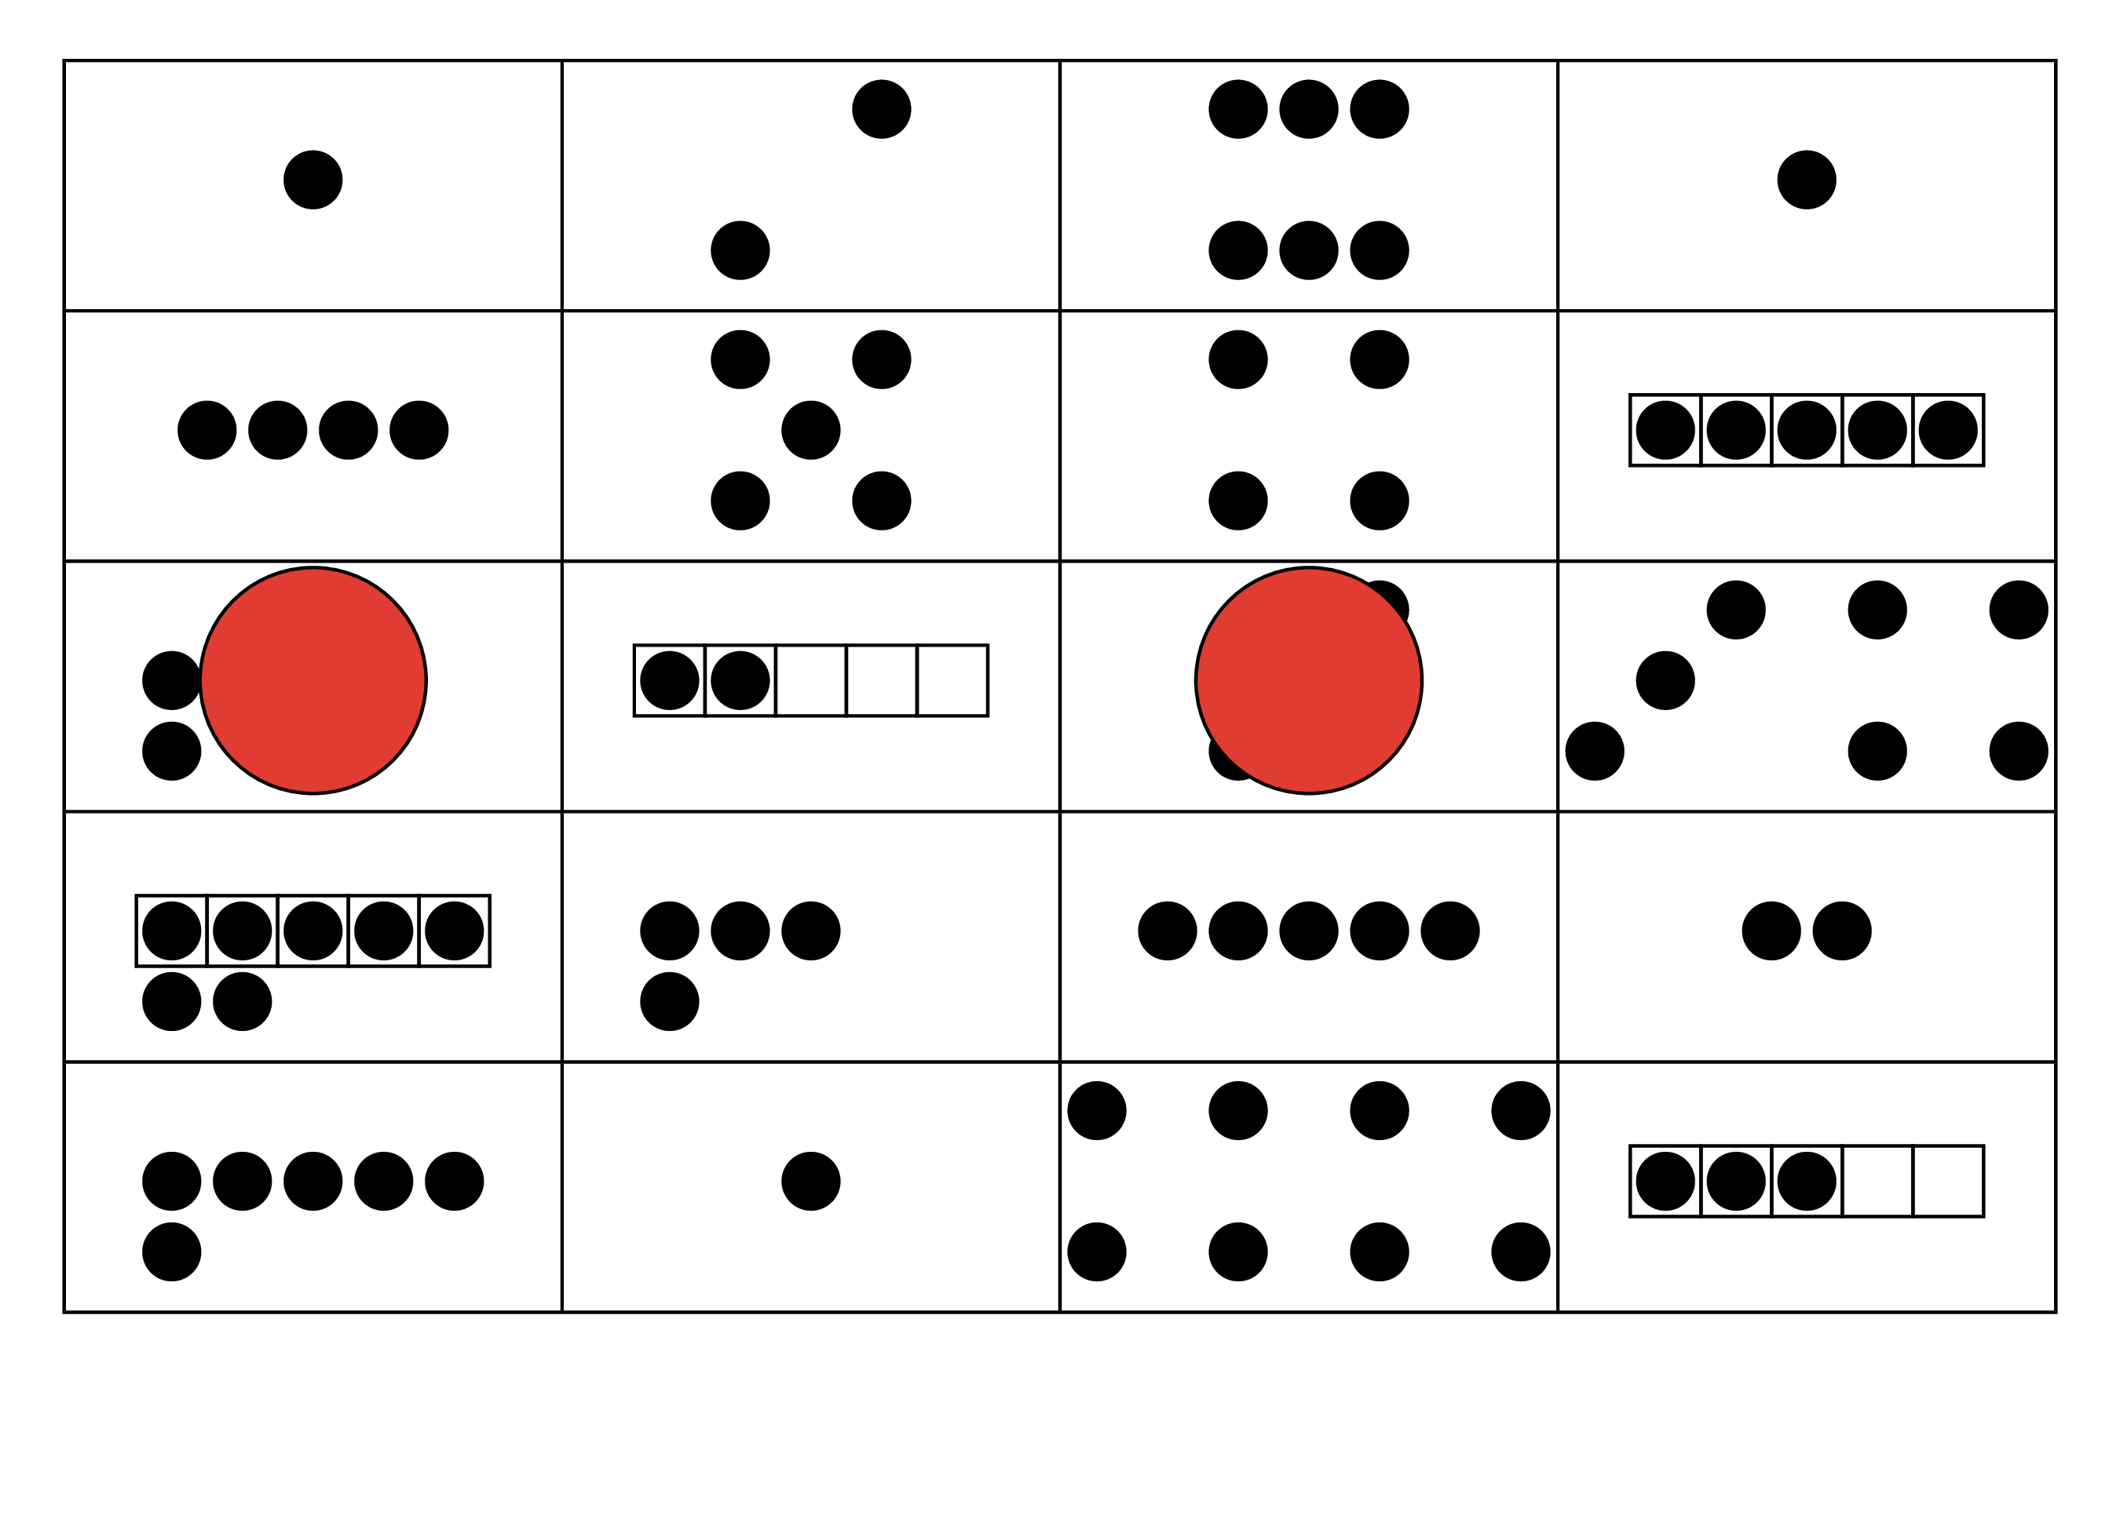
© CC BY 2021 Illustrative Mathematics®

