Unit 7 Lesson 10: Identify and Describe Solid Shapes

WU Number Talk: Add within 5 (Warm up)

Student Task Statement
Find the value of each expression.
- 2 + 3
- 3 + 2
- 4 + 1
- 5 + 0

1 Make Solid Shapes

Student Task Statement

2 Introduce Geoblocks, Describe and Find

Student Task Statement

3 Centers: Choice Time

Student Task Statement
Choose a center.
Geoblocks
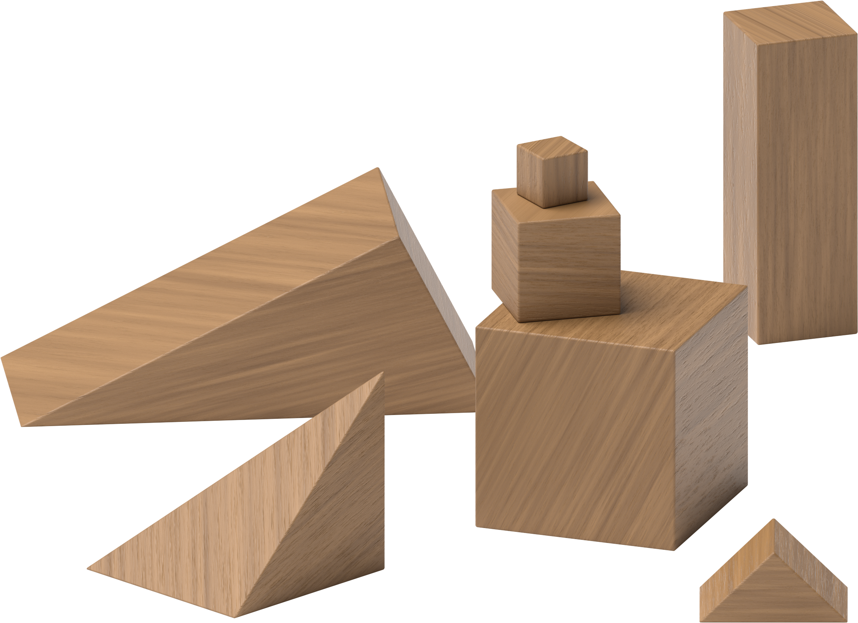
Counting Collections
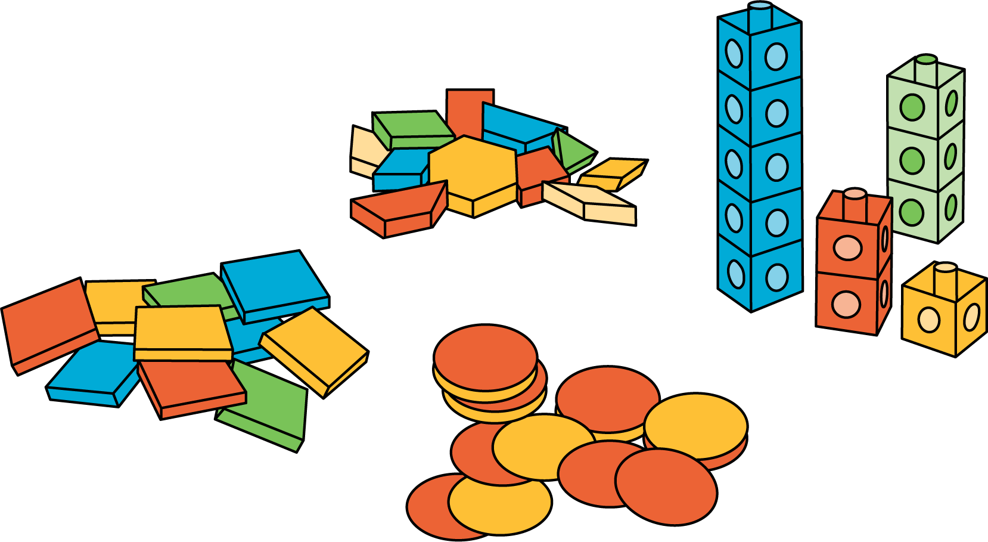
Match Mine
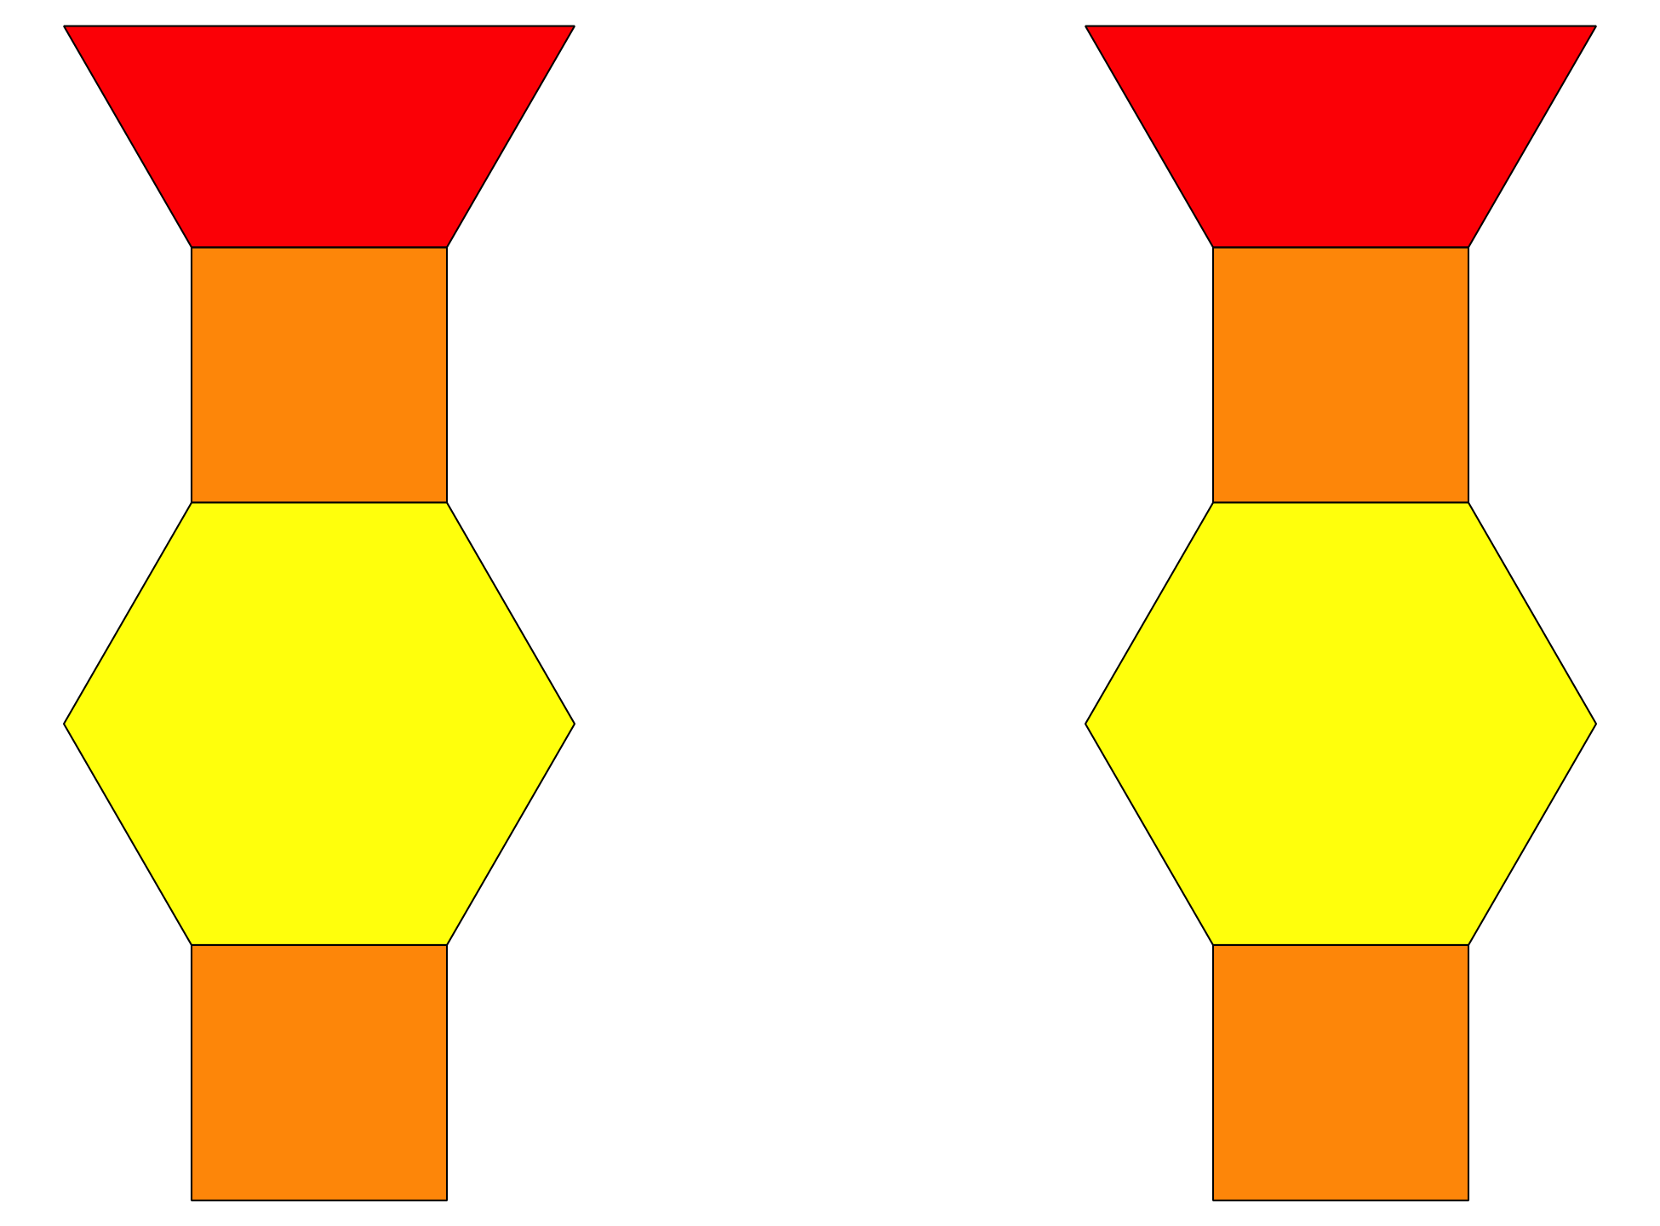
Shake and Spill
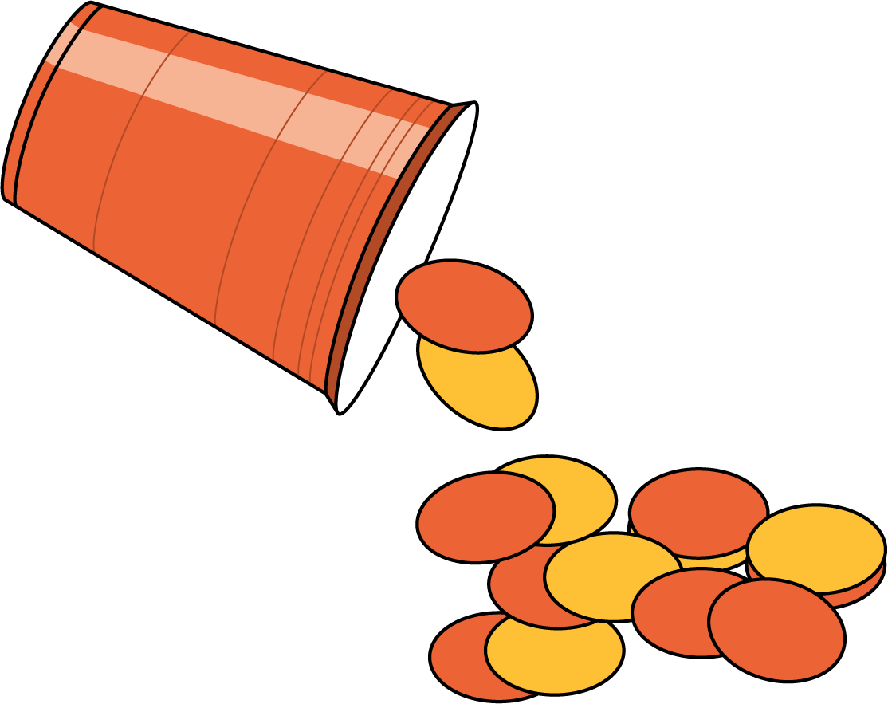
© CC BY 2021 Illustrative Mathematics®

