Lesson 5: Put Together
- Let’s show what happens in a story problem and solve it.

Warm-up: Notice and Wonder: Numberless Story Problem
What do you notice?
What do you wonder?
Elena was shopping at the market with her grandfather.
Elena chose some mangoes.
Her grandfather chose some pineapples.
How many pieces of fruit did they choose?

5.1: Fruit at the Market
Elena was shopping at the market with her grandfather.
Elena chose 4 mangoes.
Her grandfather chose 2 pineapples.
How many pieces of fruit did they choose?
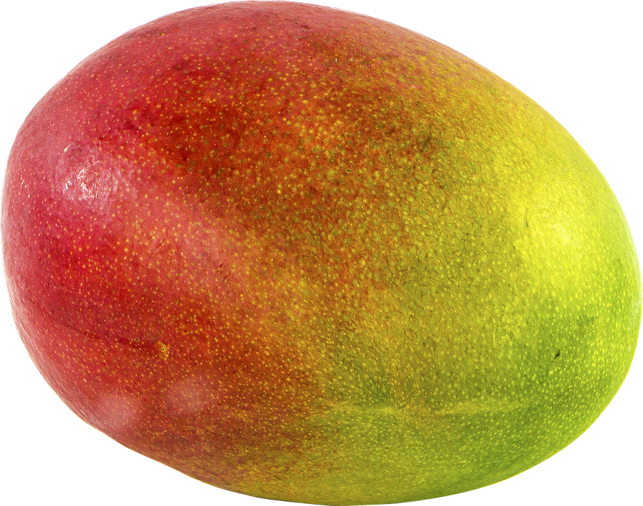
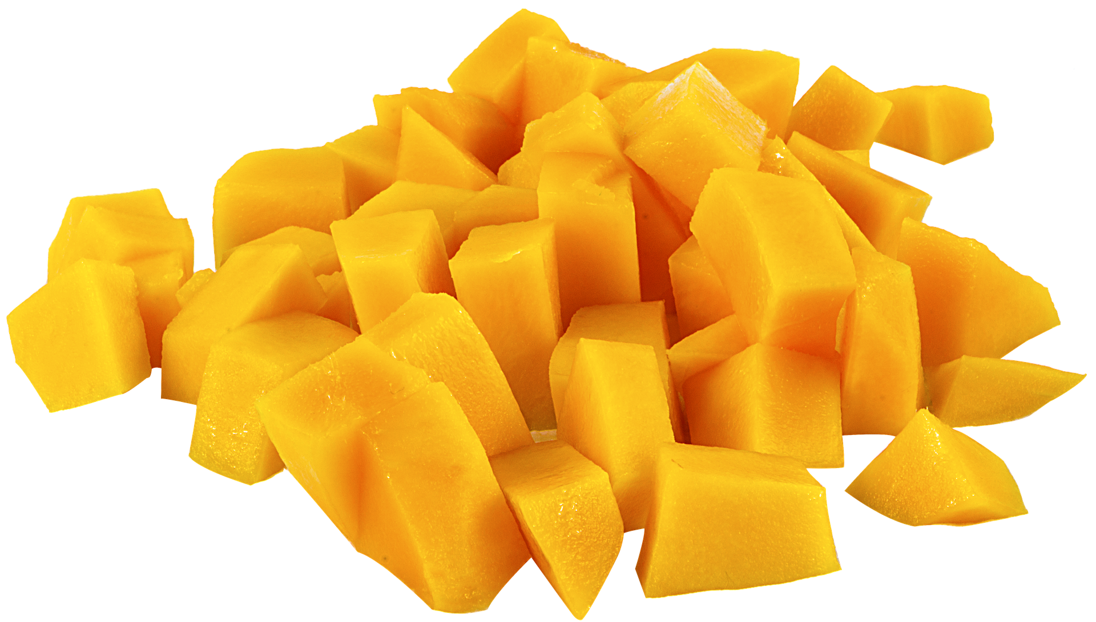
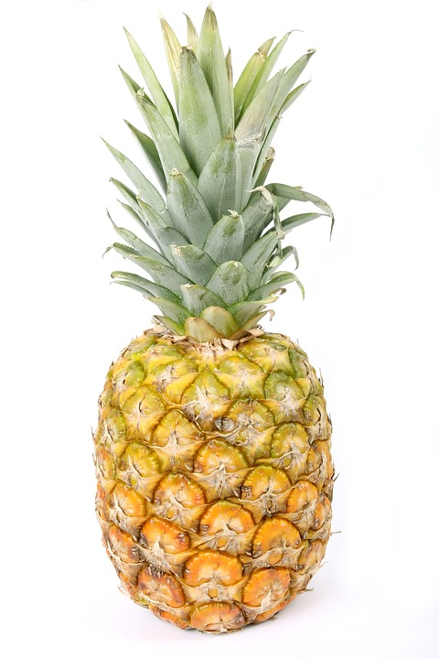

5.2: A Bear with Berries
A bear was searching for berries to eat in the forest.
He ate 3 blueberries.
He ate 6 raspberries.
How many berries did the bear eat?
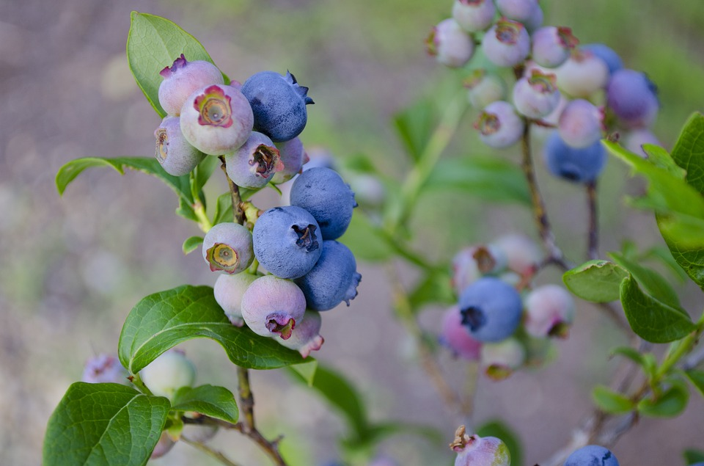
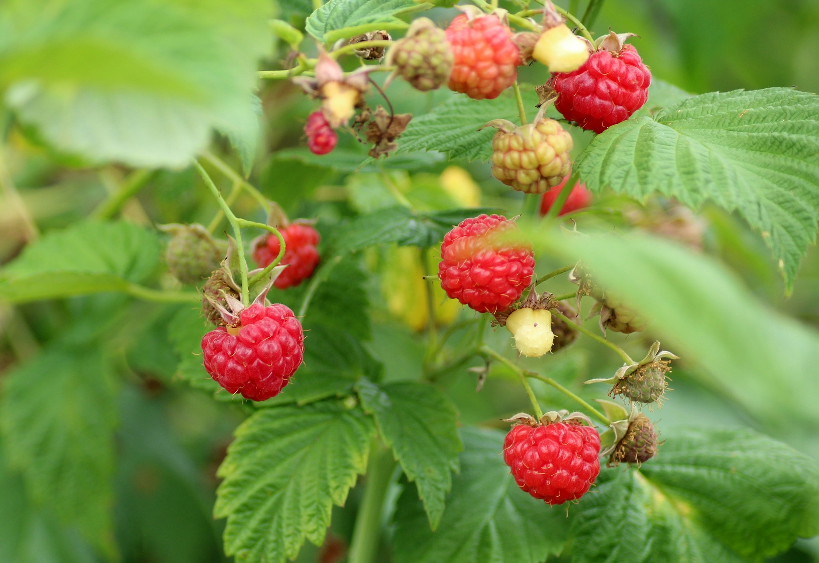

5.3: Introduce Make or Break Apart Numbers, Numbers to 9
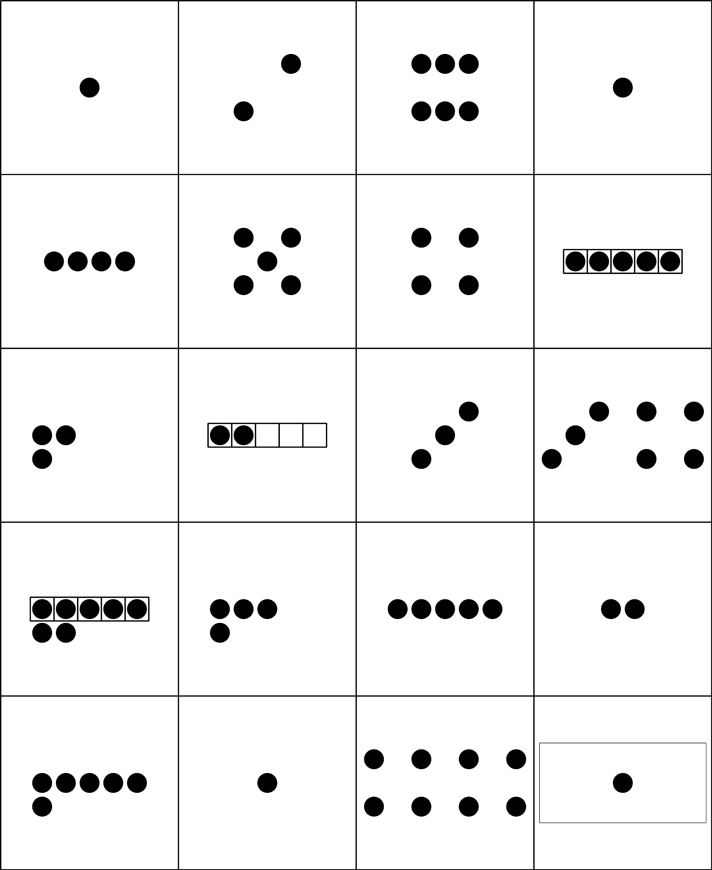
Choose a center.
What’s Behind My Back?
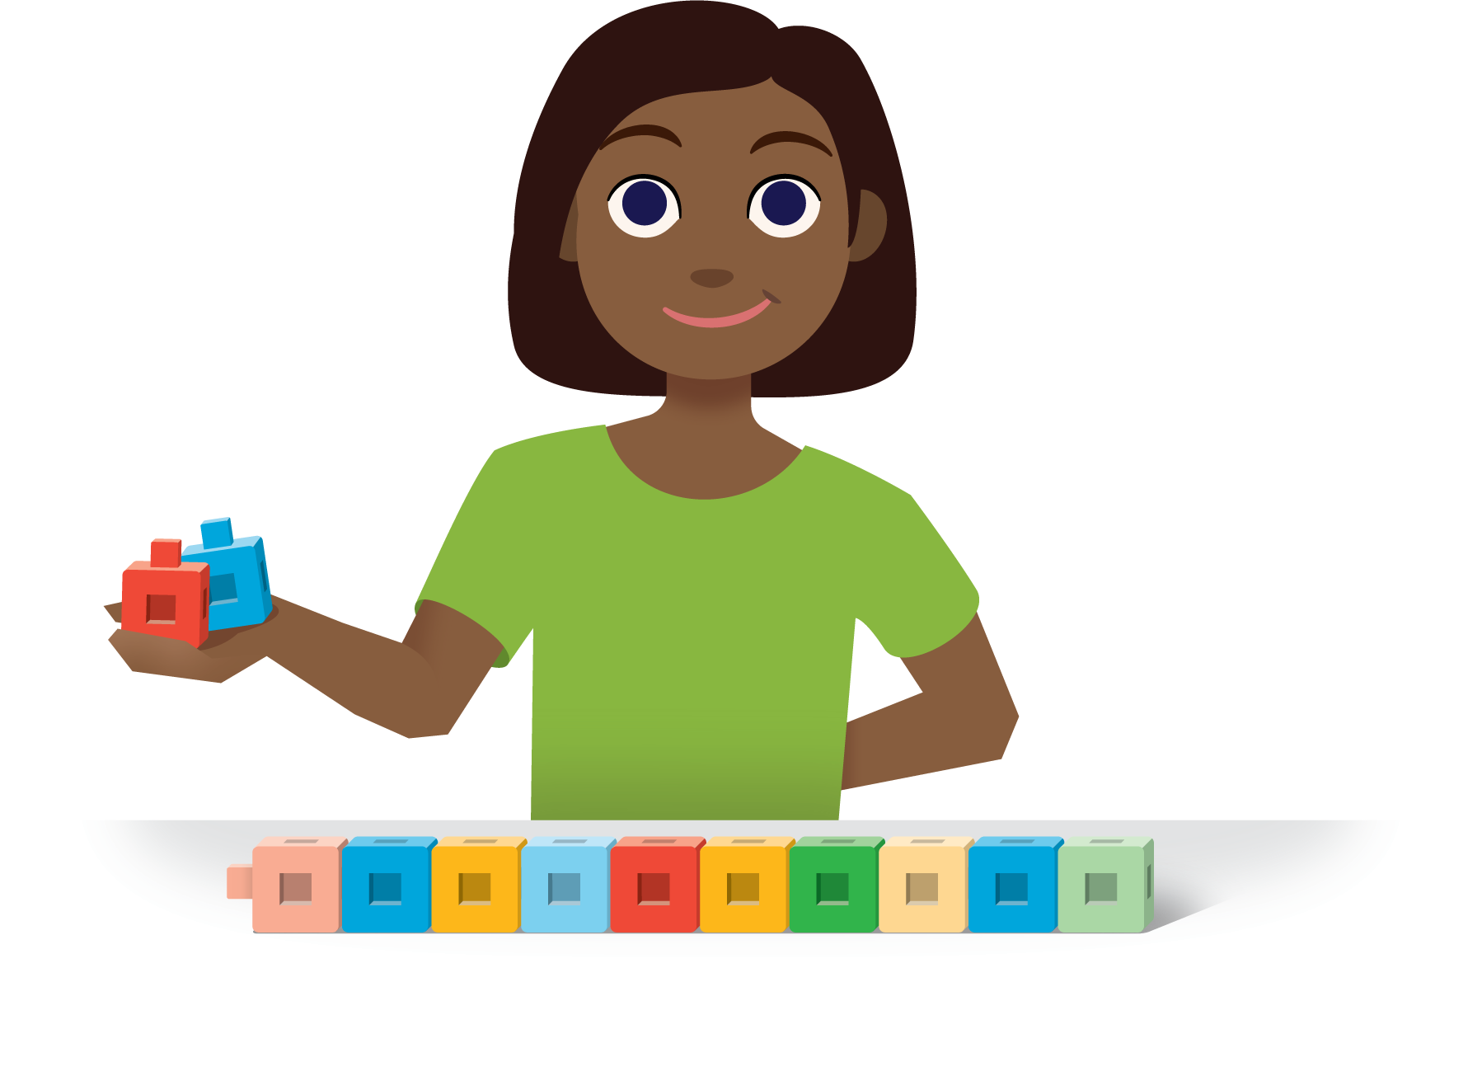
5-frames
Make or Break Apart Numbers
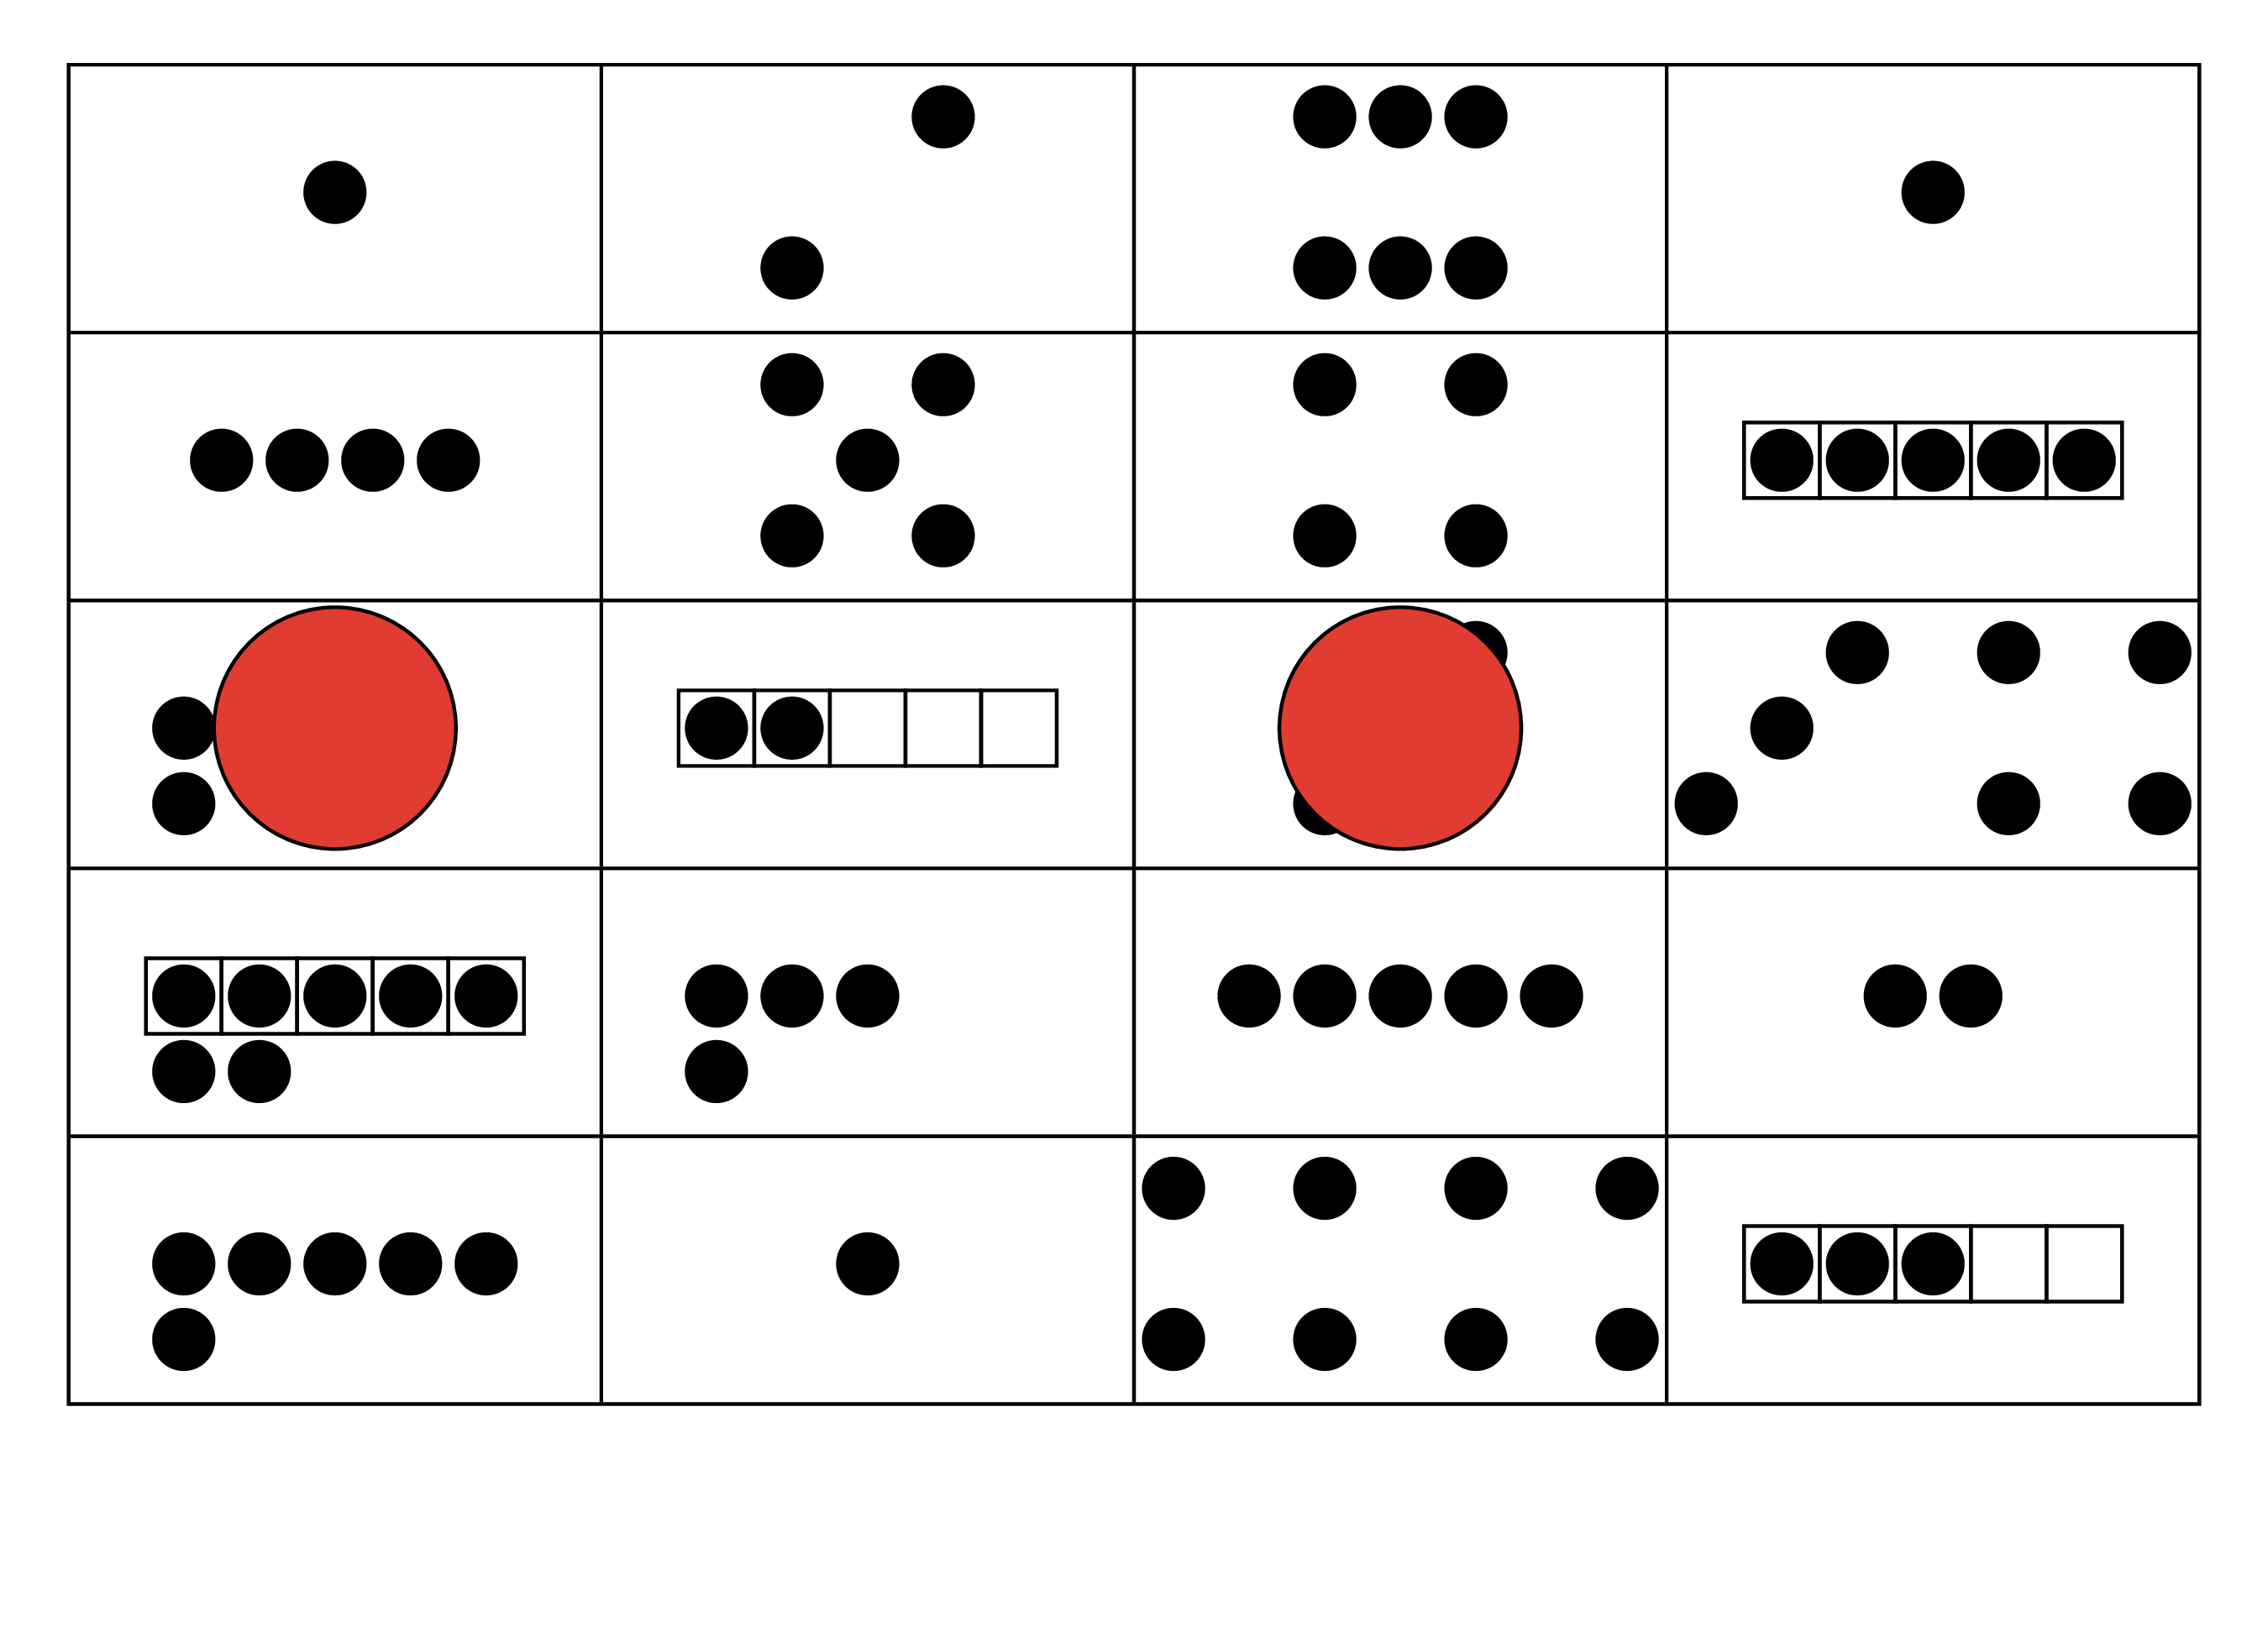
© CC BY 2021 Illustrative Mathematics®

